Operation Manual

HFT11

Hydraulic Crawler Excavator

Original Instruction
Shandong HFT Heavy Industry Machinery Co., Ltd.



Please read this manual and fully
understand its content before proceeding with the operation, inspection and
maintenance of this machine

Safety Warning Signs


This sign denotes a safety warning. The information behind the sign
includes
important safety information.
Please read and understand this information to prevent personal injuries or deaths.

The machine owner or employer is responsible for instructing every operator to operate all equipment correctly and safely in detailed manner. All personnel operating this machine shall sufficiently understand the contents of this manual.

Before operating the machine, all operation personnel must receive the guidance on related functions of excavator.
Before operating this machine in a working site, learn and practice how to use the machine controls correctly in a safe and spacious place.


The improper methods during operations, checking, and maintenance of machine will result in injuries or deaths.
Before any operation, checking, or maintenance of machine, please read and understand this
manual.

Please always carry this manual with you. It’s preferable to preserve this manual on the machine. If this manual is lost or damaged, please immediately order a new manual from a dealer. At the transfer of this machine, please
ensure to hand this manual over to the new owner.
The machine supplied by Ken stone Heavy Machinery conforms to the local standards and specifications of the country exported. If your machine is purchased from other country or from an individual or company of other country, this machine is probably not installed with the safety devices or safety standards required for the operations of this machine in your country. If you have any doubt on the compliance of your machine with the relevant standards and regulations in your country, please contact a Ken stone dealer.

Signal Words

The safety information on this manual and
machine identifications is indicated by words “Danger”, “Warning”, and “Notice” . The
meanings of these signal words are as below:

ΔDanger
“Danger” denotes high dangerous level, for which the negligence will result in death or serious injury.

It’s impossible for us to predict all possibly
existed dangers. Therefore, the warnings in this manual or on this machine can’t cover all
possible accidents. Therefore, during the
operations of machine, ensure to take cautions and abide by all conventional safety measures to prevent harms to machine, operation
personnel, or other personnel.

ΔWarning
“Warning” denotes medium danger level, for which the negligence will probably result in death or serious injury.

 Notice
“Notice” denotes low danger level, for which the negligence will result in minor or medium injuries.

Important: The word “Importance” is intended
to alert the operation and maintenance
personnel of the possible damages of machine and its components.

0-1

Introduction

Foreword
This manual describes the operations, checking, and maintenance of this machine and the safety descriptions to be observed during operations. Should you have any doubt, please contact a
dealer or service provider of Ken stone Heavy

Machinery.
● In some details, this manual probably differs from the manual attached on the machine in use.
● Please be noted that the information contained in this manual and the
parameters of machine are subject to changes without further notice.

The manual is in the circular manual box behind the seat
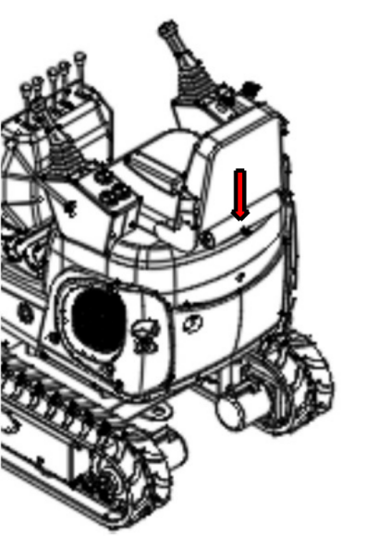

Serial number
Important: Do not disassemble the machine nameplate with serial number. Observe the serial numbers of machine and engine and
record them in the blank area below.

Machine No.:


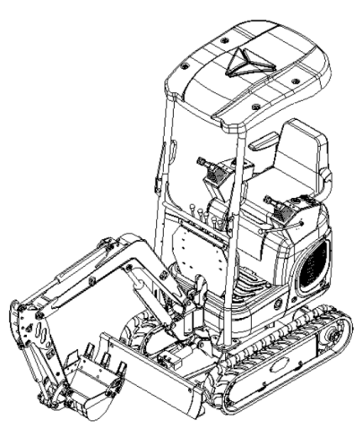
Engine No.:

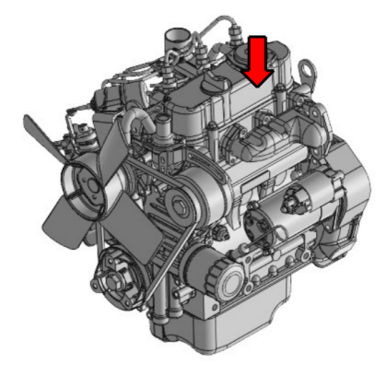

0-2

Introduction

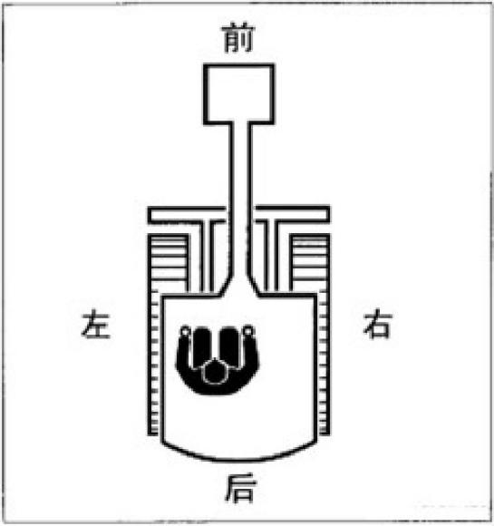
Front, Rear, Left, and Right
Right
Front
Rear
Left
The front, rear, left, and right of the machine
indicated in this manual are based on the status sitting in the driver seat, with the bulldozing
blade visible in the front.

Designated Operations
This machine is mainly applied for following operations:
● Digging
● Ditching
● Side ditching
● Leveling
● Loading

Product Features
● Small size, flexible operation
● Can be equipped with a variety of attachments
● Track width "flexible machine width structure"
Run-in period
For the first 100 hours of the new machine (as indicated by the timer), please follow the
instructions below:
Using the new machine without run-in will deteriorate acceleration performance and probably shorten the life of machine.
● Sufficiently warm up the engine and hydraulic oil.
● Avoid heavy-load and rapid operations.
Maintain the load at approximately 80% of maximum load capacity during operations.
● Do not start, accelerate, steer, or stop suddenly, unless it’s really necessary.

0-3

Introduction

Notes about Reading of This Manual
Please be noted that the descriptions and
graphics contained in this manual probably are not applicable for your machine in use. The numbers in graphics are marked by circles. The same numbers in the descriptions are marked in parentheses. (For instance: ①→(1))

Signs used in this manual

The meanings of the signs used in this manual are as below.
… . Prohibition
,

… … . Lock
……Unlock

Noise and vibration

A-Weighted emission sound pressure level at the operator's position measured according to work cycle procedures specified in “ISO
6396 “ is 78dB(A), The hands and arms are exposed to a weighted root mean square
acceleration that is less than 2.5 m/s2.

The body is exposed to a weighted root mean square acceleration that is less than 0.5 m/s2.

Measurements are obtained on a
representative machine using the procedures in the following
standards: ''ISO 2631-1" ''ISO 5349-1" ''ISO 5349-2"

0-4

Contents

Signal words 0-1
Introduction 0-2
Safety 1-1
General Precautions 1-2
Precautions during Preparations 1-8
Safety Measures at Start 1- 10
Operation Precautions 1- 12
Precautions for Parking 1-22
Precautions during Transport 1-23
Precautions for Maintenance 1-25
Safety Signs 1-35
Controls 2-1
Component Name 2-2
Cover(Start Key / engine cover / fuse case / fuel
filler port) 2-4
Seat 2-6
Electrical control panel 2-8
Switches (start switch / horn button) 2- 10
Joysticks 2- 11
Accessory 2- 14
Operations 3-1
Before Operations 3-2
Start and Stop of Engine 3-3
Operate Machine 3-7
Operations Procedures 3- 17
Parking of This Machine 3-26
Treatment in Cold Weather 3-28
Handling of Rubber Tracks 3-29

Transportation 4-1
Loading and Unloading 4-2
Lifting of Machine 4-4
Fixing of Machine 4-6
Maintenance 5-1
Overview 5-2
Service Data 5-4
Critical Safety Parts 5- 11
Maintenance List 5- 13
Walk-Around Checking 5- 15
Daily routine checking (Every 10h) 5- 17
After first 50h (For new machine only) 5-23
Every 50h 5-
25
Every 250h 5-30
Every 1000h 5-35
Every 1500h 5-39
Every 2000h 5-40
As necessary 5-42
Maintenance during Long-Time Parking 5-49
Troubleshooting 6-1
Symptoms that are not malfunctions 6-2
Engine Overheating 6-3
No Battery Power 6-4
Burnout of Fuse 6-6
Restart after Refueling 6-8
Flashing of Warning Lamps 6-9
Other Symptoms 6- 10
Towing 6- 12

0-5

Parameters 7-1
Basic Parameters 7-2
Overall Dimensions of Machine 7-
3
Operating Range 7-4
Machine lifting power 7-5
Accessories 8-1
General Safety Measures 8-2
Precautions 8-5
Hydraulic Hammer 8-6
Optional accessories 8.11
Parts number position 8- 13

0-6



Safety

1-1

Safety
General Precautions

General Precautions
You are liable to abiding by the safety laws and regulations of relevant departments and fulfilling the operations, checking, and
maintenance of machine.
As a matter of fact, all accidents are caused by the non-compliance with basic safety rules and precautions.
Most accidents can be avoided by authenticating the potential dangers in advance.
Please read and understand all safety
information related to the prevention of
accidents. Please ensure to operate the machine only after you have understood how to operate, check, and maintain the machine correctly.

Abiding by All Safety Regulations

● The machine must be operated, checked, and maintained by trained and qualified personnel.
● During the operations, checking, and maintenance of machine, ensure to understand and abide by all rules,
regulations, precautions, and safety
measures.
● Do not operate, check, or maintain the machine under the adverse influence of alcohol, drug, medicine, or fatigue or

under sleepy status.
Upon detection of machine abnormality During the operations, checking, or
maintenance of machine, upon detection of any machine abnormality (Such as noise, vibration, smell, abnormal instrument, smoking or oil
leakage, error warning indication, and abnormal display of electric control panel), immediately
notify a sales or service dealer and take appropriate measure. Do not operate the machine before the abnormality is solved.
Operating Temperature Range
To maintain the performances and prevent the earlier wear of machine, please abide by the following operating conditions.
● Do not operate the machine when the
outside temperature is more than+45℃ or less than-15℃
. The operations under+45℃ outside
temperature will probably result in engine overheating and deteriorated engine
performance. In addition, the hydraulic oil will probably become really hot to harm the hydraulic devices.
. The operations under 15℃ outside
temperature will probably harden the
rubber parts (Such as gaskets) and cause earlier wear or damage of machine.
. To operate the machine under the


1-2

Safety
General Precautions

condition beyond above-mentioned outside temperature range, please consult with
your sales or service dealer.

Wearing Appropriate Clothing and Protective Appliances
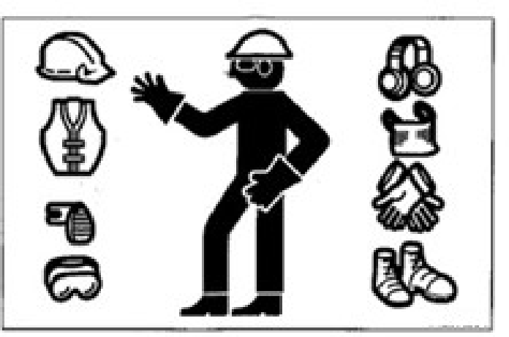
● Do not wear loose clothing or wear
decorative articles that will probably hitch to any joystick or motion part.
● Do not wear oil or fuel contaminated
clothing that is easily vulnerable to fire.
● As per the requirements of working
environment, wear safety shoes, safety
helmet, safety goggles, filtration mask,
thick gloves, ear flaps, and other protective appliances. During the use of grinding
miller, breaking hammer, or compressed air, please wear appropriate protective appliances, such as safety goggles and filtration mask, as the splashing of metal chippings or other objects will probably

cause serious harms.
● Please use the hearing protection devices

during the operations of machine.
Exposure to a high noise environment for a long time will result in harm or even
complete loss of hearing.
Installation of Fire Extinguisher and First-Aid Kit
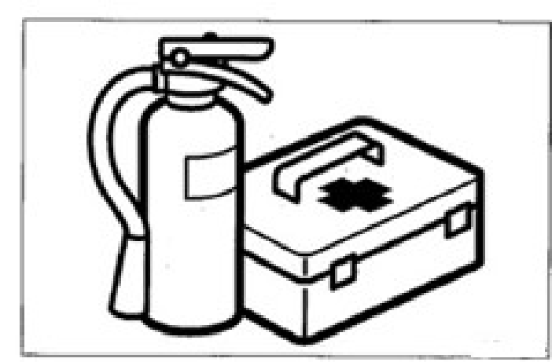
Fulfill the preparations for fire and accident.
● Install the fire extinguisher and first-aid kit and learn how to use them.
● Learn how to extinguish fire and handle accident.
● Know how to contact emergency aid and fabricate the emergency contact list.

1-3

Safety
General Precautions

No Disassembling of Safety Devices
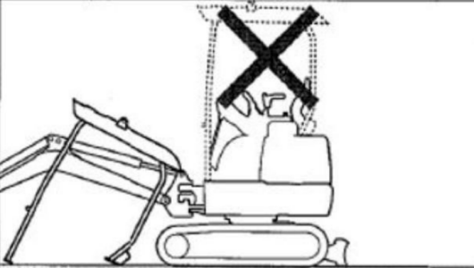

● Please ensure that all guardrails, shelters, and doors are installed properly and
securely. Before operating the machine, please repair or replace damaged parts.
● Know how to use safety lock handle, seat belt, and other safety devices and
understand the correct operation methods.
● Do not disassemble any safety device, unless for the purpose of checking and repair. Always keep all safety devices under good working condition.
Setup of Signaler and Flagman

responsible for making gestures.
● All personnel must completely understand all gestures.
● The operator must respond to the gestures of designated person only. However, the operator must abide by the stop gesture made by anyone in all cases.
● The signaler must stand in a clearly visible place while making the gestures.
Precautions for Standing up from or Leaving Driver Seat
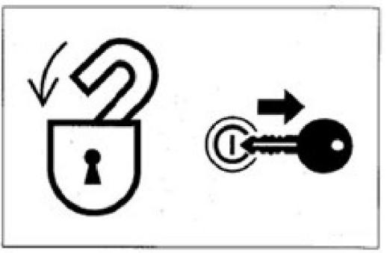
● Before standing up from the driver seat to

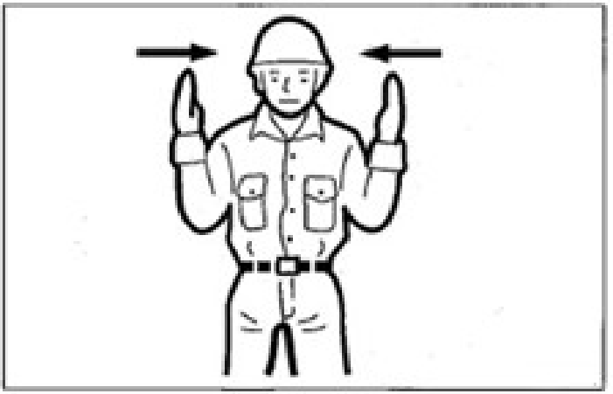
Learn how to use the gestures of specific operation needs and designate the person

open/close windows or disassemble/install the lower window, lower the working
device onto the ground, lift up and lock the safety lock handle, and stop the engine.
When the safety lock handle is lowered down (Unlocked), the accidental touch of any joystick will result in sudden
movement of machine and cause serious injuries or deaths.

1-4

Safety
General Precautions

● Please be noted that, even if the safety
lock handle is placed at locking position, the bulldozing blade, boom, and auxiliary hydraulic controls can’t be locked.
Do not touch such controls accidentally.
● While lifting up or lowering down the safety lock handle, take cautions not to touch any joystick.
Before leaving the driver seat, lower the
working device onto the ground, lift up the
safety lock handle to locking position, and stop
the engine. Meanwhile, ensure to withdraw the
key, close the doors and hoods, and carry the key with you and then preserve it in a
designated place.
Guard against Fire and Explosion Dangers
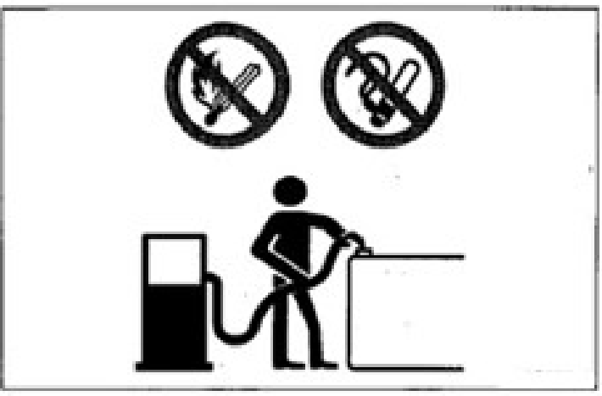
Keep fuel, lubricating oil, grease, and antifreeze away from flame. The fuel is especially
inflammable and really dangerous.
● Handle these inflammable away from
ignited cigarette, match, lighter, and other

flame or fire source.
● Do not smoke or use open fire while
handling fuel or performing the operations of fuel system.
● Do not leave the operation site while filling fuel or lubricating oil.
● Do not disassemble the fuel tank cap or
refuel while the engine is running or is not cooled down. In addition, do not splash
fuel to any machine hot surface or electronic system part.
● Immediately clean the overflown fuel or lubricating oil thoroughly.
● Check for leakage of fuel and lubricating oil. Please eliminate the leaks and clean the machine before operations.
● Please move the inflammable to a safe place before polishing or welding
operations.
● Do not cut or weld any pipeline or pipe
that probably contains inflammable liquid. Please clean thoroughly by non-
inflammable solvent before cutting or welding.
● Remove all wastes and impurities from
machine. Ensure that there is no oil
contaminated rag or other inflammable on the machine.
● Handle all solvents and dry chemicals

1-5

Safety
General Precautions

(Foam fire extinguisher) as per the
manufacturer’s procedures indicated on
the containers. Operate in a well-ventilated place.
● Never use fuel for cleaning purpose. Always use non-inflammable solvent.
● Please open doors and windows for
thorough ventilation during the handling of fuel and the cleaning of oil stain or
paint.
● Preserve all inflammable liquids and materials in a safe and well-ventilated place.
● The short-circuit of electric system will probably result in fire. Daily check the wire connections for looseness and
damage. Re-tighten loose connectors and cable clamps. Repair or replace damaged wires.
● Fire accident caused by pipelines: Ensure that the clamps, protection devices, and
cushion pads of hoses and pipes are
securely fixed. In event of looseness, the
hoses and pipes will be damaged due to
vibration or contact with other parts during operations. This will probably result in
spray of high pressure oil to cause fire accident or harms.

· Toxic Exhaust Gas from Engine ·
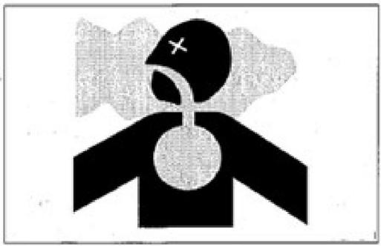
● Do not operate the engine in an enclosed place with poor ventilation.
● If the natural ventilation is not possible, install ventilation fan, fan, extended
exhaust pipe, or other ventilation device. Handling of Asbestos Powders
The inhalation of asbestos powders will
probably cause lung cancer. While handling the materials probably containing asbestos, take the following safety measures:
● Do not sweep by compressed air.
● Avoid polishing or grinding asbestos-contained parts.
● During cleaning, use a vacuum device installed with high-efficiency particulate air filter (HEPA).
● If there is no other method for control of powders, please wear the specified
respirator. During indoor operations, please install a ventilation system with polymer filter.

1-6

Safety

General Precautions

●  ● | During operations, the non-authorized personnel are prohibited to access the working zone.  Please strictly abide by the rules and
environmental standards applicable for this working zone.
Be careful to avoid crushing or cuts

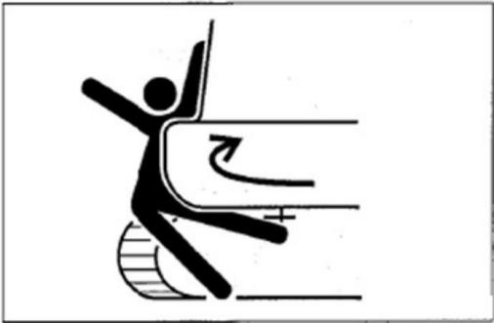
Never place your hand, foot, or other body parts between the superstructure and chassis or tracks, between machine body and working device, or between cylinder and motion parts. During
movement of machine, these clearances will change to probably cause serious injuries or deaths.

Use of Accessories
● Please consult with Ken stone company
before installing accessories. Based on the attachment types and their combinations, the attachments will probably come into
contact with the cab or other machine
parts. Before use, ensure that the installed accessories will not come into contact with other parts.
● Do not use any attachment not approved by Ken stone company. Otherwise, it will probably endanger the safety or cause
adverse influence on operations or life of machine.
● Ken stone company will not be liable for any injury, accident, or product damage arising from the use of non-approved
attachments.

No Modification to Machine
The non-authorized modifications to the machine will cause injuries or deaths.
All non-authorized modifications are prohibited for any part of machine.

1-7

Safety

Precautions during Preparations

Precautions during Preparations Understanding of working zone
Before starting operations, understand the situation of working zone to ensure safety.
● Check the terrain and ground situation of working zone. For indoor operations,
check the building structure and when necessary take safety measures.
● Ensure to keep away from dangers and
obstacles such as water ditch, underground pipelines, trees, cliffs, overhead cables,
and roads with falling stone or landslide danger.
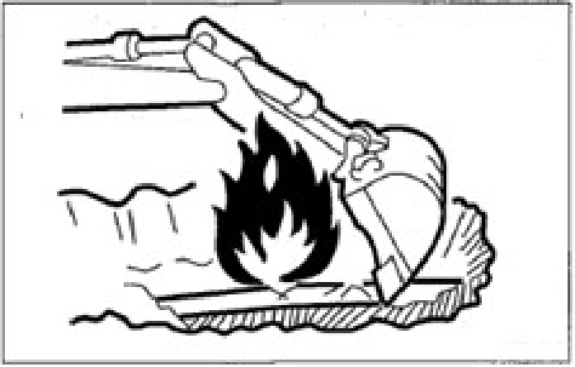

● Check the positions of underground gas pipelines, water pipelines, and electric
cables together with administrator. If
necessary, discuss with administrator to determine the detailed safety measures to be taken to ensure safety.
● During operations on road, ensure to take the safety of pedestrians and vehicles into

consideration.
. Use a signaler and/or signals.
. Isolate the working zone against the access of non-authorized personnel.
● Before operations in water or driving through shallow rivers, check the water depth, ground firmness, and flow rate in advance.
Understand more operation description
information with reference to the “Precautions during Operations”
Checking of Bridge Strength
Please check the permissible load before
driving on bridges or structures. If the strength
is insufficient, reinforce the bridges or structures.
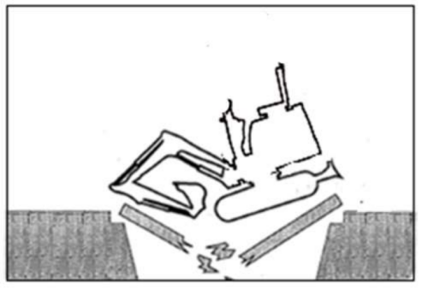

1-8

Safety
Precautions during Preparations

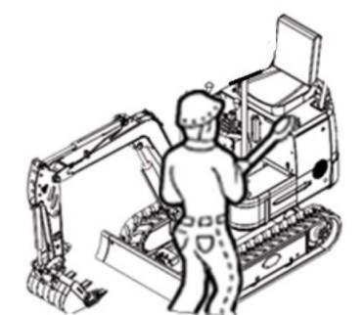
Always Keeping Clean Machine

● Eliminate all loose objects and
unnecessary devices in the machine.
● Wipe away lubricating oil, grease, mud,
snow, and ice, in order to prevent accident due to slip.
● Remove dusts, lubricating oil, and grease from engine portion to prevent fire
accident.
● Clean the area around operator's seat and remove all unnecessary objects from the machine.
Daily Checking and Maintenance
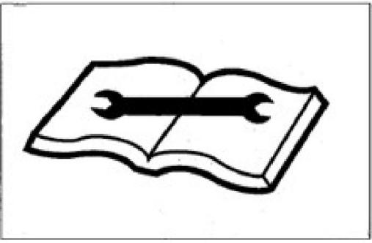
The failure to find out or repair the
abnormalities or damages of machine will cause accidents.

● Before operations, fulfill the designated checking and when necessary repair
immediately.
● In event of operation failure due to
malfunction or engine malfunction,
immediately stop the engine as per stop procedure and park the machine securely, till the malfunction is repaired.
Precautions in the driver's cabin If the machine is equipped with a driver's cab:
● Before entering the driver's cab, please
remove the dirt and grease from the soles of your shoes. Operating the machine
pedal with dirt and grease adhering to the sole can cause an accident due to slipping under your feet.
● Do not place parts or tools around the driver's seat.
● Do not place any plastic bottles in the cab or install any suction cups on the window glass. The plastic bottle or suction cup
acts as a lens and may cause a fire.
● Do not use your mobile phone while walking or working.
● Do not bring combustibles or explosives into the operation area.
● Do not leave the lighter in the driver's
cabin. When the room temperature rises, the lighter may explode.

1-9

Safety
Safety Measures at Start

Safety measures when starting
Support your body weight by three-point safety
posture while getting on/off the machine.
● Do not jump on or off the machine. Do not attempt to get on or off a moving machine.
● Before getting on or off the cab, firstly
open the door completely to locking
position and check and ensure that the door can’t move further(For machine with cab).
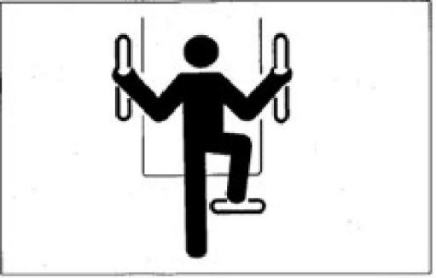
● Face towards the machine, get on/off the footplates, and grab the handrail to support your weight by three-point safety posture (Hands and feet).
● Do not use safety lock handle or any joystick as handrail.
Before starting machine, keep all
non-authorized personnel away from this zone
Start the engine only after the safe start is confirmed by checking the following items.
● Walk around the machine and alert the
repair personnel and the personnel walking

around the machine. Start the engine only after it’s confirmed that there is no person around the machine.
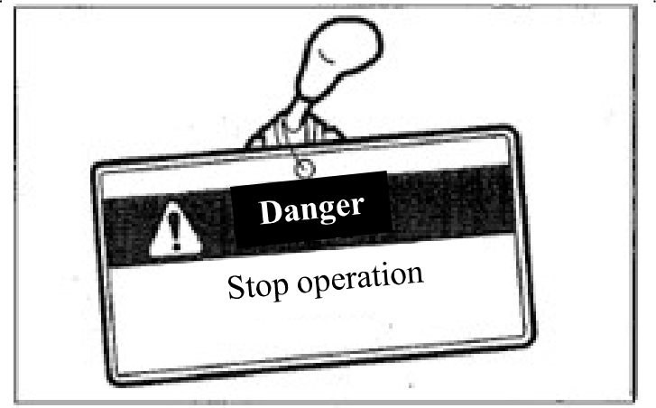
● Check for warning sign “No Operation” or similar sign affixed on cab door, control, or starter switch. If present, do not start
engine or touch any joystick.
● Sound the horn to alert the personnel around machine.
Sit in the driver seat and start the engine.
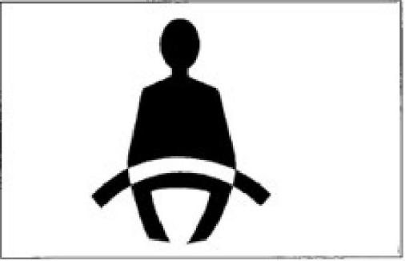
● Adjust the seat till it’s securely locked.
● Fasten the seat belt.
● Check whether the parking device is

1-10

Safety
Safety Measures at Start

actuated and all joysticks and pedals are in neutral.
● Check whether the safety lock handle is at locking position.
● Ensure there is no person near the machine.
● Start and operate the machine only in driver seat.
● Do not attempt to start the engine by short circuiting the terminals of starter device.
Start by Jumper Cable

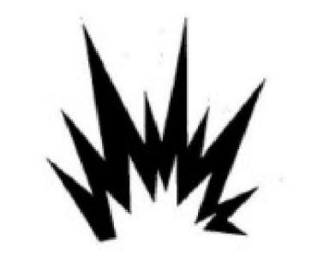
Start by jumper cable only as per the
recommended method. The improper use of
jumper cable will result in battery explosion or unexpected machine motions.
Please refer to “In event of no battery power” to
understand more operation description information.
After Start of Engine
After the start of engine, fulfill following
operations and checking in a place without personnel or obstacle. Upon detection of any malfunction, stop the engine as per the

procedure and report malfunction.
Warm up the engine and hydraulic oil.
Check all instruments and warning devices for normal functioning.
Check for presence of noise. Test the engine speed control.
Operate all control devices to ensure normal functioning.
For Cold Weathers


Take cautions that the frozen ground, footplates, and handrails are slip. Under cold weathers, do not touch any metal part of machine by bare
hands. Your skin will be frozen on metal part to cause serious injuries.
Do not use ethyl ether or starting fluid on the engine. The starting fluid can cause explosion and serious injuries or deaths.
Warm up the engine and hydraulic oil.
Operating joysticks without warm-up will result in slow or inappropriate reaction or movement of machine to cause accident.

1-11

Safety
Operation Precautions

Operation Precautions
Operating Machine with Maximum Track Width
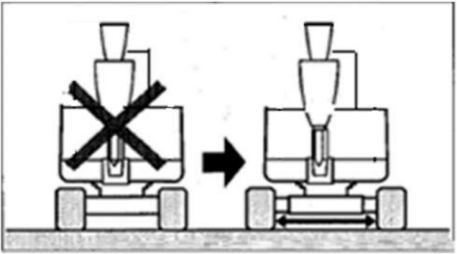

Always operate the machine with extended
track width of 950mm, in order to improve the machine stability to the maximum extent.
Operating the machine with narrow track width (800mm) will probably result in rollover of
machine due to poor stability.
If it’s necessary to operate the machine with
narrow track width (800mm), retract the bucket working device and lower the boom to reduce the gravity center and face the machine towards front before traveling.
Guarantee of Good Visibility
Checking of Visibility before Operations of Machine
During operations in a dark place, turn on the working lamp and headlamp of machine and
when necessary install additional lighting
devices. In event of poor visibility due to severe

weathers (Such as fog, snow, rain, and haze), stop the operations of machine till the visibility turns good.
Clean the windows, mirrors, lamps, and camera to keep good visibility. Adjust the mirrors and camera to optimal positions to ensure that the driver sitting in the driver seat can see the rear view (Blind spot).
The non-authorized modification or the
installation of non-approved attachments will probably impair the visibility. The operator’s visibility must conform to the requirements of
ISO 5006.
Do not carry people on the machine
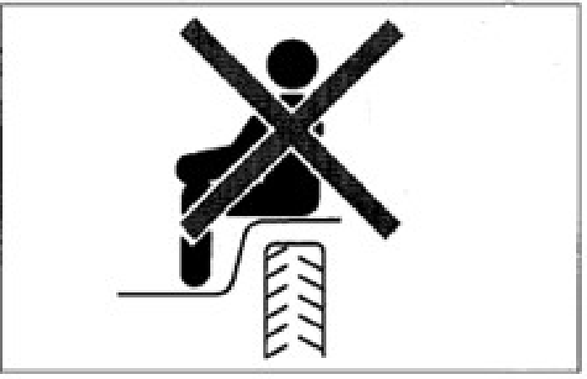
All personnel are prohibited to sit on any part of machine at any time during traveling or
operations of machine.

1-12

Safety
Operation Precautions

Checking for Safe and Reliable
Working Zone before Operations
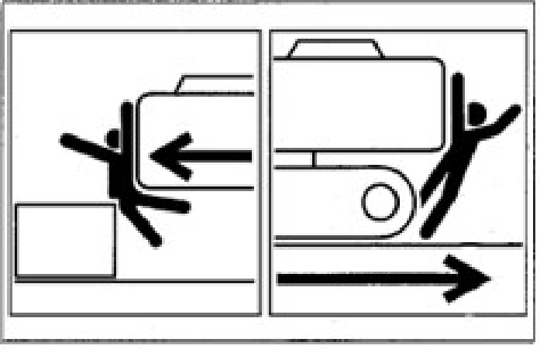

Verify the performance limits of machine.
Set up a signaler at the road shoulders, narrow places, or vision-obstructed places.
Do not allow any person to access the turning radius or path of machine.
Sound the horn to indicate your movement intention.
There are blind zones behind the machine.
Before driving backward, check the safety in the area behind machine and ensure there is no
person behind the machine.
Checking of Chassis (Tracks) before Traveling
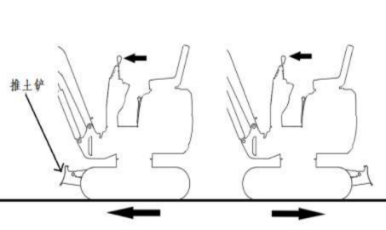

Before operating the traveling joystick/pedal, ensure that the bulldozing blade is in front of the driver seat. Please bear in mind that the operation direction of the traveling
joystick/pedal with bulldozing blade behind the driver seat is reverse to that with bulldozing
blade in front of driver seat.
Safe Traveling
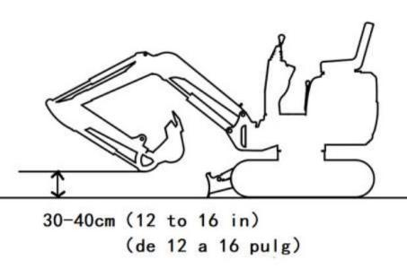

The bulldozing blade shall be lifted during
traveling. Retract the bucket working device as shown in above diagram and lift the bucket by 30~40cm off the ground.
Do not slew during the traveling. If it’s
necessary to operate the bucket working device during traveling, operate at sufficiently low
speed to ensure the complete control at all times.

1-13

Safety
Operation Precautions

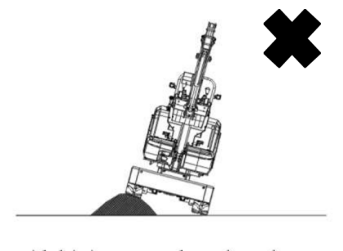
● Avoid driving over obstacles whenever
possible. If it’s necessary to drive over
obstacles, keep the bucket operating device near the ground and travel at low speed. Do not drive over any obstacle that will incline the machine by 10° or larger.
● On rugged roads, drive the machine at low speed and avoid the sudden startup, stop, and direction change. Otherwise, the working
device will probably come into contact with the ground to cause unbalance and damage of machine or destruct the structure in
surrounding area.
Precautions for Traveling on Slopes
While traveling on slopes, take cautions to prevent the rollover and gliding of machine.

● Do not drive the machine on a slope
steep enough to cause instability of
machine. Please be noted that, in the
actual applications, the performances of machine on a slope will be deteriorated due to severe working conditions.

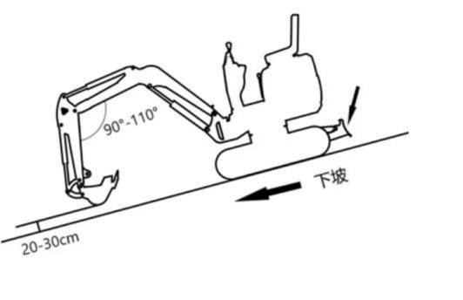
Bulldozing blade



● Keep the driver seat facing towards the up slope direction while climbing up a slope. Keep the driver seat facing
towards the down slope direction during down slope traveling. In both cases, pay special attention to the ground ahead of
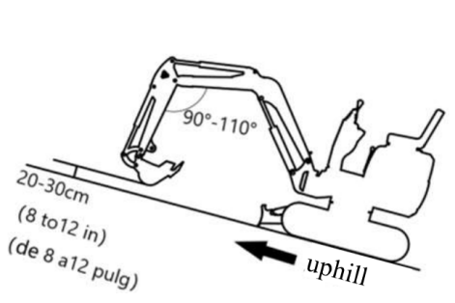
the machine during traveling.
● While traveling on a slope, lower the bucket to 20~30cm off the ground. While climbing up a steep slope, extend the bucket working device to the front position. In event of an
emergency, lower the bucket onto the ground and stop the engine of machine.
● When walking on slopes or ramps, drive slowly. Reduce engine speed when going downhill.
● Do not reverse the machine down a slope.

1-14

Safety
Operation Precautions

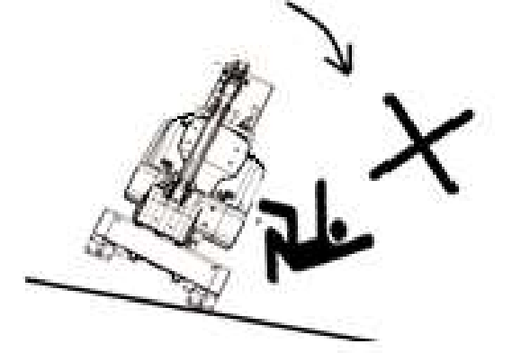
● Do not change direction on slopes or
cross slopes. First return to the flat surface, and then take another path.
● When walking on a gentle slope covered with grass or dead leaves, or when
walking on wet metal plates or frozen
ground, the machine may slip. Make sure that the machine does not stop laterally on
· a slope. ·
● If the machine stalls on a slope, return the operating levers to the neutral position,
and then restart the engine.

Special Cautions for Operations of Machine on Ice/Snow
● While traveling on snowy or icy roads, drive at low speed and avoid the sudden startup, stop, and direction change.
● In snowy regions, the road curbs and the
roadside objects are buried in the snow to become invisible. In addition, there is a
danger of machine rollover or collision with covered objects. Therefore, always operate with cautions.
● There is a danger of rollover or snow
entrapment while driving the machine into thick snow. Drive with cautions and do not drive over road curbs or entrap in the snow.
● For frozen soil surface, the ground becomes soft when the temperature rises, which will probably result in rollover of machine and entrapment of operator in the machine.
● While parking the machine on a unstable ground, lower the bulldozing blade.

1-15

Safety
Operation Precautions

No Movement of Bucket over Personnel
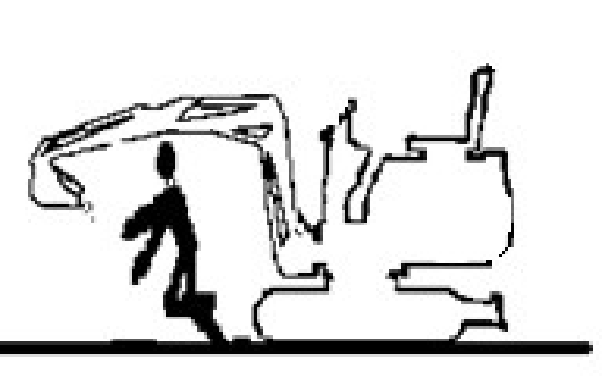
Moving the bucket over the personnel has a danger of splashing of loaded material or the sudden falling of bucket.
Guarantee of Driver’s Safety during Loading
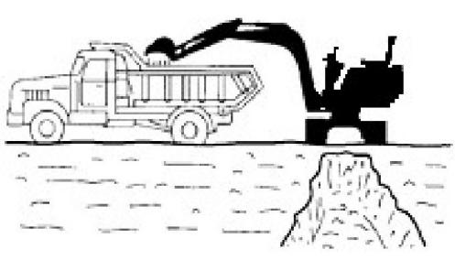
Do not load before the driver reaches a safe place.
● Do not swing or position bucket above personnel or cab.
● Load from the backdoor of trucks.

Keeping a Safe Distance from Overhead High-Voltage Cables
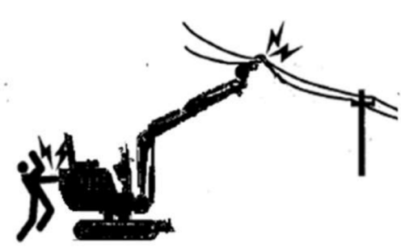
Never close any part or loaded material of
machine to high-voltage cables, unless all
safety measures specified by local and national authorities are already taken. There is a danger of electric shock and death when any person
approaches to the machine that is discharging electric spark or is near or in contact with
power supply.
● Always keep a safe spacing between machine and high-voltage cables.
● Before starting operations, please verify the relevant operation safety procedures with local power grid.
● Consider all electric cables as high-voltage cables. Even if it’s known or believed that the power supply is cut off or the cable is clearly grounded, consider such cables also as live cables.
● If the machine is too close to high-voltage

1-16

Safety
Operation Precautions

cables, set up a signaler to sound warnings.
● Keep all personnel within operation zone away from machine and loaded material.
● Pay special attention to the underground high-voltage cables.
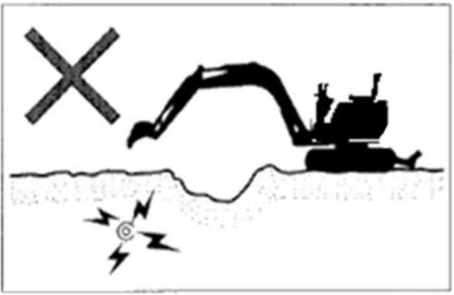
Close Observation on Dangerous Working Conditions
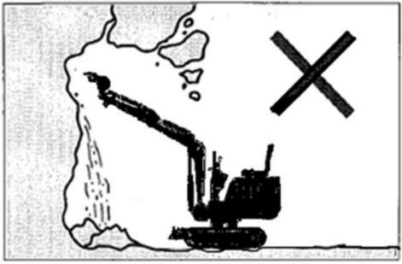

● Never dig on the bottom of any high
embankment. It’s really dangerous because such operation will probably result in
surface collapse.
● Do not operate in any place with falling stone danger.

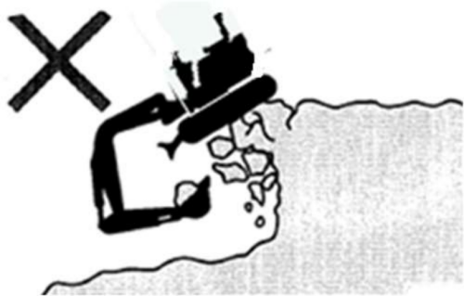

● Keep a safe spacing between machine and edge of digging site. Do not dig the ground ahead of machine.
● During the operations near a cliff or road
curb, to ease the escape in any event, form a right-angle between tracks and cliff or road curb and place bulldozing blade in the front.
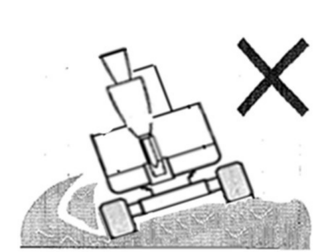
● Do not access any soft ground area. This will probably result in inclination of
machine due to dead weight to cause rollover or ground entrapment.

1-17

Safety
Operation Precautions

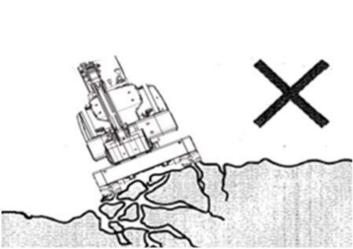

● Keep away from unstable ground (Cliffs,
road curbs, and deep ditches). If the ground collapses due to machine weight or
vibration, there is a possible danger of machine falling or rollover.
• Please bear in mind that the soil turns infirm after heavy rain or explosion.
• The ground on the top of embankment and the ground around and on top of the dug ditches are also infirm.
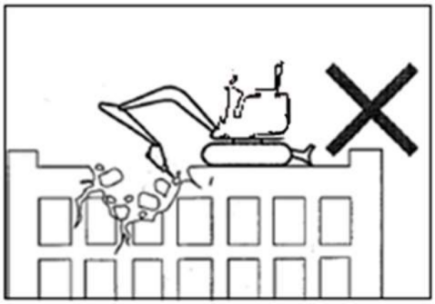
● Do not perform demolition operations beneath the machine. There is a possible falling danger of machine when the ground becomes unstable.

● Before the operations on the top of any
building or other structure, check the
strength and structure. It will cause serious harms or destruction if the building or
structure collapses.
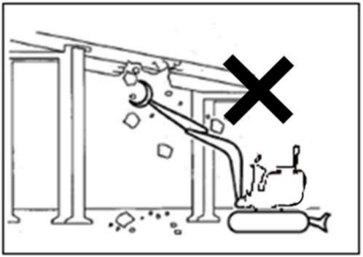
● Do not perform demolition operations above your head. There is a falling damage of
damaged parts or collapse danger of building to cause serious harms or destruction.
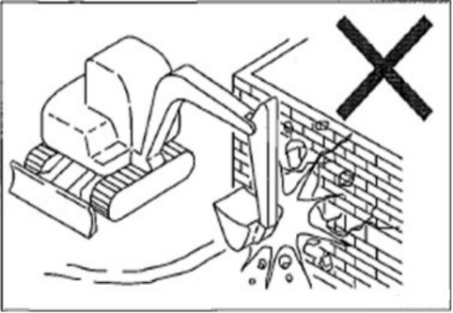
● Do not perform the demolition operations by the impact force of bucket working device. The splashed material fragments and the
damaged bucket working device have a danger of serious harms.

1-18

Safety
Operation Precautions

Danger during Operations on Slopes
During operations on slopes, slewing or
operating the working device can probably
result in instability or rollover of machine.
Avoid operations on slopes whenever possible.

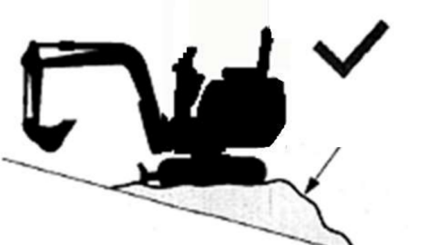

Landfill

● Leveling operation zone
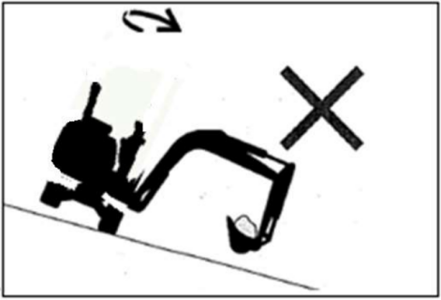
● If the bucket is fully loaded with material, avoid slewing towards the down slope
direction. Otherwise, it will deteriorate the machine stability and probably result in
rollover.

No Lateral Slewing (Swing) with Bucket Heavily Loaded
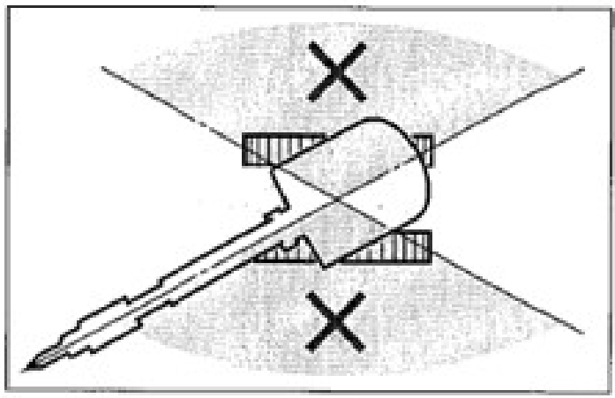
The machine is more vulnerable to rollover in lateral direction than longitudinal direction.
● Do not laterally slew (swing) when the
bucket working device is heavily loaded. Especially, do not laterally slew (swing) on a slope.
● When the machine is equipped with
breaking hammer, grinder, or extended
bucket arm, the attachment end is heavier than that with standard bucket. For machine with such heavy end, do not face the bucket arm (boom) towards down slope direction for digging or towards lateral direction for operations.

1-19

Safety
Operation Precautions

Please pay attention to the objects above your head
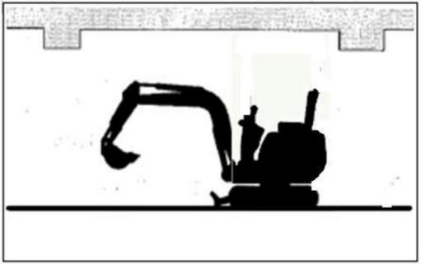
During operations under bridges, in tunnels, near cables, or indoors, guard the boom and bucket arm against impact with any overhead object.
Not Designed for Lifting Application
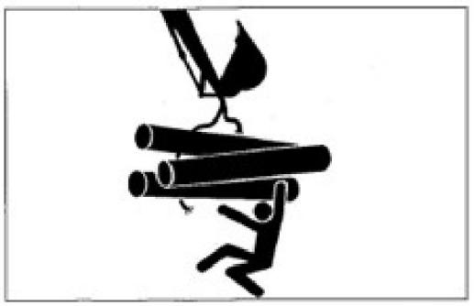
This machine is specially designed for digging operations. Therefore, it’s not installed with
safety devices for lifting operations. Take
special cautions while using this excavator for lifting operations.
● Do not overload during lifting. The overload will result in rollover of machine to cause

serious injuries or deaths.
● All rated lifting capacities are based on the
condition of using this machine on a firm and level ground. The user’s is recommended to
reserve an appropriate allowance for specific
working conditions, in order to ensure the safe lifting operations. The soft or uneven ground, non-level status, lateral load, dynamic or
sudden load, dangerous environment, and
personnel experience are included. Before
operating the machine, the operation personnel and other personnel shall be really familiar with the Operation Manual. The safe operation
regulations of the machine shall be strictly followed in all cases.
● If the chain or lifting device is incorrectly
connected, the bucket connecting rod or the
lifting device will probably fail to cause serious injuries or deaths.
● While using this machine as a crane, do not attempt to pull out a stump from the ground. For this application, the load applied onto the machine is completely unknown.
● Do not allow any person to stand on or beneath the lifted object or close to the operation zone.
Please pay attention to flying objects
This machine is not installed with any protective device to guard the operator against the harms of flying objects. Do not operate this

1-20

Safety
Operation Precautions

machine in any dangerous place in which the operator is probably subject to the impact of flying objects.
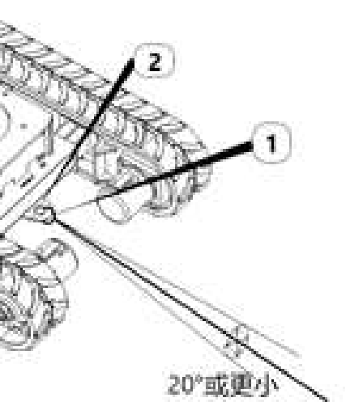
Precautions for Towing

Please refer to the section “Towing” to
understand more description information.

20°or less
During towing, the improper operations, the
incorrect use of rope, or the improper checking will cause serious injuries or deaths.
● The breakage or cracking of rope can cause danger. Use wire ropes compatible with the towing force.
● Do not use any kinked, twisted, or even damaged rope.
● Do not suddenly apply heavy load onto the
rope.
● Please wear safety gloves during the handling of rope.
● Ensure that an operator is assigned each on the towing machine and the towed machine.
● Do not operate the towing operation on a slope.
● Keep all personnel away from the rope
during towing.
1-21

Safety
Precautions for Parking

Precautions for Parking Safe parking
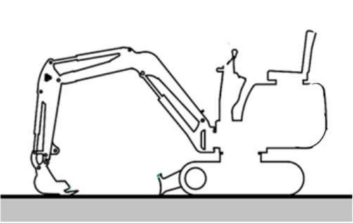
● Stop the machine on a level, solid, and safe ground. Set the parking device.

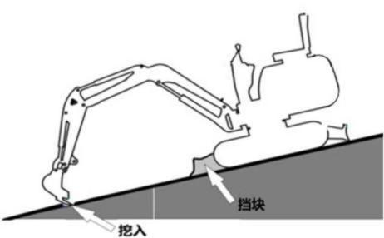

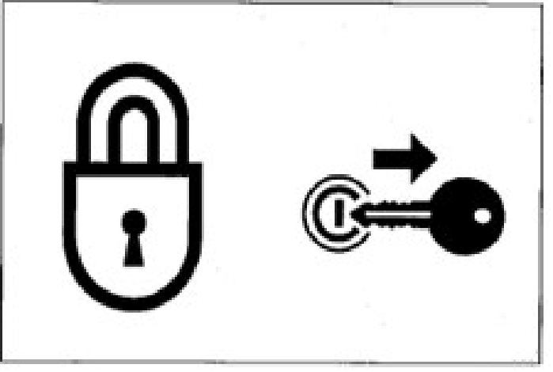
● Complete the following operations before leaving the machine:
Lower the bucket and bulldozing blade onto the ground.
Lift up the safety lock handle to the locking position.
Stop the engine and withdraw the starter key.
Lock the cab and hood and carry the key with you.

● If it’s necessary to park the machine or tilt the machine on a slope, securely park the machine and block the machine against
movement.
While parking the machine in a street, use gratings, warning signs, or lamps to keep the visible even in the night, in order to
prevent the impact with other vehicles.

1-22

Safety
Precautions during Transport

Precautions during Transport Safe loading/unlocking of machine

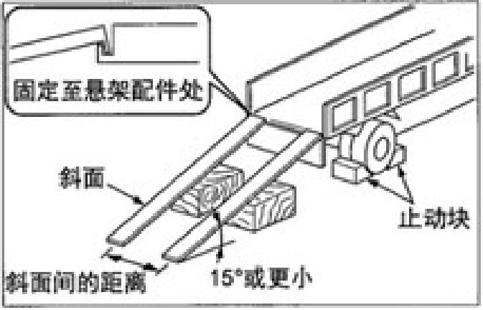
Fix to suspension parts
Distance between
Stop block
15°or less
Ramp
The machine will probably roll over or fall off during loading and unloading. Ensure to take the following safety measures:
Select a solid and level ground and keep a sufficient spacing from the road curb.
Fix the ramps of sufficient strength and
dimensions to the cargo body of truck. The
inclination of the ramps shall not exceed 15°. If the ramps deflect downward excessively, please support the ramps by supports or cushion
blocks.
Do not load or unload the machine by working device. Otherwise, it will probably result in
rollover or falloff of machine.
Keep the truck cargo body and the ramps clean without oil, sand, ice/snow, or other impurity, in order to prevent the side slip of machine. Clean the tracks.
Block the wheels of transport truck by wedges

to prevent movement. While loading or
unloading the machine, drive the machine
slowly in 1st gear (low speed) as per the signals of the signaler.
Do not change direction on ramps.
Do not slew/swing on ramps. Otherwise the machine will probably roll over.
Slewing (swinging) the machine on the cargo body of truck will probably result in unstable legs of machine. Therefore, operate slowly. If possible, lock the cab doors after loading. Otherwise the cab doors will probably open during the transport.
Plug securely the tracks by wedges and then fix the machine to the truck cargo body securely by ropes or chains.

1-23

Safety
Precautions during Transport

Safe Lifting of Machine
Master and utilize the correct lifting gestures. Daily check the lifting device for damaged and missing parts and when necessary replace.
Please use the ropes of sufficient capacity for the machine weight during lifting.
Lift the machine as per the procedure described below. Do not operate by any other method,
otherwise it will probably result in unbalance of machine.
Please refer to the section “Lifting of Machine” to understand more description information.
Do not operate the lifting if there is any operator on the machine.
Operate slowly during lifting to prevent the rollover of machine.
During lifting, keep all personnel away from
working zone. Do not move the machine over any person.

Safe Transport of Machine
During the transport of machine, understand
and abide by all applicable safety rules, vehicle codes, and traffic regulations.
Take the length, width, height, and weight of the transport truck with loaded machine into consideration, in order to select the best
transport route.
During the transport, do not start up or stop the transport truck suddenly or drive at high speed. Otherwise, it will result in movement or
unbalance of loaded machine.

1-24

Safety
Precautions for Maintenance

Precautions for Maintenance Warning Information of “No
Operation” Sign
During the checking or maintenance of
machine, the start of engine or the touch of any joystick by non-authorized personnel will
probably result in serious injury accidents.
Before maintenance, please stop the engine and withdraw and carry the key.
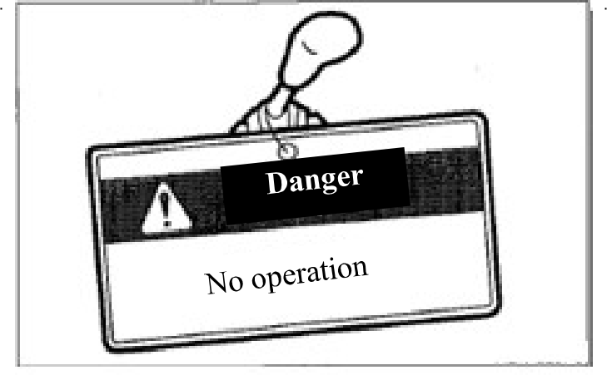

Affix warning information “No Operation ” to an eye-catching place such as starter
switch and joystick.
Use of Correct Tools
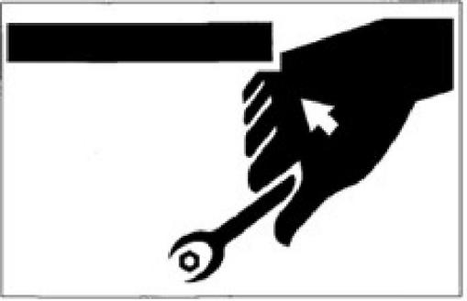

Do not use any damaged or deteriorated tool or any tool designed for other application. Use tools suitable for related operations.
Periodically Replaced Critical Safety Parts
Replace the fuel hoses periodically. The fuel
hoses will wear gradually along with time, even if no wear symptom is visible.
Upon detection of any wear symptom, replace the fuel hose, regardless of the replacement schedule.
To understand more details, please refer to the section “List of Critical Safety Parts” .
Explosion-Proof Lamps
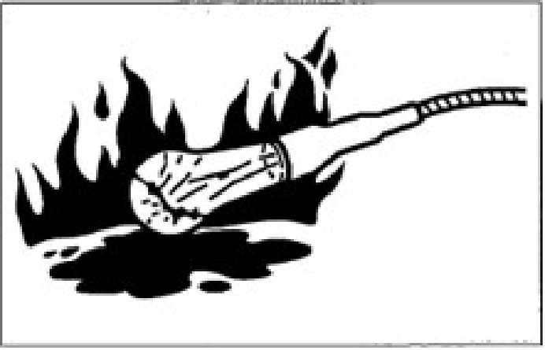
While checking the fuel, lubricating oil,
coolant, and battery electrolyte, please use
explosion- proof lamps to prevent fire and
explosion. Otherwise, it will probably result in explosion to cause serious injury accidents.

1-25

Safety
Precautions for Maintenance

No Access of Non-Authorized Personnel
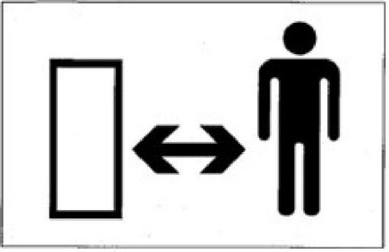
During operations, the non-authorized
personnel are prohibited to access the working zone. Take cautions during grinding, welding, and use of hammer. You will probably be
injured by the flying fragments from the machine.
Preparations of Working Zone
Select a stable and level working zone. Ensure the appropriate illumination conditions. For
indoor operations, keep well ventilated.
Remove obstacles and dangerous goods. Clear slippery areas.
Always Keeping Clean Machine

Please clean the machine before maintenance.
Stop the engine before cleaning the machine.
Cover the electric parts against water ingress.
The water ingress into the electric parts will
probably result in short-circuit or malfunction. Do not clean the battery, electronic control units, sensors, connector, or cabby water or steam.
Stop of Engine before Maintenance
While the machine is working or the machine is not working but the engine is running, avoid
lubricating or further adjusting the machine.
If the maintenance requires the running of
engine, assign two operators for teamwork and keep contact with each other.
One operator must sit in the driver seat to get ready to stop the engine immediately when necessary. This operator must pay special
attention not to touch any joystick or pedal, unless it’s absolutely necessary.
The other operator for the maintenance must keep the body and clothing away from motion parts of machine.

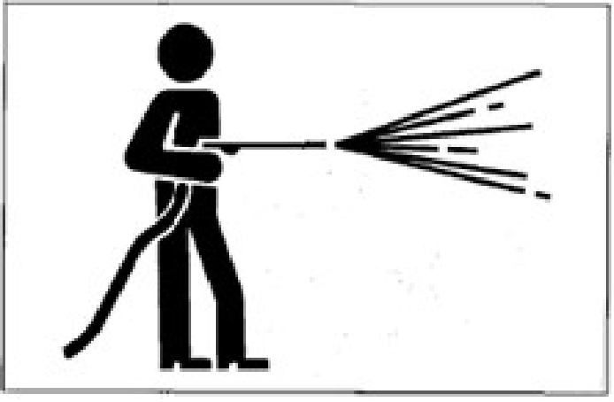
1-26

Safety
Precautions for Maintenance

Keeping Away from Motion Parts
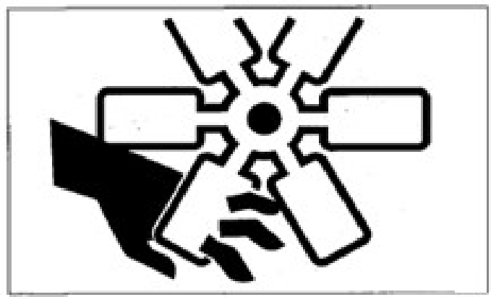

Keep away from all rotating and motion parts. The entanglement of hands or tools into
rotating or moving parts will probably cause
accidents of serious injuries or even deaths.
The tools or other objects fallen or inserted into the fan or fan belt will be crushed or cut. Never throw or insert any object into fan or fan belt.
Secure Fixing of Machine and Possibly Falling Parts
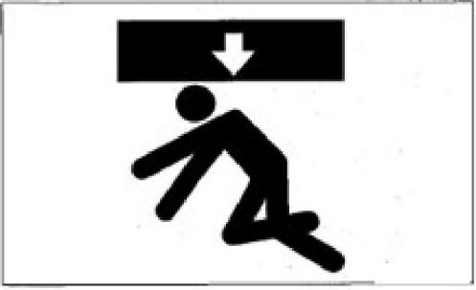

Before the maintenance or repairs beneath the machine, lower all movable working devices onto the ground or lowest position and fix the

tracks.
If it’s necessary to operate beneath the lifted machine or device, always fix by cushion
woods, jack, or other firm and stable supports. Do not access the area beneath the machine or working device before it’s firmly supported. This operation is especially important for the hydraulic cylinder operations.
Fixing of Working Device
During the repairs and replacements of bucket teeth or side teeth, to prevent the accidental
movement of machine, securely fix the working device.
Steady Placement of Opened Engine Hood and Cover
Before operations within the machine, please
securely fix the engine hood or machine hood. Keep the engine hood or cover closed under
windy weather or while parking the machine on a slope.
Placement of HeavyWeights at Steady
Place
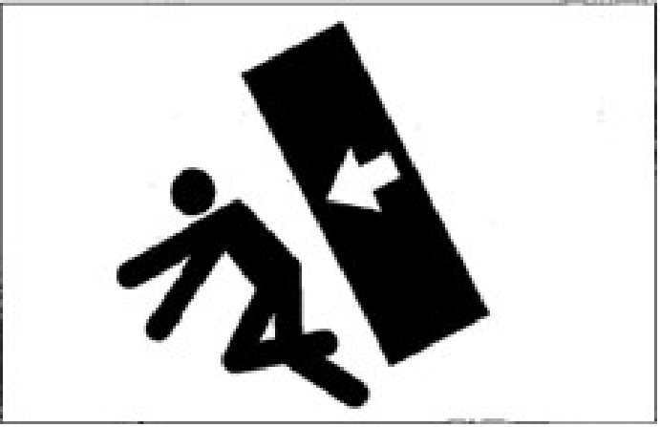
If it’s necessary to place temporarily heavy

1-27

Safety
Precautions for Maintenance

weights or attachments onto the ground during disassembling or installation, please ensure to place them in a steady place. Keep the non-
authorized personnel away from the place for storage of such objects.
Precautions for Refueling
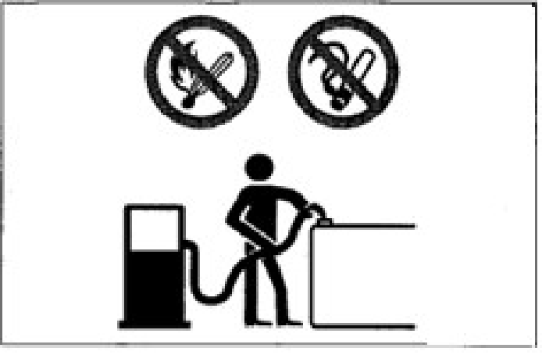
The smoking and open fire are prohibited
during refueling and near the refueling point. Do not disassemble the fuel tank cap or refuel while the engine is running or is not cooled down. Do not splash fuel to any high
temperature surface of machine.
Refuel the fuel tank in a well-ventilated place. Do not top up the fuel tank. Leave an expansion

pressure in the fuel tank.
Do not use fuel for any cleaning purpose. Use correct fuel grade based on the season.
Handling of Hoses
The leakage of lubricating oil or fuel can result in fire accident.
Do not distort, bend, or impact any hose.
Do not use any distorted, bent, or cracked
pipeline, metal pipe, or hose, otherwise it will probably result in burst.
Re-tighten any loose connector.
Absolution Caution during Handling of High Temperature and High
Pressure Parts
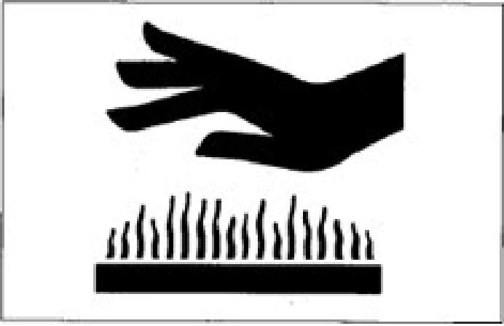

space for the fuel.
Any overflown fuel shall be wiped away immediately.
Tighten the fuel tank cap securely. If the fuel tank cap is missing, replace with original cap only. The use of non-authorized fuel tank cap with poor ventilation will cause internal

Please stop the engine and wait for the machine to cool down before maintenance.
The engine, exhaust pipe, radiator, hydraulic
pipes, sliding parts, and many other machine parts are really hot when the engine is just
stopped. Touching such parts can cause
scalding. The engine coolant, hydraulic oil, and

other 1-28

Safety
Precautions for Maintenance

fluids are also under high temperature and high pressure status.
Take cautions not to touch the hydraulic oil while loosening engine hood or connector. Operating the machine under such condition will cause out-spray of hot oil to result in
scalding or injuries.
Absolution Caution during Handling
of High Temperature and High Pressure Parts
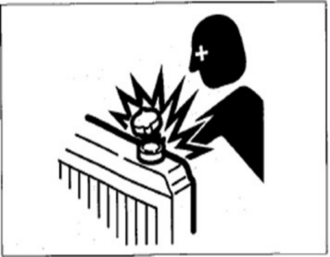
Do not disassemble the radiator cap or drainage plug when the coolant is hot. Stop the engine
and wait for the engine and coolant to cool
down. Slowly loosen the radiator cap to relieve the internal pressure and then take it out.
Caution against Internal Oil Pressure
Take caution against internal oil pressure. After the stop of engine, the pressure in the hydraulic oil pipes can hold for a long time.
Before the maintenance, thoroughly relieve the internal pressure.

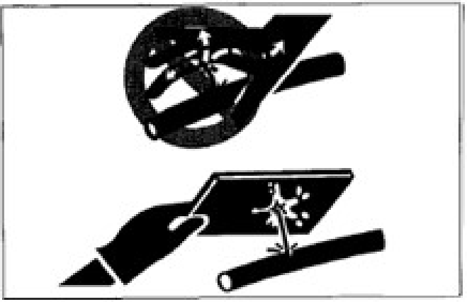

The high pressure of hydraulic oil can penetrate skin and eyes to cause serious injuries and
blindness or even death. Please bear in mind that the hydraulic oil permeating from orifices is nearly invisible to naked eyes. While
checking for leakage, wear goggles and thick gloves and protect the skin by paper boards or plywood to protect against the harms of
spraying hydraulic oil.
The hydraulic oil penetrating into your skin
must be cleared by a doctor familiar with such injuries with surgical method within several
hours.
Pressure Relief before Operations of Hydraulic System
Disassembling cap or filter or disconnecting pipeline before the pressure relief of hydraulic system will probably result in out-spray of
hydraulic oil.
● Slowly loosen the bleeding plug to relieve the pressure of oil tank.

1-29

Safety
Precautions for Maintenance

● While disassembling connector or plug or disconnecting hose, stand on one side,
loosen slowly to gradually relieve internal pressure, and then take out.
● The engine oil or oil plug will probably spray out under the internal pressure of traveling motor oil tank. Please slowly loosen the oil plug to relieve the internal
pressure.
Guard against Splashed Fragments during Use of Hammer
During the use of hammer, the pins and the metal fragments will probably fly out. It will probably cause serious personal harms.
● While hammering hard metal parts such as pins, bucket teeth, side teeth, and bearings, please wear protective articles including
goggles and gloves.
● While hammering pins and bucket teeth, ensure there is no person in surrounding
area.
Guard against High Pressure Grease
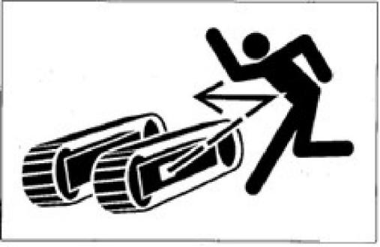

In the track pensioner, the grease is injected
under high pressure. If the tension is not
adjusted by the following designated procedure, the grease relief valve will probably fly out to cause injuries.
● Never loosen the grease pipe fittings.
● Slowly loosen the grease relief valve. Do not rotate it for >1 turn.
● Do not place your face, arms, legs, or body in front of the grease relief valve.
● If no grease flows out when the grease
relief valve is loosened, the valve is
malfunctioned. Please contact a Ken stone Heavy Machinery service dealer for
repairs.
No Disassembling of Track Pensioner
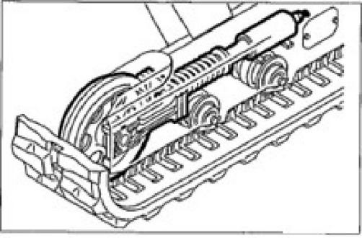
The track pensioner is installed with a high
strength spring. If the track pensioner is
disassembled carelessly, the spring will spring
out to cause serious injuries. Do not disassemble the track pensioner.

1-30

Safety
Precautions for Maintenance

Operations of Additional Devices
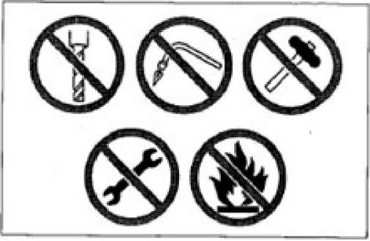
Take special cautions while handling the high pressure nitrogen stored in the tank. The
improper handling will probably result in
explosion of nitrogen to cause serious injuries.
Please strictly abide by the following safety measures:
● Do not break up or disassemble.
● Keep away from open fire and fire source.
● Never drill hole, weld, or melt.
● Guard against physical vibration, such as hammering, rolling, and falling.
● Bleed the sealed air before handling the cylinder body. If you need help, please contact a Ken stone Heavy Machinery service dealer.

Disconnection of Battery Cables
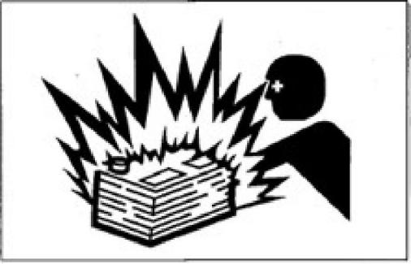
Please disconnect the battery cables before
operations or electric welding of electronic
system. Firstly disconnect the negative (-) cable
of battery. During re connection, finally connect the negative (-) cable of battery.
Caution during Handling of Battery
● The battery contains sulfur acid. The
accidental touch will harm your eyes or skin.
In event of accidental contact with eyes, immediately flush by clean water and quickly seek for medical treatment.
In event of accidental swallowing, drink a lot of water or milk and immediately seek for medical treatment.
If the sulfur acid comes into contact with your skin or clothing, immediately flush by a lot of water.
● Wear goggles and gloves during handling of battery.

1-31

Safety
Precautions for Maintenance

● | The battery can generate inflammable hydrogen to probably cause explosion. Keep away from fire sources including open fire, spark, and ignited cigarette. | electrolyte will leak out. The contact with such electrolyte can harm your skin or  corrode the machine parts.  ● Clean the surrounding area of electrolyte
● | Use a flashlight to check the electrolyte level. | level marking by a wet cloth and check the level. Do not clean by a dry cloth,
● | Ensure to turn off the starter switch and stop the engine before checking or  handling battery. | otherwise it can cause electrostatic  accumulation and combustion or  Perliocslny. Replaced Critical Safety
● | Never touch the electrodes by any metal tool or object, in order to prevent short- circuit. | Parts  ● To guarantee the safe operation of machine for a longer time, add the oil and fulfill the
● | The loose electrodes can generate electric spark. Ensure to tighten any loose  electrode. | checking and maintenance periodically. To promote the safety, periodically replace the critical safety parts, including hoses and
● | Ensure that the battery cover is securely covered. | seatbelts. To understand more details, please refer to the section “Periodically
● | If the battery is frozen, do not charge the battery or attempt the jumper start of  engine, otherwise it will probably cause explosion. Before use, heat the frozen battery to 15°C. | Replaced Critical Safety Parts” .  ● “Periodically replaced critical safety parts” refers to the parts aged, worn, and  functionally deteriorated after repeated use. The performances of such parts will
● | Do not use the battery when the electrolyte level is below the lower limit. Otherwise it will speed up the internal aging and  shorten the life of battery. In addition, it can lead to burst (explosion). | change along with time. These  characteristics of such parts can cause serious mechanical damages or personal harms and the remaining lives of such parts can’t be judged by merely
● | Do not fill the distilled water till the level is above the upper limit. Otherwise the | appearance checking or operation hand-feel.

1-32

Safety
Precautions for Maintenance

● Upon detection of any visible damage on the appearance, please replace the
“periodically replaced critical safety parts”, even if the designated replacement period is not reached.
Jumper Start with Battery Charging Cable
● To start the engine by battery charging
cable, ensure to connect the cable correctly as per following procedure. The incorrect connection of cable can cause discharging and battery explosion.
● Keep the “Malfunctioned machine” and “Rescue machine” away from mutual contact.
● Never touch the positive (+) and negative (-) electrodes of battery charging cable
with each other or with the machine.
● During connection, firstly connect the
positive electrode of battery charging cable to positive (+) terminal. During
disconnection, firstly disconnect the
negative (-) terminal (grounding terminal) from the negative cable.
● Ensure to connect the cable clamps securely.
● Connect the last clamp of battery charging cable to a place as far as possible from the battery.
● To start the engine with battery charging

cable, always wear goggles and gloves.
● Use the battery charging cable and clamps of dimensions suitable to the battery
capacity. Never use damaged or corroded battery charging cable or clamps.
● Ensure that the battery capacity is same for the “Malfunctioned machine” and “Rescue machine” .
Asking Ken stone Heavy Machinery Service Dealer for Welding Repair The welding operations, if necessary, must be fulfilled by competent personnel in a working site with complete equipment. To prevent
damaging any machine part by over-high
current or electric spark, please abide by the following precautions.
● Disconnect the battery cables before electric welding.
● Do not apply 200V or higher voltage continuously.
● Connect the grounding point within 1m reach from the welding area. Do not
connect the grounding terminal near the electronic control device/instrument or connector.
● Ensure there is no seal ring or bearing between welding area and grounding terminal.
● Do not connect the grounding terminal to

1-33

Safety
Precautions for Maintenance

the any place near the working device pin or hydraulic cylinder.
● Before the welding of machine body, disconnect the connector of electronic control device.
Vibration Applied on Operator
According to the results of the test on the vibration transmitted from the machine to the
operator, the vibration applied on the operator’s
upper limbs is <2.5m/s2 and the vibration
applied on the operator’s body in the seat is <0.5m/s2.
Accelerate the engine speed slowly from low idling speed to fastest speed and check for leakage of oil or water from repaired
Checking after Maintenance
parts.
● Operate all joysticks and check machine for normal operations.
Waste Disposal
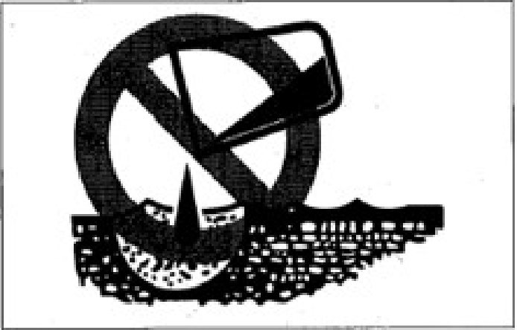
● Ensure to collect the drained oil of

machine into a container. The improper treatment of waste oil will pollute the environment.
● While disposing harmful objects,
including lubricating oil, fuel, coolant,
solvent, filter, and battery, please abide by the applicable laws and regulations.
Disposal of Harmful Chemicals
The direct contact with harmful chemicals will cause serious harms. The harmful chemicals
used in this machine include oils/greases,
battery electrolyte, coolant, paint, and adhesive. Please dispose the harmful chemicals carefully and properly.

1-34

Safety
Safety Signs
Safety Signs
To guarantee the safety of operator and operation personnel in the working zone, please set up the following safety signs (markings) at some portions of machine. Walk around the machine with this manual and observe the contents and placement locations of these safety signs. Please review these signs and operation instructions contained in this manual jointly with the machine driver.
● The safety signs shall be clean, clear, and easily legible. If any safety label falls, is damaged, or becomes illegible, please replace with new one. Please provide your product serial number while ordering new signs from a Ken stone Heavy Machinery service dealer.
● If a part/body on which a safety sign is affixed is already replaced, affix a new sign to new part/body.

1-35

Safety
Safety Signs

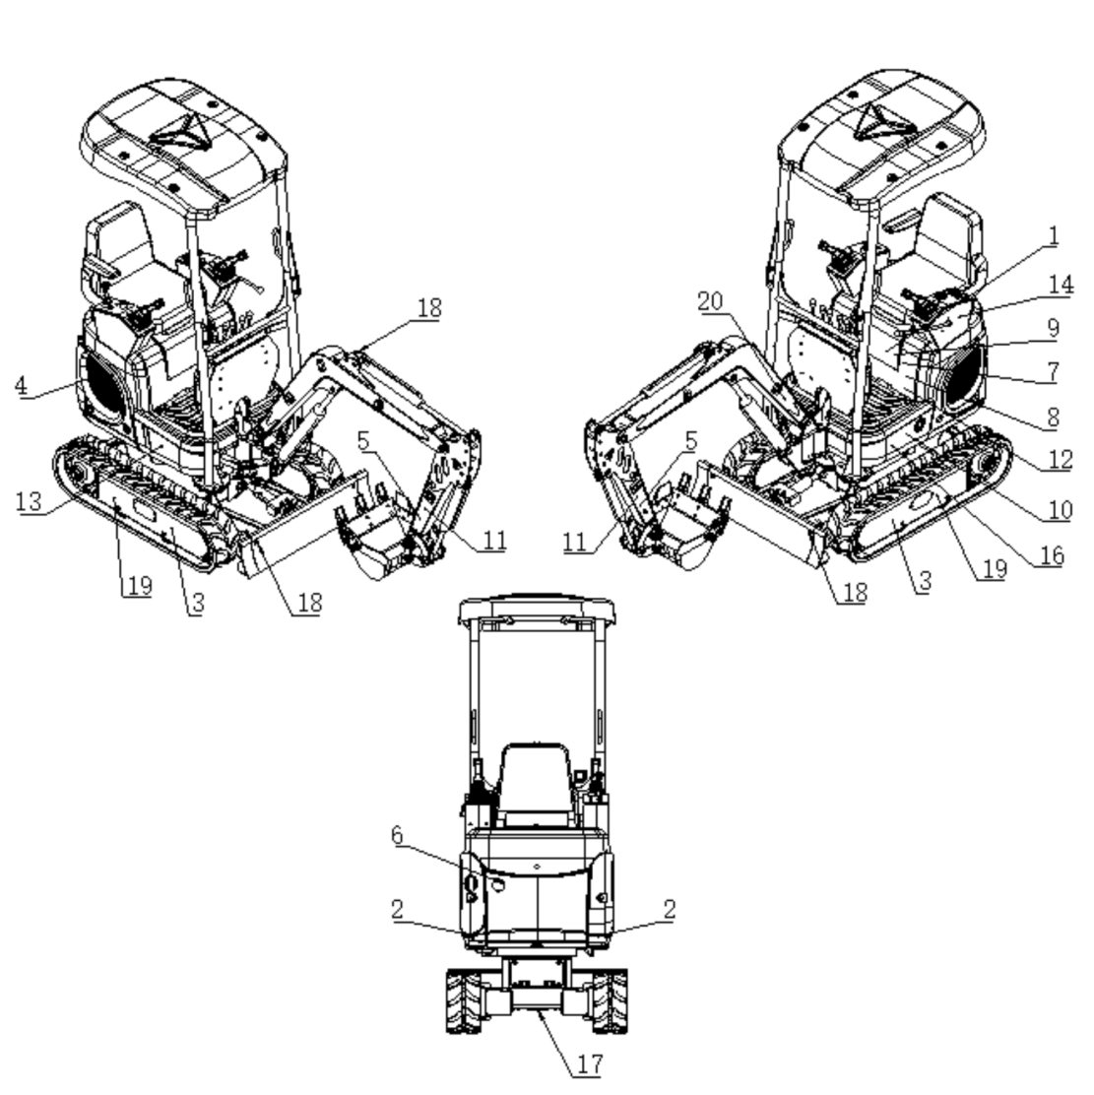

1-36

Safety
Safety Signs

1. Warning
Carefully read and understand the manual before operations, checking, and repairs of machine.
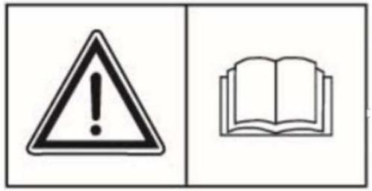
2. Safe distance.
Never approach to or stand in the working zone of machine.
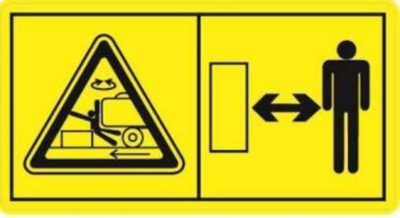
3. Danger from underbody bolts thrown from track roller adjuster. To guarantee the safe and correct operations, ensure to read the operation manual before
adjusting the track roller adjuster.
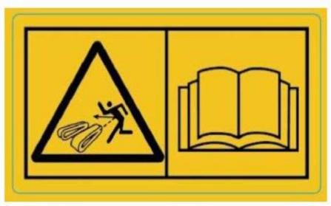

4. Risk from rotating parts. Please turn off before checking and maintenances.
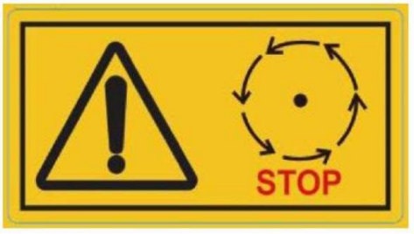

5. Safe distance and danger from
collision with working device. Please keep away from machine during
operations.

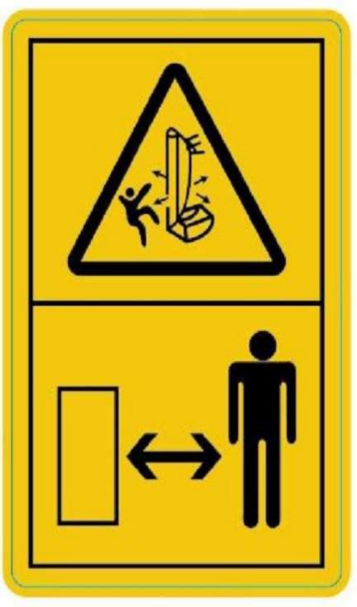

1-37

Safety
Safety Signs

6. This sign denotes not to touch any hot part during operations or just after
operations. Do not touch before these parts, including engine, pump, and exhaust pipe, are cooled down.
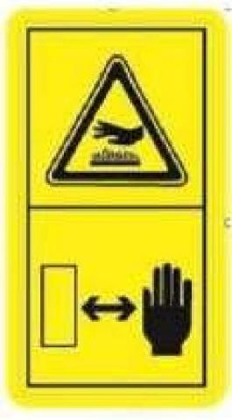
7. This sign denotes that the entanglement into steering belt can cause injury danger. Ensure that the steering belt completely
stops rotation before maintenance or
repairs.
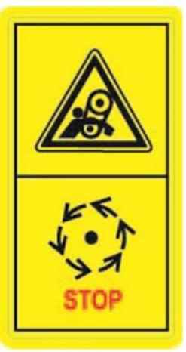

8. This sign denotes that opening the radiator or hydraulic oil tank before its cools down will
probably cause scalding risk by the spraying hot water or oil. Cool down the radiator or hydraulic oil tank before opening the cap.
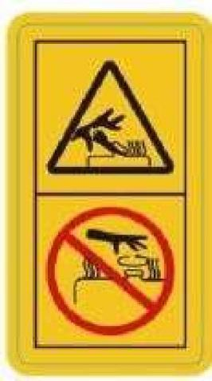

9.
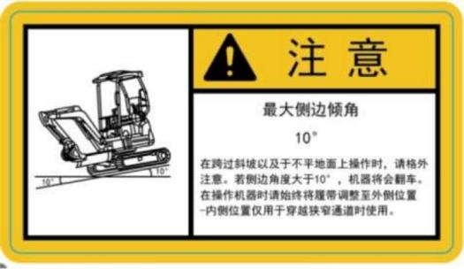
Caution
Maximum lateral angle at 10°
Take special cautions while driving over a slope or during operations on rugged road. If the lateral angle is >10°, the machine will roll over. During the operations of machine, always adjust the tracks to the outer
position. The inner position of the tracks is only used for driving through narrow
passages.

1-38

Safety
Safety Signs

10.
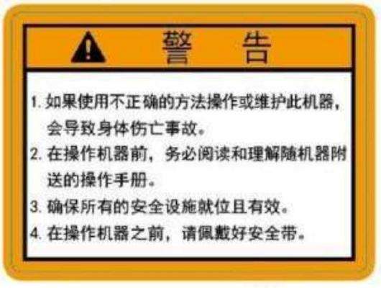
1. The operations or maintenance of this
machine by incorrect method will cause bodily injury accident.
2. Before operating the machine, ensure to read
and understand the operation manual attached in the machine.
3. Ensure that all safety facilities are ready and
effective.
4. Before operating the machine, please fasten
the seat belt.
Warning
11.

Warning
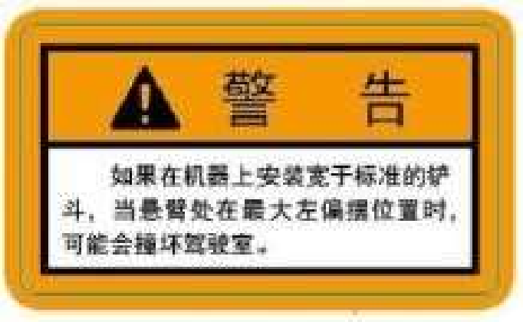
If the machine is installed with an enlarged bucket, the cab will probably be impacted when the boom is at the maximum leftward deflection position.

12.
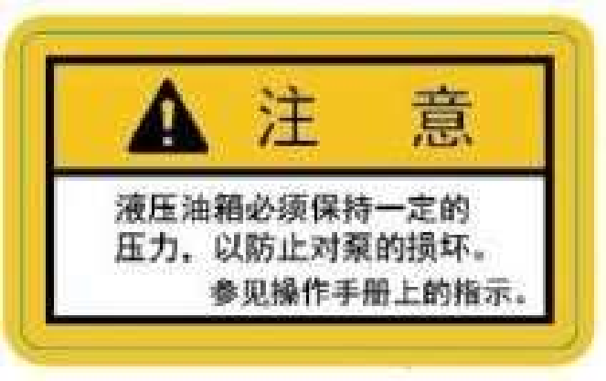

Caution
The hydraulic oil tank must contain a
certain pressure to prevent damaging the
water pump. Refer to the instructions on the operation manual.

13. Diesel
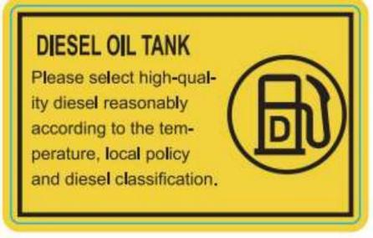

14. It’s prohibited to touch any joystick or
traveling joystick while getting on or off the machine, otherwise the parts will be damaged.
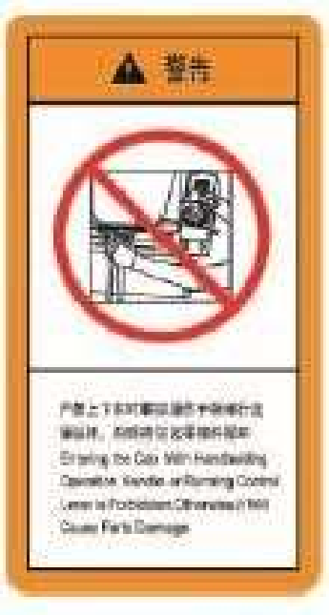
Warning

15. There is a danger of electric shock during operations of cables.


1-39

Safety
Safety Signs

16. Hydraulic oil
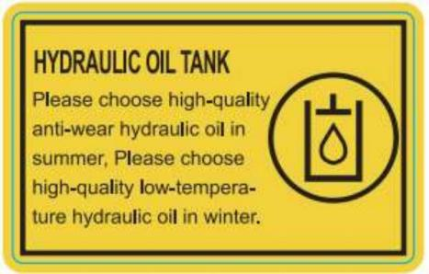

17. Fixed point

18. Lifting direction
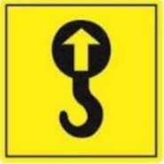
19. When the machine is lifted, fix it by
cushion blocks or supports. Do not operate beneath the lifted machine when the
machine is not fixed by any support.
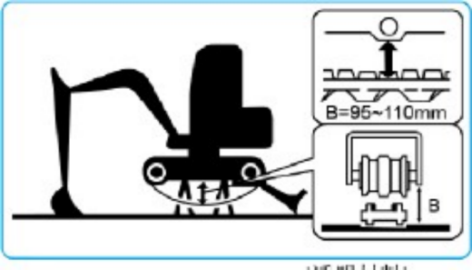
1-40

20. Keep the boom and bulldozing
blade separated. While lowering the boom, take cautions not to touch the boom with bulldozing blade.

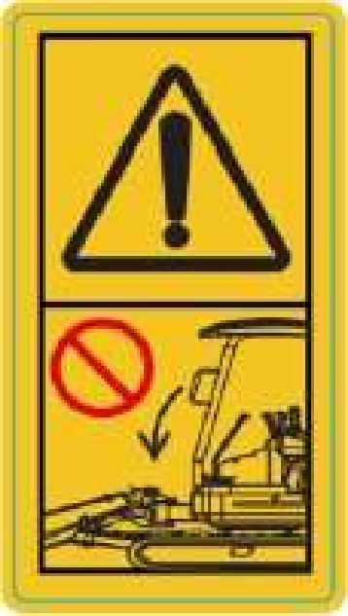
21 、No people are allowed to stand in the working area

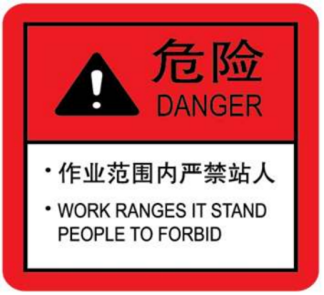

Safety
Safety Signs
22 、Pay attention when relieving pressure

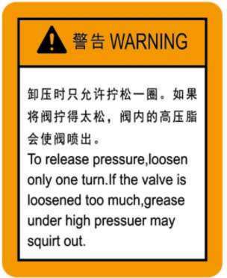
23 、Keep away from the engine fan
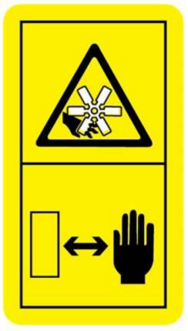

1-41

Controls 

2-1


Control
Component Name
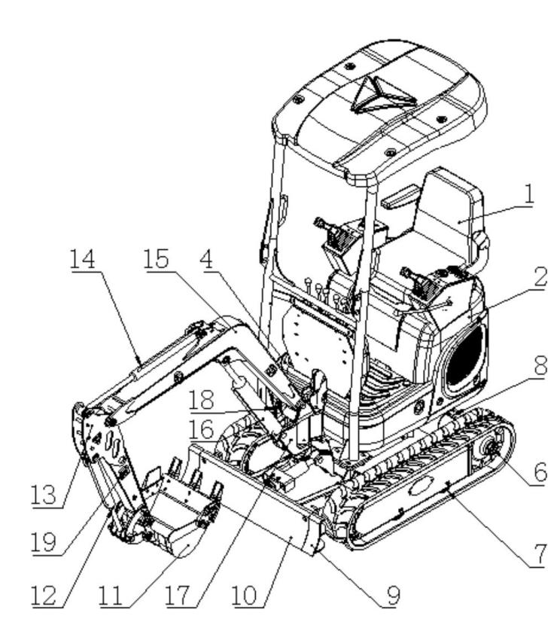
Component Name

Up frame | Chassis | Working device
1 、seat | 5 、Track | 11 、Bucket
2 、Engine hood | 6 、Drive wheel | 12 、Bucket cylinder
3 、Hydraulic oil tank | 7 、Track roller | 13 、Arm
4 、Fuel tank | 8 、Traveling motor | 14 、Arm cylinder
 | 9 、Bulldozer blade | 15 、Boom
 | 10 、Cylinder of blade | 16 、Boom cylinder
 |  | 17 、Swing joint
 |  | 18 、Swing cylinder
 |  | 19 、Hydraulic circuit

2-2

Control
Component Name

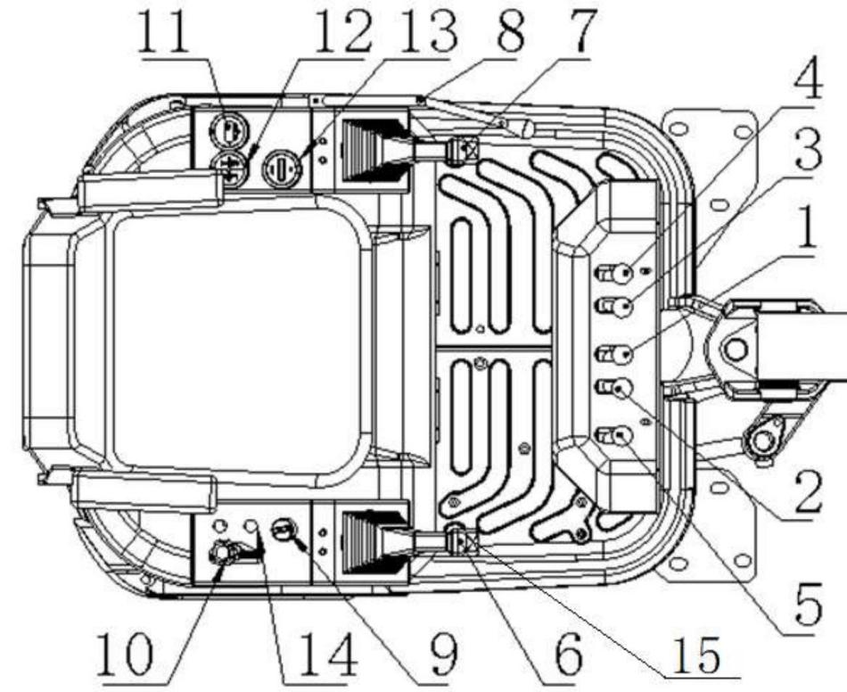

1. Left traveling lever
2. Right travelinglever
3. Bulldozer blade lever
4. Lever for telescopic track
5. Boom swing lever
6. Right joystick
7. Left joystick

8. Safety lock handle
9. Start switch
10. Throttle lever
11. Water temperature meter
12. Warning sign
13. Hour meter
14. Lighting switch
15. Switch auxiliary oil circuit button

The specific configuration depends on the machine specification or selected product.

2-3

Control Cover

Start Key
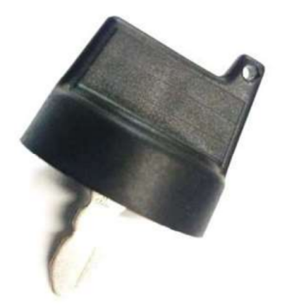
The start key is used to start the engine.

Repair cover (rear cover, hood, engine cover)
 Warning
Before opening the repair cover, ensure that the safety lock handle is at locking position and the engine is stopped.
When opening or closing the service cover, please be careful not to pinch your hands or other parts of your body.
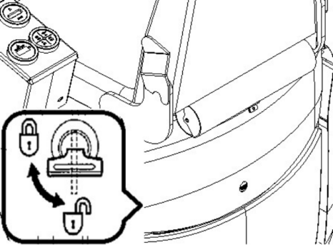
Opening
1. Insert the hood key and turn it
counterclockwise to unlock the maintenance cover.
2. Lift the hood lock and lift the maintenance
cover Closing
1. Unlock the limit lever and close the maintenance cover.
2. Insert the hood key and turn it clockwise to lock the maintenance cover.

2-4

Control Cover

Fuse Case
This case is functioned to protect the electric system against over-current.
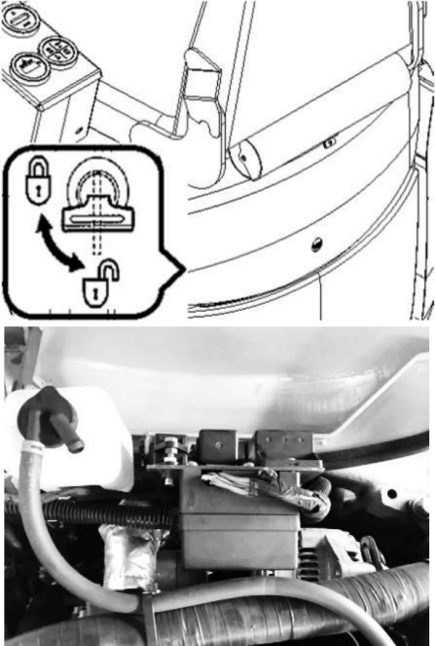

Open
1. Insert the hood key and turn it
counterclockwise to unlock the maintenance cover.
2. Lift the hood lock and lift the maintenance cover.
3. Locate the fuse box. Close
1. Unlock the limit lever and close the maintenance cover.
2. Insert the hood key and turn it clockwise to lock the maintenance cover.

Fuel filler port
 Warning
● During the refueling into the fuel tank, keep away from heat source and open fire and do not smoke.
● Refuel the fuel tank in a well-ventilated
place. Stop the engine before refueling.
● Any overflown fuel shall be wiped away immediately.
● Do not top up the fuel tank. Leave an expansion space for the fuel.
● Tighten the fuel tank cap securely.
Opening
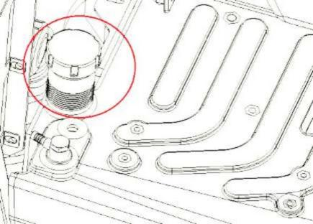
1. Insert the hood key and turn it
counterclockwise to unlock the maintenance cover.
2. Lift the hood lock and lift the maintenance cover.
.3. Hold the fuel tank cap and turn it
counterclockwise to unlock the fuel cap.
Closing
Fasten the fuel tank cap and turn it clockwise to lock the fuel cap.

2-5

Control Seat
Seat

Warning
Adjustment and Fixing of Seats (For high-end seats only)
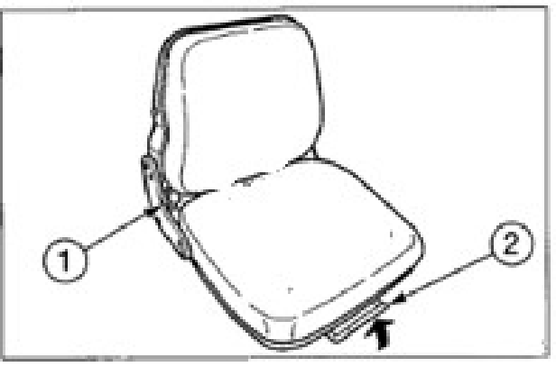

A. Adjust the backrest angle
1. Stand up straight and sit back on the seat.
2. Adjust the backrest to the angle you want by rotating the handle (1).
B. Front and back adjustment
1. Pull up the adjustment lever (2), slide the seat back and forth, and adjust it to the position you want when operating the machine.
2. Loosen the adjustment handle (2) at the position you want to fix the seat.

2-6

Records

2-7

Control
Electrical control panel

Panel Name and Description
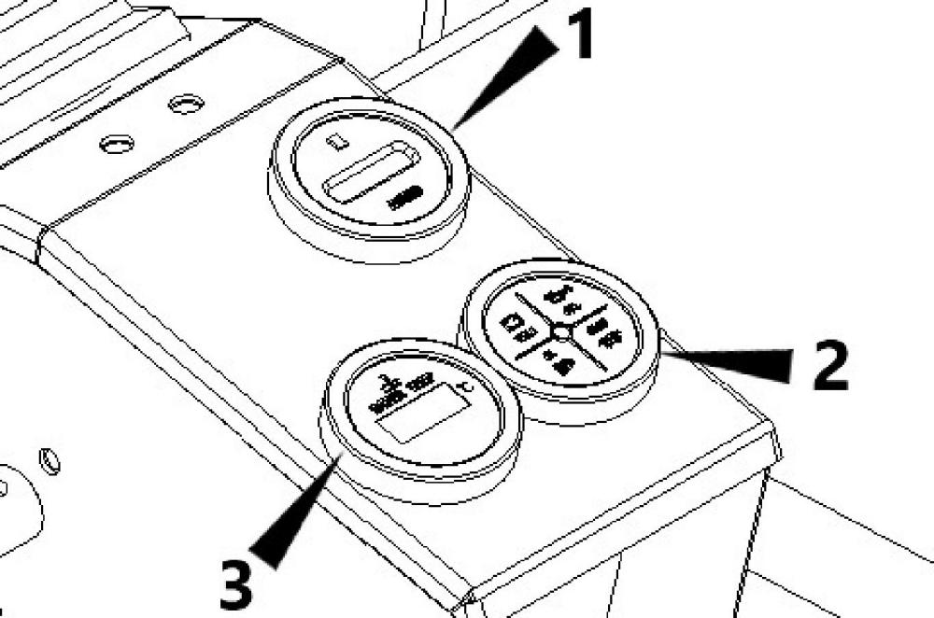

no. | name | note
1 | hour meter | Display working hours, the range is 0-9999.9h.
2 | Charging warning light | When the engine is running, if there is a problem with the charging system, the light flashes and an alarm sounds.
2 | Oil pressure indicator | When the engine is running, if the oil pressure is abnormally low, the light flashes and an alarm sounds.
2 | Work light indicator | Show the working conditions of the work lights.
2 | Warm-up indicator | When the engine is warmed up, the light goes out.
3 | Water temperature meter | Shows the change of cooling water temperature.

2-8

Control
Electrical control panel

Precautions
This instrument is a water-proof instrument, featuring stable performance and high
conciseness and elegance, and is an
intelligent instrument developed specially for small excavators. To guarantee the stable
data and prolong the life of instrument, please notice the following issues:
1. Do not disassemble the instrument without permission.
2. Never brutally hammer or knock the instrument.
3. Guard against external damages.
4. Keep clean the panel. Any organic solvent or corrosive liquid, including diesel and gasoline, shall be timely wiped away, in order to prevent corroding the panel.
5. Should you have any question during use, please timely contact service personnel.

After-Service Information
Provided that the operations are performed
normally as per the instructions of the manual, the malfunctions occurred within the warranty period will be repaired free of charge. Please carry this warranty certificate during the repair of this product and repair by a sales point of this device. The repair expense will be charged under the following conditions:
1. No warranty certificate.
2. Malfunction due to incorrect use of this
device or non-authorized repair or modification of this device.
3. Malfunction due to falling at user’s default during transport after purchase.
4. Malfunction due to fire, earthquake, gas
leakage, windstorm, thunder and lightning, and abnormal voltage.
5. The purchase date or customer name is not recorded in this manual or the information is altered.

2-9

Control
Switches

Start Switch

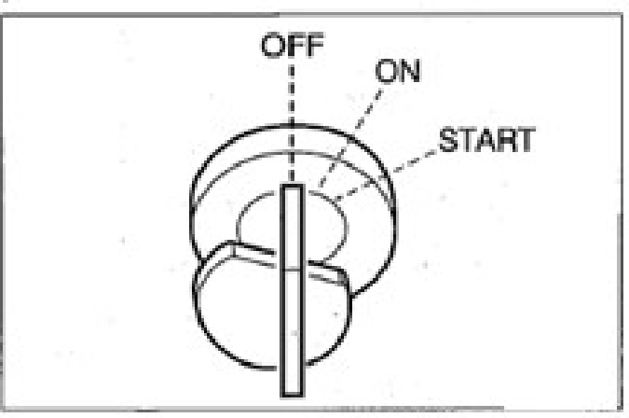

Horn button

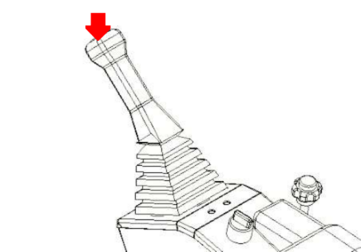

Important: Do not rotate the starter key
from OFF to ON and then from ON to OFF repeatedly within a short time, otherwise it will probably result in engine malfunction.

OFF …… This position is used to stop the
engine and insert and withdraw the starter key. ON …… Engine running position. All electric devices are functional at this position.
START …… Engine running position. Upon release of key, the switch automatically returns to ON.

If the coolant temperature is too low,
rotate counter-clockwise the key, hold for 10~15s, and then release before start.
Rotate the key to ON and then to START to start the engine.

2-10

Control
Joysticks

Joysticks
Safety lock handle

ΔWarning

● Before standing up from the driver seat to adjust the operator’s seat, lower the working device to the ground, lift up the safety lock handle to lock it, and stop
the engine. When the safety lock handle is lowered down (Unlocked), the
accidental touch of any joystick will
result in sudden movement of machine and cause serious injuries or deaths.
● Please be noted that, even if the safety
lock handle is placed at locking position, the bulldozing blade, boom, and
auxiliary hydraulic controls can’t be locked.
Do not touch such controls accidentally.
● While lifting up or lowering down the safety lock handle, take cautions not to touch any joystick.
● Before leaving the driver seat, lower the working device onto the ground, lift up the safety lock handle to locking
position, and stop the engine.
Meanwhile, ensure to withdraw the key, close the doors and hoods, and carry the key with you and then preserve it in a
designated place.

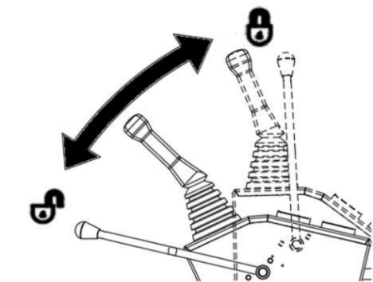
This device is functioned to lock the operations of bucket working device and machine slewing.
When pushing the lever forward, except for the walking lever, the other levers cannot work
Accelerator joystick
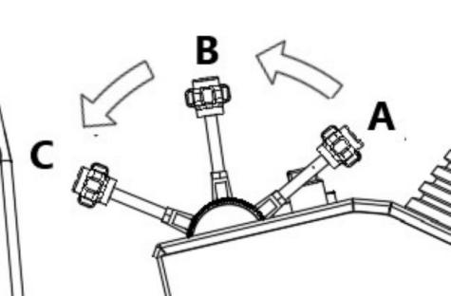
Used to control engine speed. (A)...low idle
(B)...Maximum speed Joysticks

ΔWarning
● Before starting operations, please carefully check and confirm the joystick mode to be used.

2-11

Control
Joysticks

● The descriptions in this manual use the ISO mode of machine.
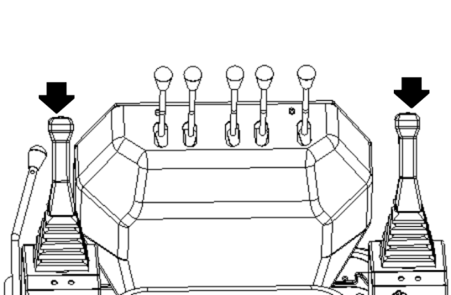

ΔWarning

Control Mode

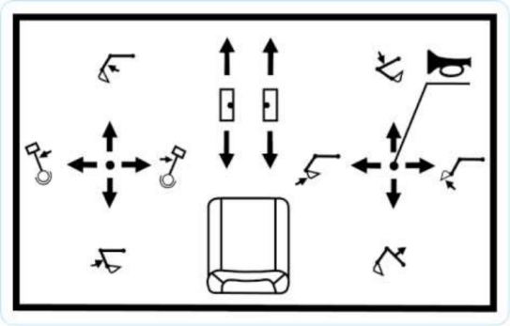
Bulldozing blade joystick
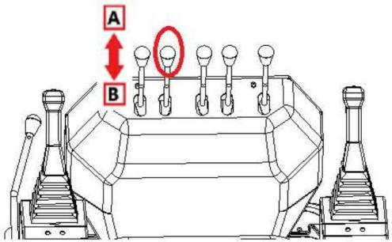
Use this joystick to operate the bulldozing blade.

(A) … Lower the bulldozing blade. (B) … .Lift the bulldozing blade.
Traveling Joystick

● Before operating the traveling
joystick, ensure that the bulldozing
blade is in front of the driver seat.
Please bear in mind that the operation direction of the traveling joystick with bulldozing blade behind the driver seat is reverse to that with bulldozing blade in front of driver seat.
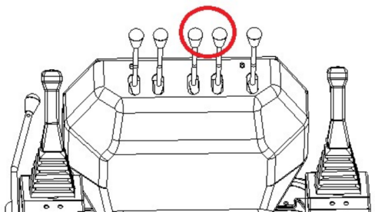
Use these two levers to move forward or backward and change direction.

2-12

Control
Joysticks

Boom swing lever
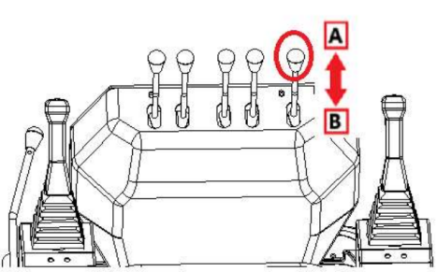
This lever controls the hydraulic oil flow and direction in the auxiliary hydraulic circuit.
(A) ......Boom swing right (B) ......Boom swing left

Auxiliary hydraulic circuit control button
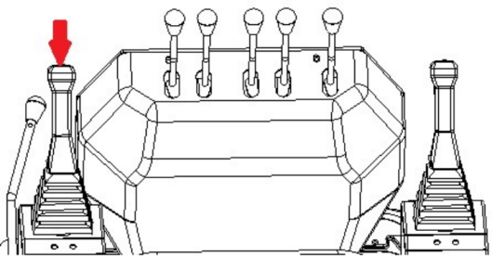

This button is used for the operation of
attachments that require hydraulic power such as breakers.
1. First of all, make sure that you have correctly installed hydraulic attachments such as breakers. 2. Keep pressing this button to control the
hydraulic attachments, and automatically return to normal control after releasing it.

2-13

Control
Accessory
Auxiliary hydraulic pipeline (If installed)
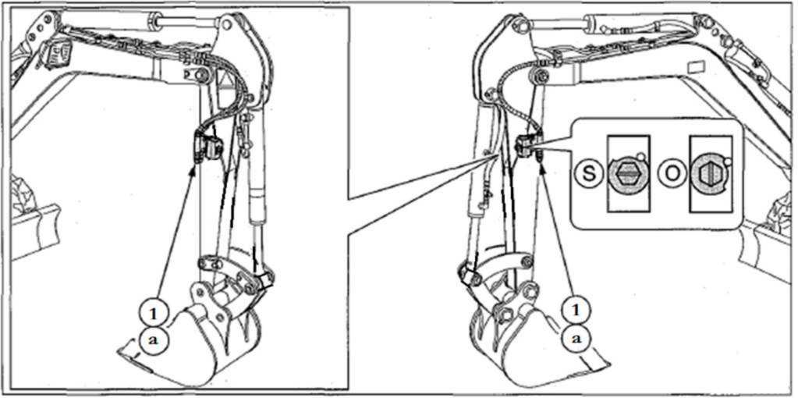

ΔWarning

Disconnecting the pipelines before the
pressure relief of hydraulic system will
probably result in out-spray of hydraulic oil.
● After the stop of engine, immediately press auxiliary switch for several times to relieve the pressure in the auxiliary hydraulic circuit.
● Slowly loosen the bleeding plug to
relieve the internal pressure of hydraulic oil tank.
● While disconnecting hoses, stand on one side and loosen slowly. Slowly relieve the internal pressure before disassembling.

These pipelines transport the hydraulic oil needed to operate hydraulic breakers or
other working devices.
(1)... Auxiliary hydraulic pipeline

Shut-off valve (S): Close
(0): open

2-14

Control
Accessory

Connection of Hydraulic Circuits
To connect the attachment hydraulic pipeline, please operate as per following procedure:
1. Relieve the residual pressure from system
and then close the shutoff valve.
2. Take out the plug.
3. Connect the attachment hydraulic pipes to
ports (a). While installing a hydraulic
breaking hammer, connect the oil inlet port
to port (a) and oil return port to port (b).
4. Open the shutoff valve. While installing a
hydraulic breaking hammer, open the selector valve (1).
5. After connections, fully bleed the air from
hydraulic pipes.

a. Start the engine and run at low idling
speed under no-load condition for
10min.
b. During the running of engine at low idling speed, operate the hydraulic auxiliary switch repeatedly (for
approximately 10 times) to bleed the air from hydraulic pipes.
c. Stop the engine and wait for at least 5min, till the air bubbles overflow
from the hydraulic oil in the oil tank.

Important: If applicable, follow the attachment manufacturer’s procedure to bleed the air.
6. Check for presence of oil leakage.

Disconnection of Hydraulic Circuits
1. Relieve the residual pressure from system
and then close the shutoff valve.
2. Disconnect the pipelines from ports.
3. Install the plug.
Relieve residual pressure
After using the auxiliary hydraulic circuit, there is residual pressure in the circuit. This
is called residual pressure. Before
disconnecting the pipeline, release the residual pressure.

2-15

Operations

3-1

Operations
Before Start of Operations

Before Operations
Getting on/off Machine

ΔWarning
● Do not jump on or off the machine. Do not attempt to get on or off a moving machine.
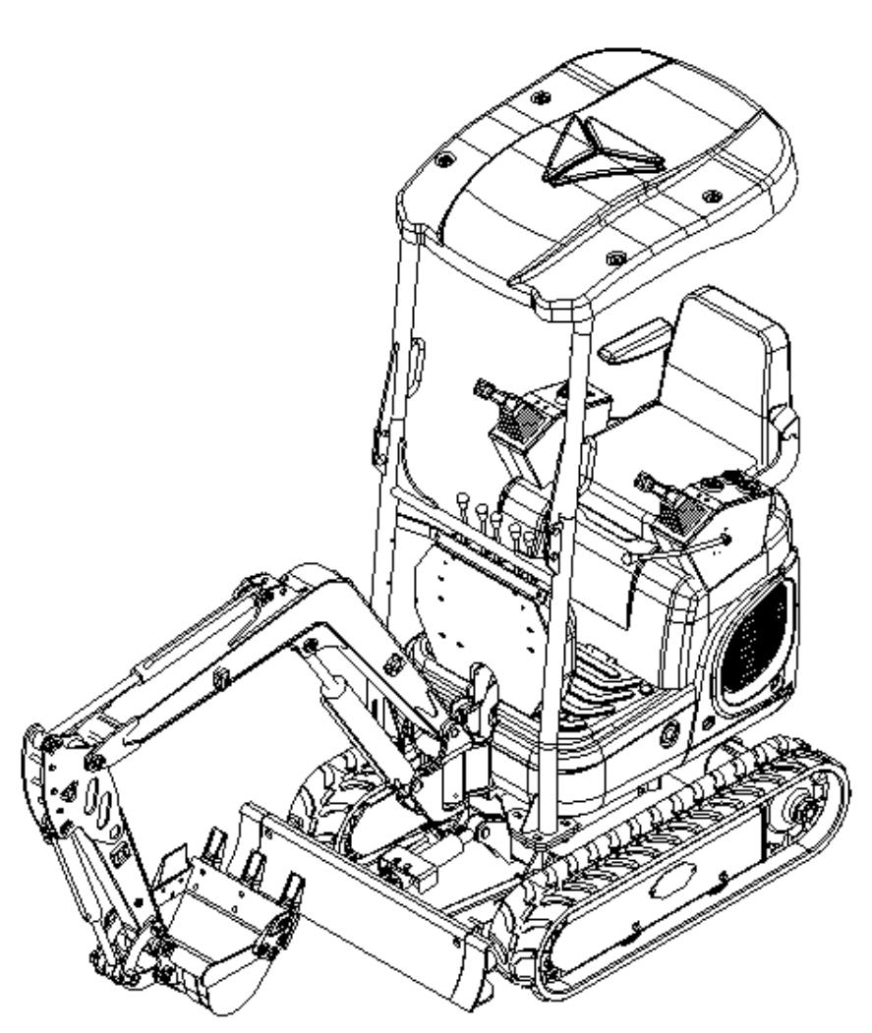
● While getting on/off the machine, hold the handrails to support your body weight and maintain three-point balance posture
(Hands and feet) for your body.
● Do not use safety lock handle or any joystick as handrail.

Walk-Around Checking
Before the first start of engine each day, fulfill one walk-around checking.
Refer to page 5-14 and 5-15 “Maintenance, Walk-Around Checking” .

Daily Routine Checking
Before the first start of engine each day, fulfill one walk-around checking.
Refer to page from 5-17 to 5-21 “Maintenance, daily routine inspection” .

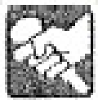

3-2

Operations
Start and Stop of Engine

Start and Stop of Engine Before Start of Engine
1. Adjust the seat to comfortable operating
position.
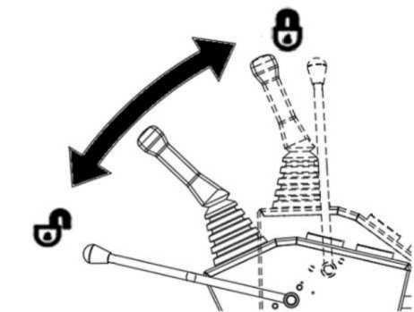
2. Check and ensure that the safety lock
handle is at locking position.
3. Check and ensure that all joysticks are in
neutral position.
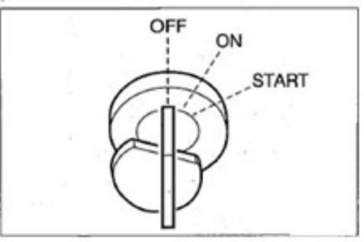
4. Insert the key into start switch, rotate to
ON position, and then check as below:

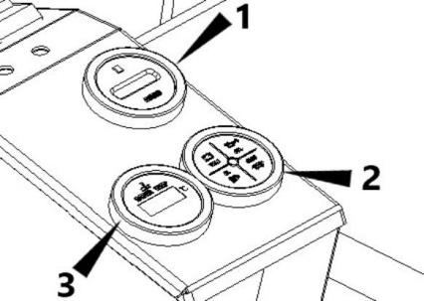
● All warning lamps turn on for 1s and the warning tone is issued for 2s. The
instruments start working.
● Press the lamp switch and check and ensure that the boom lamp turn on.
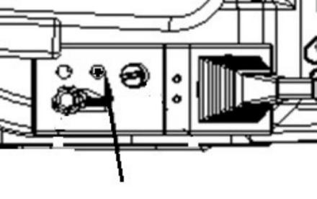
If a lamp fail to turn on or a warning lamp fails to sound, the lamp bulb or wire is probably
damaged. Please contact Kenstone service agent
for repair.

3-3

Operations
Start and Stop of Engine

Start of Engine

Warning

● Keep all personnel away from working

zone.
● Sound the horn to alert the personnel around machine.

Important: Do not run the starter motor
continuously for >15s. If the engine fails to
start, wait for 60s and then attempt to restart the engine.
Important: If the engine stops due to shortage of fuel, please add fuel, rotate the key to ON for 60s, and then rotate it to START position.
Running the starter motor for a long time before the supply of sufficient fuel will cause start
failure of starter motor.

Normal Start
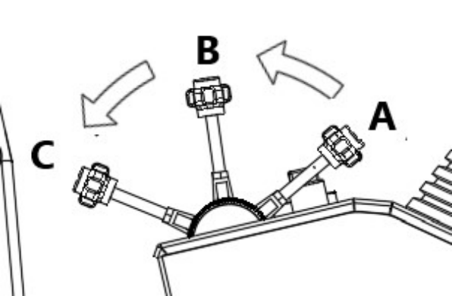
1. Pull the accelerator joystick to neutral
position(B).

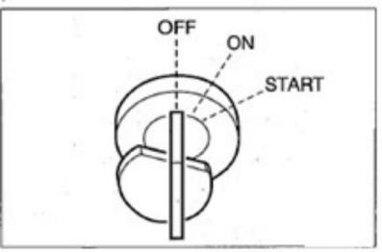
2. Rotate the starter key to START position
to start the engine.
3. After the engine is started, release the key.
The key will automatically return to ON position.
4. Check and ensure that all warning lamps
are already off.
5. Return the accelerator joystick Start in Cold Weathers

ΔWarning

Never use starting fluid on this engine, as the starting fluid will probably explode.

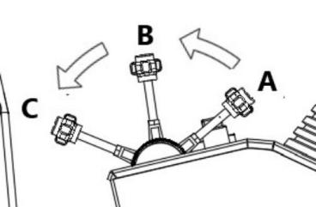

1. Pull the accelerator joystick to neutral
position(B).

3-4

Operations
Start and Stop of Engine

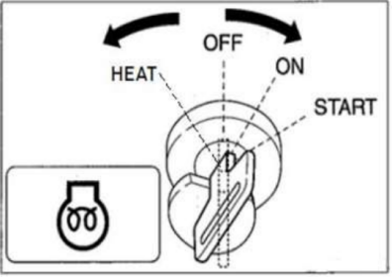
2. Rotate the start key counter-clockwise to HEAT position for approximately 10s. The preheated indicator lamp turns on to
indicate the running of preheated.
3. Rotate the key to ON position, wait for the instrument lamp to turn off and the buzzer to stop sounding, and then rotate the key to START.
4. After the engine is started, release the key.
The key will automatically return to ON position.
5. Check and ensure that all warning lamps
are already off.
6. Return the accelerator joystick and warm
up the engine. Refer to “Warm up the engine " item
Warm up the engine
Important: Before the completion of warm-up. Avoid the full-speed running of engine. Do not warm up the engine for a long time (20min or longer). When the idling is required,
occasionally apply the load or run the engine at medium speed.

Return the accelerator joystick and then run the engine at low idling speed under no-load condition for 5min.

3-5

Operations
Start and Stop of Engine
Stop of Engine
· Important: Do not stop the engine suddenly · under heavy load or during high-speed running. Otherwise it will result probably in overheating or blockage of engine. Do not stop the engine hastily, unless in event of emergency

1. Return to the throttle lever.
2. Let the engine idle for about 5 minutes.
3. Turn the starter key to the OFF position to turn off the engine.
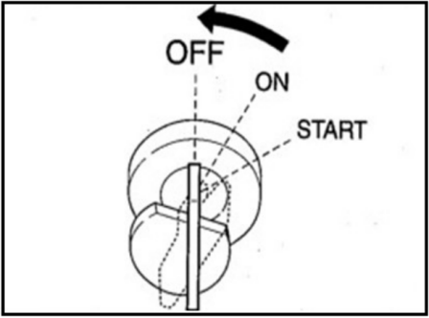

3-6

Operations
Operate Machine
Operatie Machine
Joystick Mode (ISO Mode)

ΔWarning
● Before starting operations, please carefully check and confirm the joystick mode to be used.
● The descriptions in this manual use the ISO mode of machine.
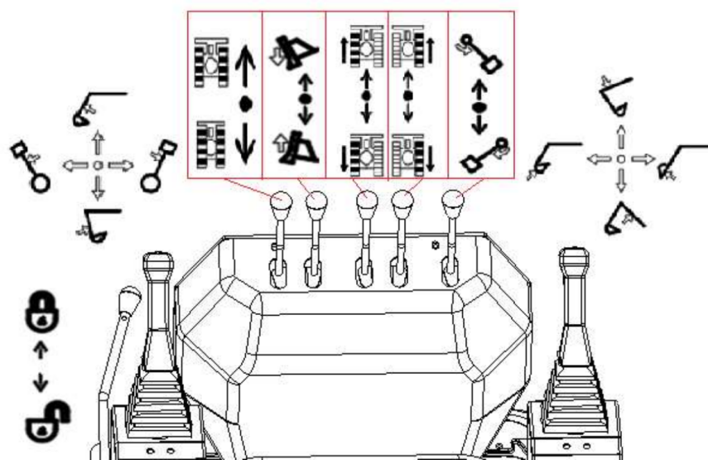
（ISO）

 | Drive leftward | 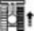 | Drive rightward |  | Safety lock locked
 | Back up to left | 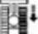 | Back up to right |  | Safety lock unlocked
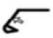 | Extend arm | 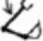 | Lower boom |  | Swing leftward the boom
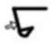 | Retract arm |  | Lift boom |  | Swing rightward the boom
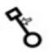 | Slew leftward upper frame | 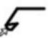 | Load bucket | 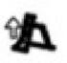 | Lift bulldozing blade
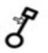 | Slew rightward upper frame | 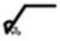 | Dump bucket | 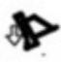 | Lower bulldozing blade

3-7

Operations
Operate Machine

Warm up the engine (hydraulic oil)

Warning

It’s really dangerous to operate the working device without warm-up (Hydraulic oil), as the working device can’t respond quickly to the controls or will motion probably in
unexpected manner and the safety devices can’t work normally probably. Therefore, ensure to warm up the machine sufficiently.

Important: When the hydraulic oil
temperature is <20℃, do not operate any joystick quickly. During the operations, the appropriate hydraulic oil temperature is
50~80℃. If it’s necessary to operate under low temperature, warm up the hydraulic oil to at least 20℃.

Normal Warm-up

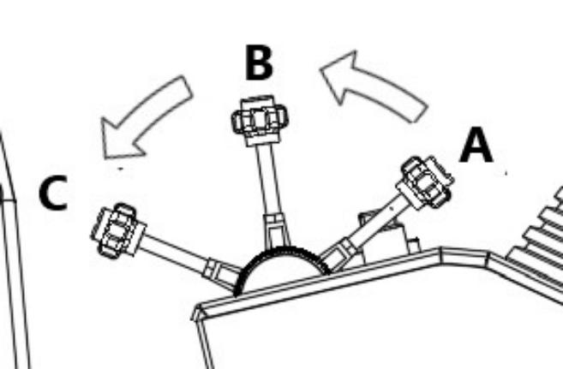

speed under no-load condition for approximately 5min.
2. Completely lower down the safety lock
handle to unlock and lift the bucket from the ground.
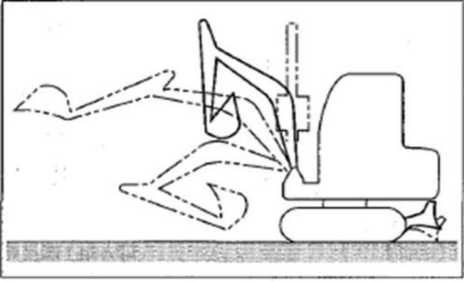

3. Slowly telescope all cylinders for several
times under no-load condition.
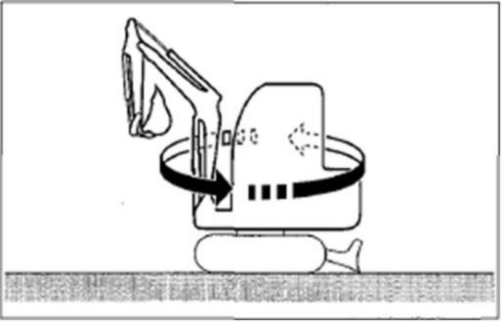
4. Slew slowly leftward and rightward for
several times.

1. Pull the accelerator joystick to neutral
position. Then, run the engine at medium
3-8

Operations
Operate Machine

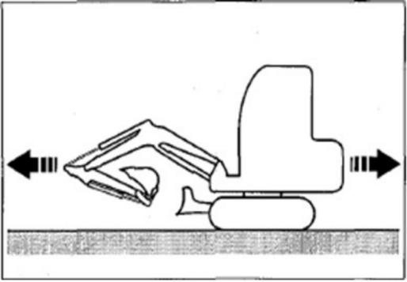
5. Drive forward and backward slowly for
several times.
Warm-up in Cold Weathers
1. Fulfill the normal warm-up procedure.
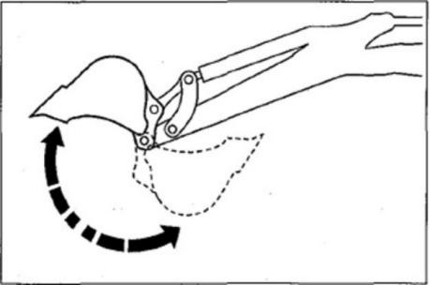
2. Operate the bucket cylinder to an end and
hold.
Do not hold at this position more than 30s.
3. Repeat step 2, till the running speed of the
bucket is normal.
Checking after Warm-up
After the warm-up of engine and machine (Hydraulic oil), check as per following
procedure and when necessary repair.

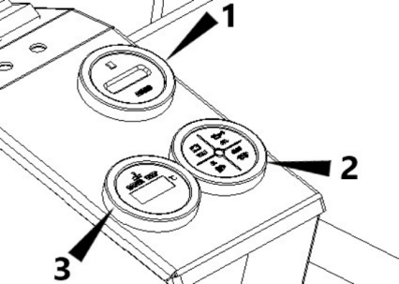
1. Check the warning lamps and instruments
as below:
● Whether all warning lamps turn off.
● Whether the water temperature meter is ≤105℃ .
2. Check for normal engine exhaust gas color,
sound, and vibration.

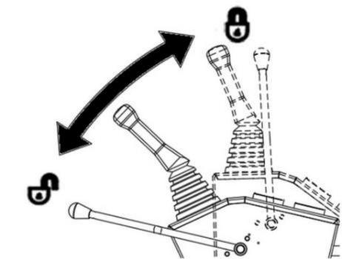

3. Lift up the safety lock handle to locking
position and check whether the operation and traveling joysticks are locked.

3-9

Operations
Operate Machine

Change of Chassis Width

Warning

Operating Machine with Maximum Width
● Always operate the machine with
extended chassis width of 950mm, in
order to improve the machine stability to the maximum extent. Operating the machine with narrow chassis width
(800mm) will probably result in rollover of machine due to poor stability.
● If it’s necessary to operate the machine with narrow chassis width (800mm),
retract the bucket working device and lower the boom to reduce the gravity center and face the machine towards front before traveling.

This machine can change the track width.
Normally, to keep stable of machine, it’s better to operate with extended track width.
Change of chassis Width
Operate in a level and solid ground without obstacles.

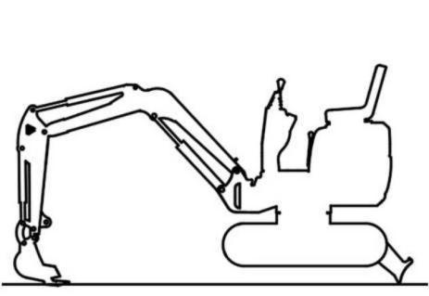
1. Lift the machine body by bucket working
device and bulldozing blade.
Important: Ensure to lift the machine body before the change of track width. Attempting the operation with tracks on ground will
probably damage the side traveling frame or span cylinder.
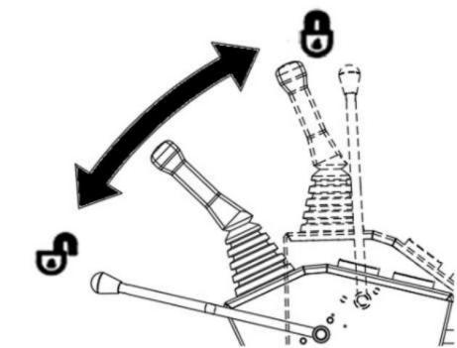

2. Unlock the safety lever.

3-10

Operations
Operate Machine

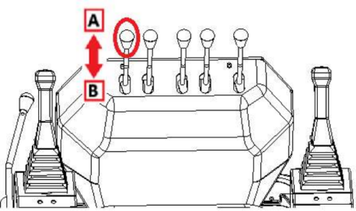

3. Push the lever forward to increase the width of the chassis to 950 mm.
4. Pull the lever backward to reduce the width of the chassis to 800 mm.

Change of bulldozer blade width
1. loosen the bolts(1) and take out the
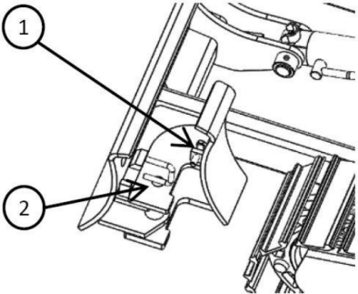
pins(2)

2. Rotate the extension plate around the pins
for 180°.
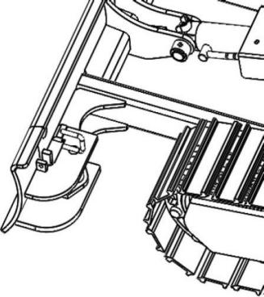
3. Install the pins and tighten the bolts.
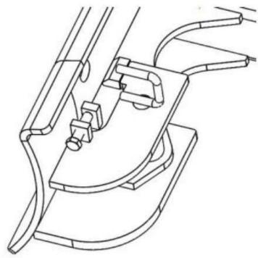

3-11

Operations
Operate Machine

Operations of Traveling Joystick

ΔWarning

● Do not allow any person to access the turning radius or path of machine.
● There are blind zones behind the
machine. To reverse the machine, if necessary, slew the cab to check the safety and ensure there is no person behind the machine.
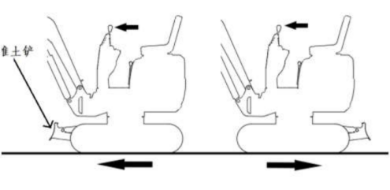
● Before operating the traveling
joystick, ensure that the bulldozing
blade is in front of the driver seat.
Please bear in mind that the operation direction of the traveling joystick with bulldozing blade behind the driver seat is reverse to that with bulldozing blade in front of driver seat.
● Remove all obstacles from the path of machine.

Move the machine back and forth

1. Pull the accelerator joystick to increase the
engine speed.

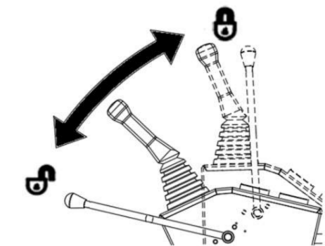
1. Fully lower the safety lock lever to release
the lock.
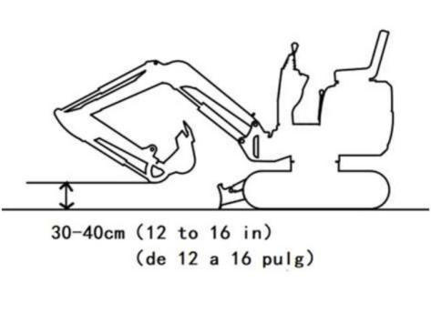

3-12

Operations
Operate Machine

3. Retract the bucket and lower to 30~40cm ·
off the ground.
4. Lift the bulldozing blade.
5. Operate the traveling joystick as per
following procedure.
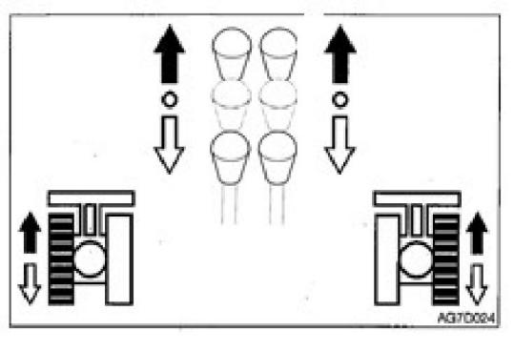
When the bulldozing blade is in the front of seat:
To drive forward: Pull forward the joystick. To drive backward: Pull backward the
joystick.
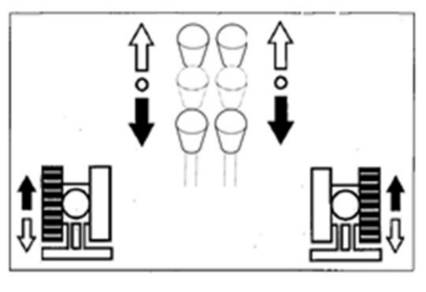

When the bulldozing blade is behind of seat: To drive forward: Pull backward the
joystick.
To drive backward: Pull forward the joystick.
Pivot Steering
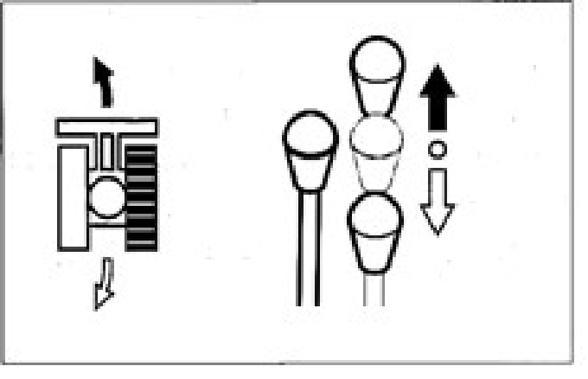
Turn left when parking:
to turn forward left: push the right traveling lever;
to turn back left: pull the right traveling lever.
Turn right when parking, same operating to operate the left traveling lever.

3-13

Operations
Operate Machine

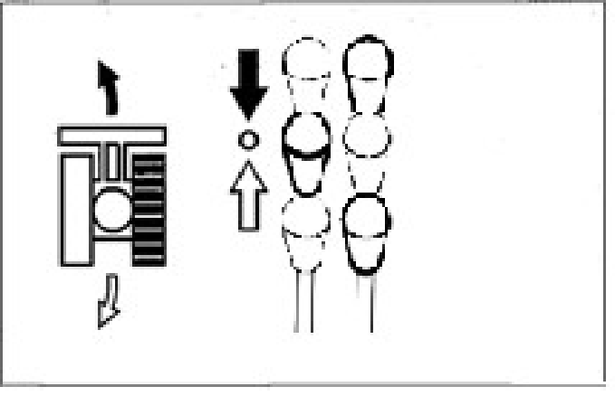
Turn left during traveling:
To turn left during traveling forward:
Place the left joystick to neutral position. To turn left when traveling backward:
Place the left joystick to neutral position.
To turn right during traveling, operate the right traveling lever by same operation method of left traveling lever.
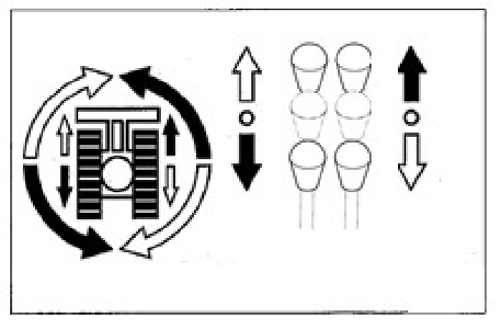
Rotate in situ
Rotate left in situ: pull left traveling lever backward and push the right traveling lever forward.
Rotate right in situ: pull right traveling
lever backward and push the left traveling lever forward.

Parking

Δ Warning

● Park the machine on a level, solid, and safe ground. Set the parking device. If it's necessary to park the machine on a slope, block the track by wedges to
prevent movement of machine.
● When the safety lock handle is unlocked, the accidental touch of any joystick will result in sudden movement of machine
and cause serious injuries or deaths.
● Please be noted that, even if the safety
lock handle is placed at locking position, the bulldozing blade, boom, and
auxiliary hydraulic controls can’t be locked.
Do not touch such controls accidentally

Caution

Do not stop the machine hastily, unless in
event of emergency. Stop the machine at the optimal timing whenever possible.

3-14

Operations
Operate Machine

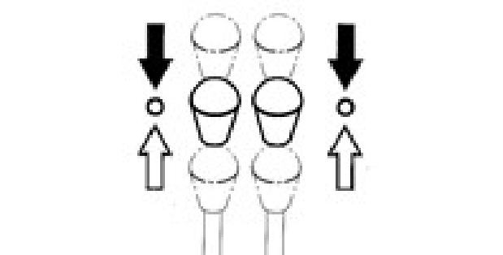
Slowly place the left and right traveling levers to neutral position. Stop the machine.
Operations of Working Device

ΔWarning

● Before starting operations, please
carefully check and confirm the joystick mode to be used.
● The descriptions in this manual use the ISO mode of machine.

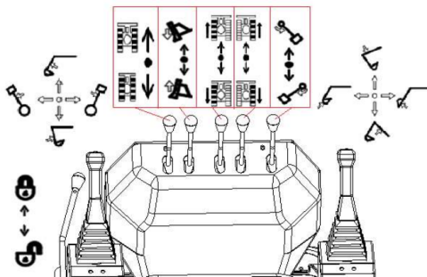
Use the right joystick to control the boom and bucket.
Use the left joystick to operate the arm and slewing.
Return the joysticks to neutral position to stop the bucket working device.
Lower down the safety lock handle to the unlocking position.

Slewing

 Warning

Before slewing, check the surrounding area for safety.

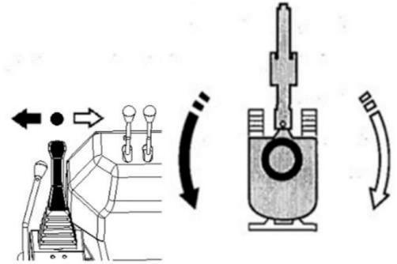
Slew the up-frame left: Push the left joystick left.
Slew the up-frame right: Push the left joystick right.
Operate the boom
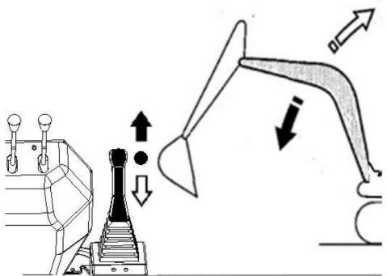
Lower boom: Push the right joystick forward .
Raise the boom: Push the right joystick backward .

3-15

Operations
Operate Machine
Operations of Arm
Swing of Boom
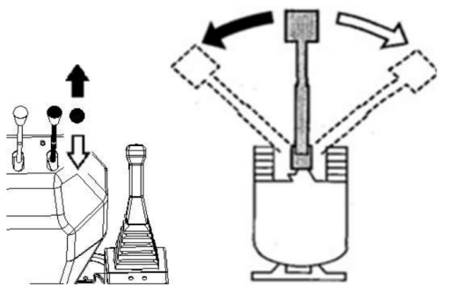
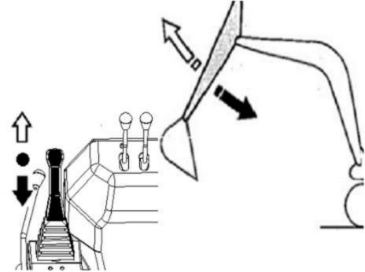

Retract bucket arm: Push the left joystick backward.
Extend bucket arm: Push the left joystick forward.
Operations of Bucket
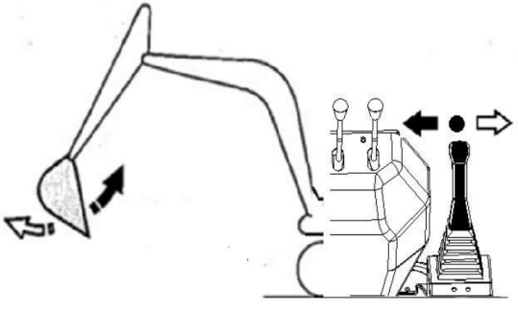
Load bucket: Push the right joystick left.
Dump bucket: Push the right joystick right.

Swing the boom left: push this lever forward.
Swing the boom right: pull this lever backward.
Operations of Bulldozing Blade
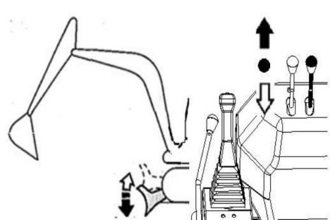

Lower bulldozing blade: Push this lever forward.
Raise bulldozing blade: Pull this lever backward.

3-16

Operations
Operations Procedures

Operations Procedures

Prohibited Operations

ΔWarning

● Do not operate on a bed rock (hard or soft).
● Do not slew during the traveling. If it’s necessary to operate the bucket working device during traveling, operate at
sufficiently low speed to ensure the complete control at all times.

Do not use the slewing force for
demolition or leveling operations.
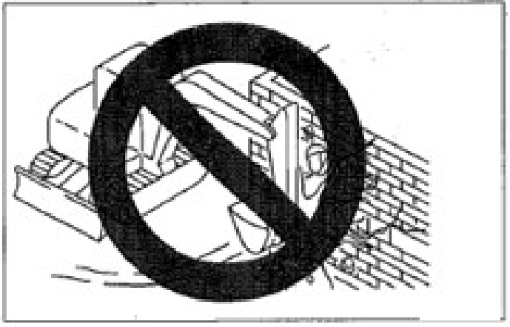

Do not use slewing force to dismantle walls or level ground. In addition, do not insert the
bucket teeth into the ground during slewing. Otherwise the bucket working device will be damaged.

No Digging during Traveling
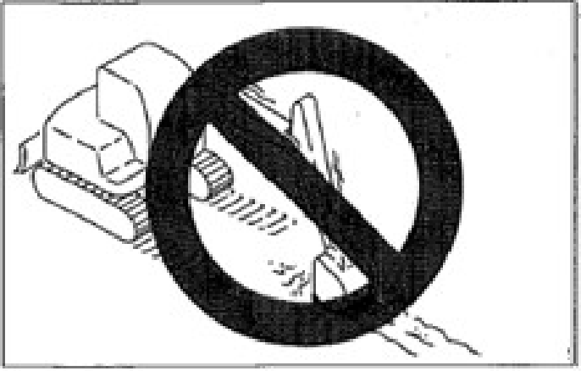
Do not insert the bucket into the ground or use the traveling force for digging.
Steady Operations of Hydraulic Cylinders
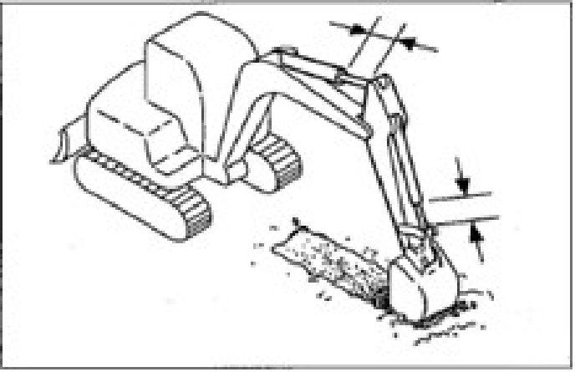
Do not extend any hydraulic cylinder to the end. Reserve an allowance during operations.
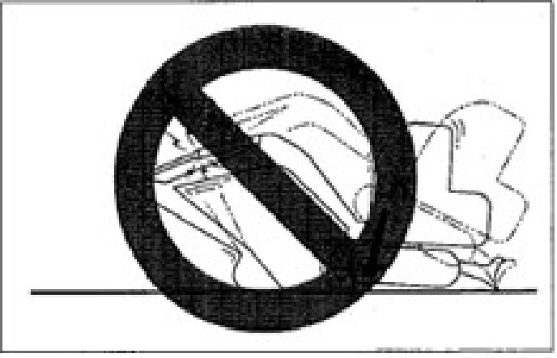

3-17

Operations
Operations Procedures

When the machine body is lowered and the bucket arm cylinder is completely extended, do not support the machine body by bucket working device. Otherwise, the load will be concentrated on the bucket arm cylinder to probably damage the bucket arm cylinder.
No Digging by Pulling or Hammering Bucket
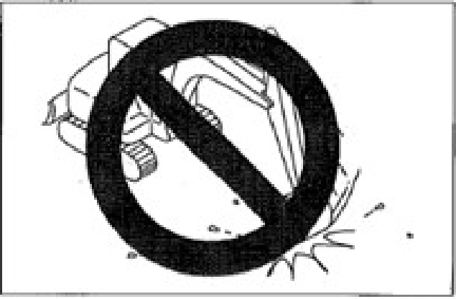
This will shorten the life of bucket working device. Dig by hydraulic force.

Do not operate by the down force of machine.
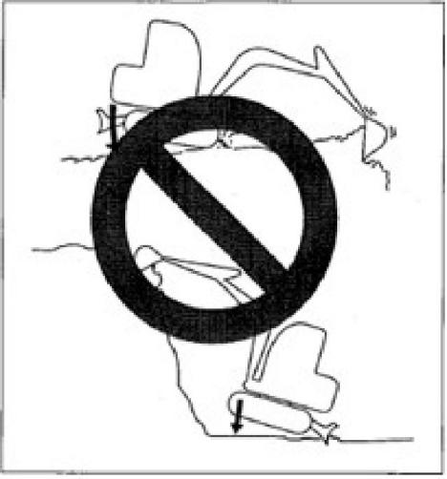

Using additional tension onto the machine will shorten the life of machine. During digging, use the hydraulic force of cylinders by shallow depth and large travel.
Digging of BedRock
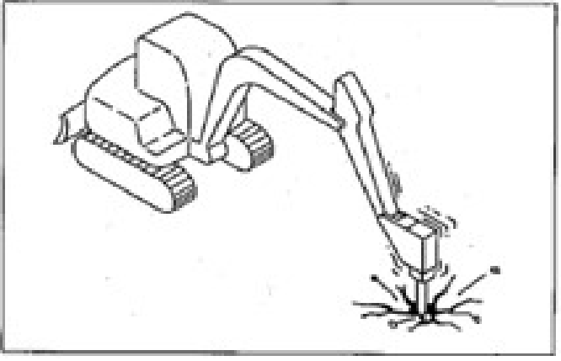

For hard bed rocks, it’s preferable to break the

3-18

Operations
Operations Procedures

rock into small pieces by breaking hammer before digging. It can prevent the damages of machine and thus can be more economic.
Guard Bulldozing Blade against
Impact
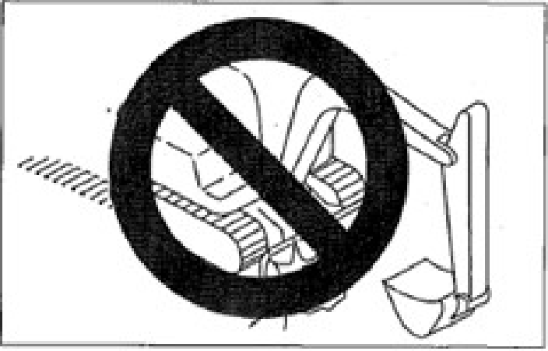
Impacting the bulldozing blade with rock will damage the bulldozing blade and bulldozing blade cylinder.
Careful Retraction of Bucket Working Device
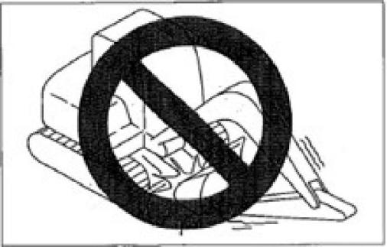
While retracting the bucket working device, take cautions not to impact the bucket with bulldozing blade.

Prohibited Use of Bulldozing Blade as Support
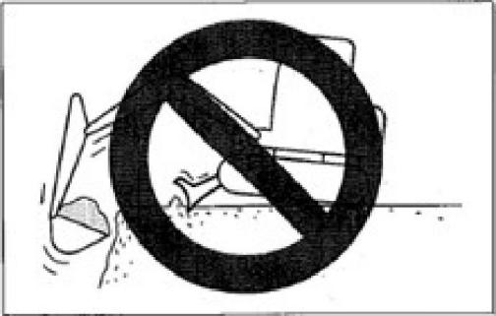
Caution of Bulldozing Blade during Digging
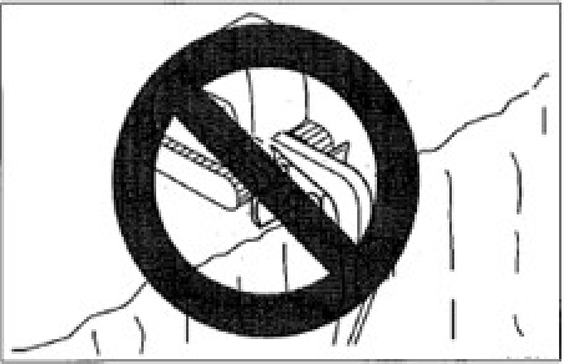
For deep digging operations, if the bulldozing blade is in the front, take cautions to prevent
impacting the boom and bucket with bulldozing blade.
During operations, place the bulldozing blade on the rear of machine whenever possible.

3-19

Operations
Operations Procedures

Caution of Downward Digging with Bulldozing Blade
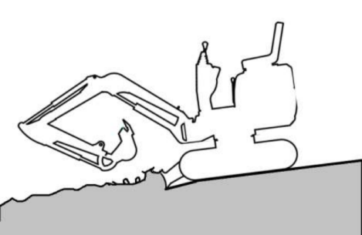

This bulldozing blade is designed for simple bulldozing operations. Do not use the
bulldozing blade for deep digging. Otherwise,
the bulldozing blade and the under frame will probably be damaged.
Precautions for Operations Precautions during Traveling
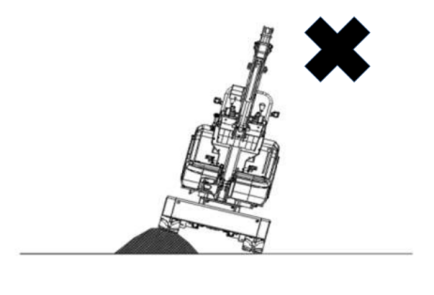

Driving the machine over obstacles (Including rocks and stumps) will probably apply high
load onto the machine body and damage the machine. Avoid driving over obstacles

whenever possible. If it’s necessary to drive
over obstacles, close the bucket working device to the ground, drive the machine at low speed, and drive the machine in such manner that the obstacles are in the middle of tracks.
Precautions for Operations of This Machine in Water

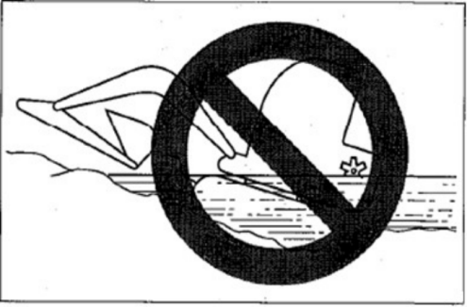
It's prohibited to immerse the rear of machine in the water.
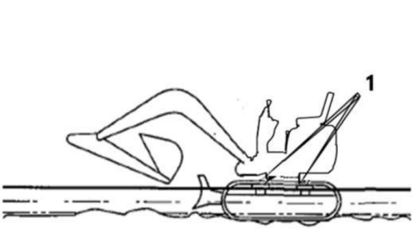

3-20

Operations
Operations Procedures

● Permissible water depth

ΔWarning

Operate this machine in the water only when the water level is not above the
· middle of track shoe (1). ·
● For those parts used in water for a long
time, add sufficient grease till the used grease is squeezed out.
● Do not immerse the slewing support or body in the water or sand. If already
immersed, please contact a Ken stone service dealer for checking.

Precautions for Traveling on Slopes

● Do not drive the machine on a slope
steep enough to cause instability of
machine. Please be noted that, in the
actual applications, the performances of machine on a slope will be deteriorated due to severe working conditions.
● While traveling on a slope, lower the
bucket to 20~30cm off the ground.
While climbing up a steep slope, extend the bucket working device to the front position. In event of an emergency,
lower the bucket onto the ground and stop the engine of machine.
● While traveling on a slope, drive slowly in 1st gear (Low speed).
● Keep the driver seat facing towards the up slope direction while climbing up a
slope. Keep the driver seat facing
towards the down slope direction during down slope traveling. In both cases, pay special attention to the ground ahead of
the machine during traveling.
● Do not reverse the machine down a slope.

3-21

Operations
Operations Procedures

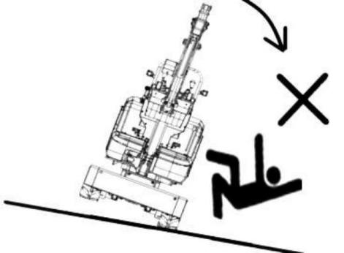
● Do not change direction on a slope or
lateral slope. Firstly return the machine to a level ground and then select another path.
● The machine will probably slip laterally while traveling on a gentle slope covered by grass or dry leaves or traveling on a wet metal plate or frozen surface. Do
not park the machine laterally on a slope.

Traveling Posture on Slopes Up slope Traveling
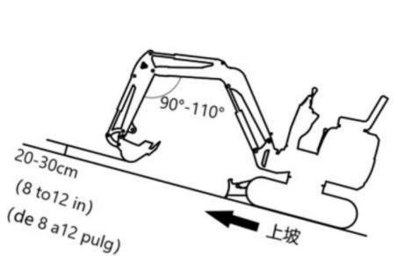

To climb up a 15° or higher slope, maintain the machine posture as shown in above diagram.
Downs lope Traveling
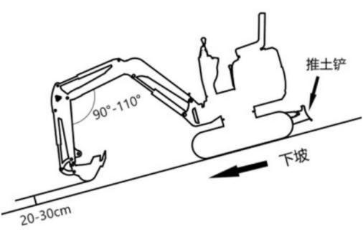
While driving down a 15° or higher slope, reduce the engine speed and maintain the machine posture shown in above diagram.

3-22

Operations
Operations Procedures

Braking during Downs lope Traveling
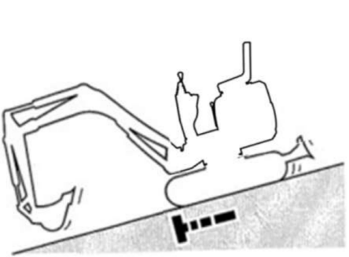
While driving down a slope, the brake applies braking automatically after the traveling joystick returns to neutral position.
In Event of Track Slip
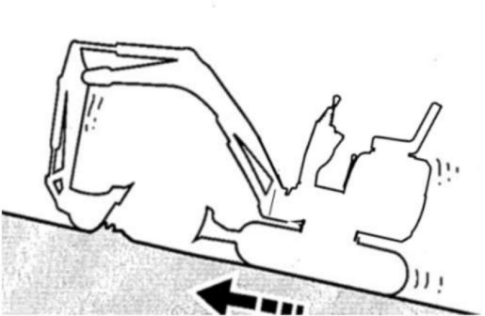
In event of traveling failure due to track slip
while climbing up a slope, use the digging force of bucket arm to climb up the slope.

In Event of Engine Flame out
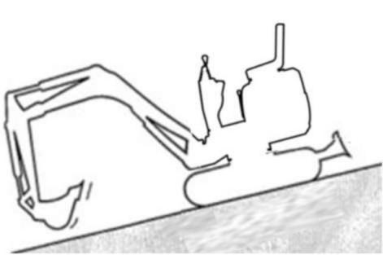

If the engine stops while driving down a slope, shift the traveling joystick to neutral position, stop the machine, and then restart the engine.

3-23

Operations
Operations Procedures

Out of the mud
If the machine is entrapped in the mud, drive · out as per following procedure.
If a track gets stuck in the mud
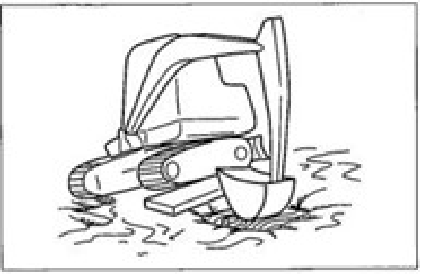
1. Swing the bucket towards the track
entrapped in the mud.
2. Set the angles at 90~110° for bucket arm
and boom.
3. Push the bucket bottom (Not bucket teeth)
onto the ground.
4. Place a wood plate or similar object
beneath the lifted track.
5. Lift the bucket and drive out the machine
from the mud slowly.
If both tracks are stuck in the mud
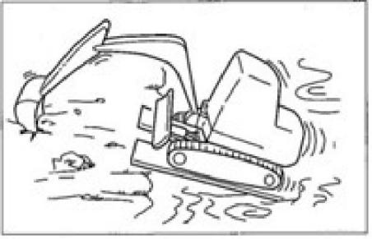

1. Operate above-mentioned steps 1~4 for
both tracks.
2. Insert the bucket into the ground in the
front of machine.
3. Pull the bucket joystick during forward
traveling to slowly drive out the machine.

Allowed Operations of Machine Digging
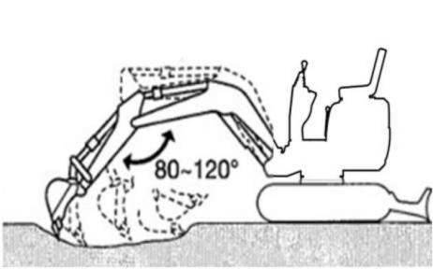

1. Place the bulldozing blade to the opposite
side of the digging zone.
2. Digby bucket arm and bucket. It’s
preferable to dig by shallow depth and
large travel. The maximum digging force is achieved when the angle between boom and bucket arm is 80~120°. It’s preferable to change the angle for effective digging.

3-24

Operations
Operations Procedures

Ditching
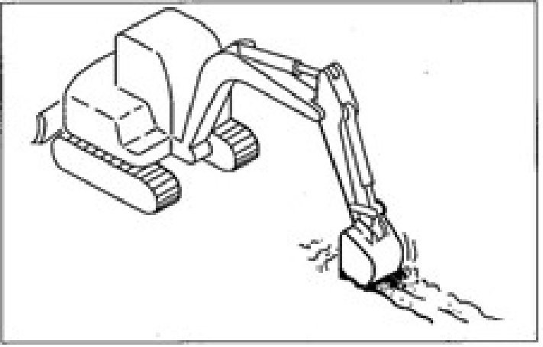
Install a bucket suitable for digging of ditches, adjust the tracks to be parallel with the ditch to be dug, in order to improve the working
efficiency. While digging a wide ditch, dig the side faces and then the middle area.
Digging of Side Drainage Ditch
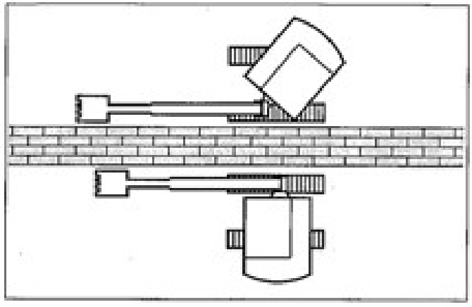
As shown in the diagram, dig the side ditch by swing function of boom.

Loading
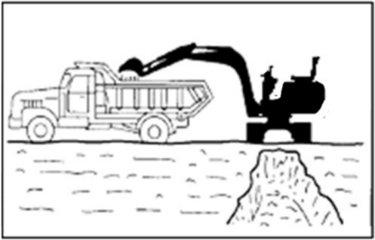
While loading soil into the cargo body of a
truck, loading from the rear end of truck can load more soil easier than loading from the
front end. In addition, the small angle slewing can be used to improve the efficiency.
Leveling
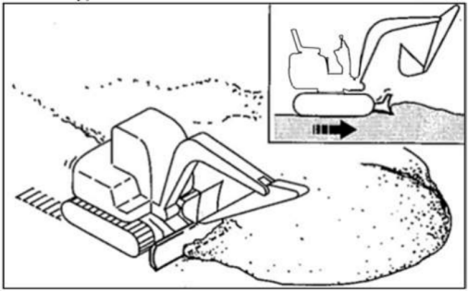
1. Close the bucket working device to the
machine body.
2. Slowly push away the soil from the side
face of soil pile.
3. If the soil pile is low, push the soil from
the top. If the load is too heavy for the
machine body, lift or lower the bulldozing blade for adjustment.

3-25

Operations
Parking of This Machine

Parking of This Machine Parking

ΔWarning
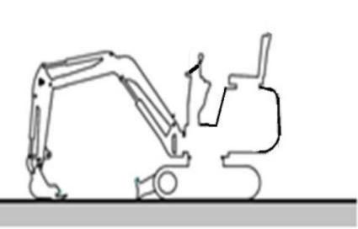

● Stop the machine on a level, solid, and safe ground. Set the parking device.

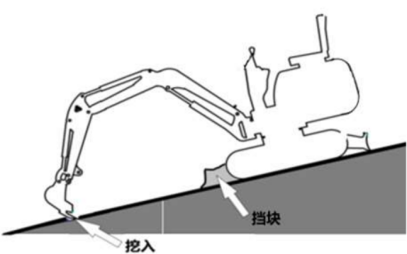

Digging
Stopper
● If it’s necessary to park the machine or tilt the machine on a slope, securely
park the machine and block the machine against movement.
● While parking the machine in a street, use gratings, warning signs, or lamps to keep the visible even in the night, in
order to prevent the impact with other

vehicles.
● Before leaving the seat, lift up the safety lock handle to the locking position and stop the engine. Meanwhile, ensure to withdraw the key, close the doors and
hoods, and carry the key with you and then preserve it in a designated place.
1. Place the left and right traveling joysticks
to neutral positions.
2. Push backward the accelerator joystick to
idle the engine.
3. Lower the bucket and bulldozing blade
onto the ground.
4. Lift up the safety lock handle to the
locking position.
For details, please refer to "Stopping the Engine" on page 3-6.
Checking after Stop of Engine
1. Check for leakage of oil and water and
check the working device, cover, and under frame. Upon detection of any abnormality, repair.
2. Fully fill fuel.
Refer to page 5-21 “Checking of fuel level” .
3. Remove paper fragments and dusts from
engine compartment.
4. Remove the mud from under frame.

3-26

Operations
Parking of This Machine
Locking
Ensure to lock the following parts.
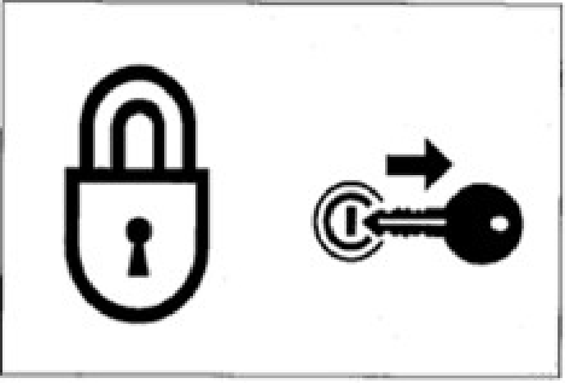

3-27

Operations
Treatment in Cold Weathers

Treatment in Cold Weathers
Preparations for Cold Weathers
It’s difficult to start the engine in cold weathers. Replacement of Fuel and Lubricants
Replace the hydraulic oil, engine oil, and fuel with trademarks suitable to cold weathers.
Refer to page 5-4 “Fuel and Lubricant Table” .
Battery
The battery performance deteriorates along with the reduction of temperature.
Check the battery. Upon detection of battery
discharging, please contact a Ken stone service provider for charging.
Refer to page 5-28 Checking of battery
electrolyte level and adding of electrolyte” .

Precautions after Operation
Please abide by the following precautions to prevent the movement failure of machine due to frozen mud, water, or under frame.
● Remove all mud and water from machine body. Especially, wipe clean the hydraulic cylinder rod to prevent the ingress of rod surface mud and dusts into the seals along with water drops from damaging the seals.
● Park the machine on a solid and dry
ground. If impossible, park the machine on a ground paved with wood boards.

● Fully drain the water from fuel tank to prevent freezing.
Refer to page 5-27 “Water drainage from fuel tank ”.
● As the battery capacity will drop
remarkably in low temperature
environment, cover the battery or take the battery out of the machine and store it in a warm place. If the electrolyte level is too low, add distilled water before starting
operations in the morning. To prevent the freezing of battery electrolyte at nighttime, do not add water after the daytime
operations.

After Cold Weathers
When the weather becomes warm, fulfill the following operations.
● Replace the fuel and lubricating oil for all parts as per the trademarks specified by “Fuel and Lubricant Table” .
Refer to page 5-4 “Fuel and Lubricant
Table” .

3-28

Operations
Handling of Rubber Tracks

Handling of Rubber Tracks
This machine is equipped with rubber tracks and the rubber tracks have their intrinsic
weakness, namely low strength. Please ensure to abide by the following prohibitions and
precautions to prevent damage and falloff of rubber tracks.
Prohibition
Do not drive or operate the machine in following sites:
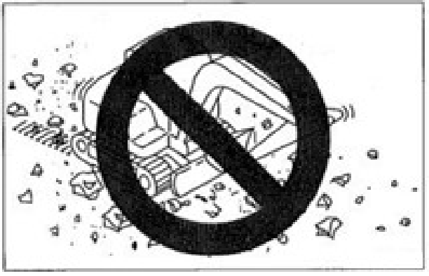

● Driving and steering the machine on
gravels, rough and hard rocks, steel beams, or scrap irons or near the edges of steel
plates will damage the rubber tracks.
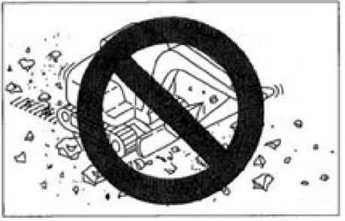

● Driving the machine on a riverbed or place · with numerous pebbles can probably result in inclusion of pebbles in the tracks and
the damage or falloff of tracks.

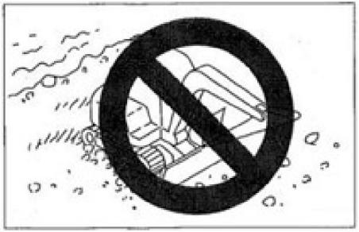
● Do not operate this machine by the sea. The salt content will probably corrode the steel core.
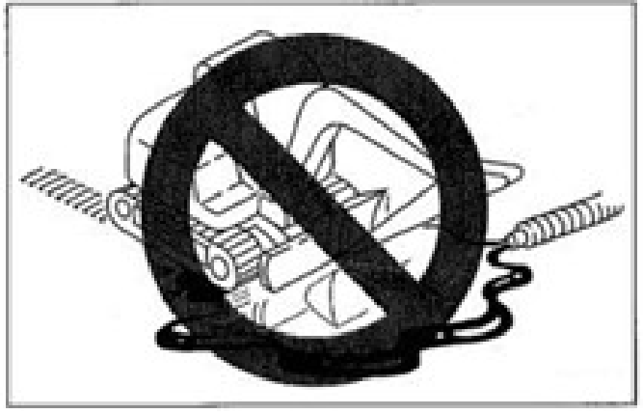
● Keep the tracks away from the adhesion of fuel, lubricating oil, salt, and chemical
solvent. These substances will probably corrode the welds of track steel cores to cause rusting or falloff. Such substances adhered onto the tracks shall be
immediately removed by water.

3-29

Operations
Handling of Rubber Tracks

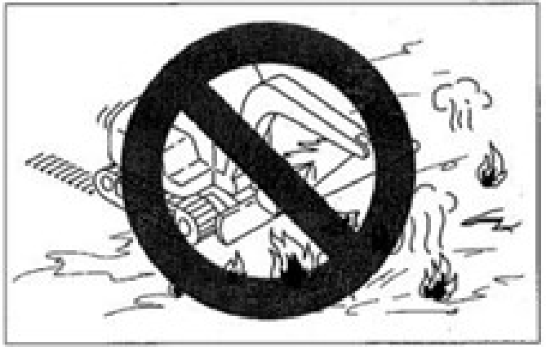
● Driving the machine on irregular surfaces, such as new asphalt pavement and hot
steel plates exposed to campfire or burning sun will result in irregular wear or damage of tracks.
● Do not move the rubber tracks to possibly slip ground. Otherwise, the wear of the
tracks will be probably accelerated.

Precautions
Please abide by the following precautions during the operations of this machine:
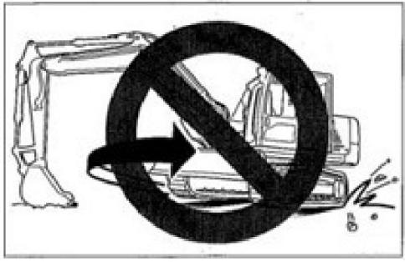
● Do not slew the under frame (The
superstructure is not slewed) when the
bucket working device is lifted in the front of machine body. Otherwise, the load will be concentrated at single point of tracks
and the tracks will be twisted to cause rapid damage.
● In all cases, avoid changing the route
suddenly or avoid the in-situ steering on concrete surface whenever possible.
Otherwise the rubber tracks will be worn or damaged.
● Avoid the strong impact onto the rubber tracks due to falloff.
● The tracks will be damaged by salt,
potassium chloride, ammonium sulfate,

3-30

Operations
Handling of Rubber Tracks

potassium sulfate, and lime triple super phosphate. Such substances adhered onto the tracks shall be immediately removed thoroughly by water.
● Keep both sides of rubber tracks away
from friction with concrete or wall surface.
● Do not impact the bucket with the rubber tracks, otherwise the tracks will be
damaged.
● Take special cautions on snowy or icy surfaces in winter, as the tracks are
vulnerable to slip on such conditions.
● Please use rubber tracks within -25℃~55℃ .
● For long-time storage (≥3 months) of rubber tracks, please store in an indoor place without direct sun exposure or
rainfall.
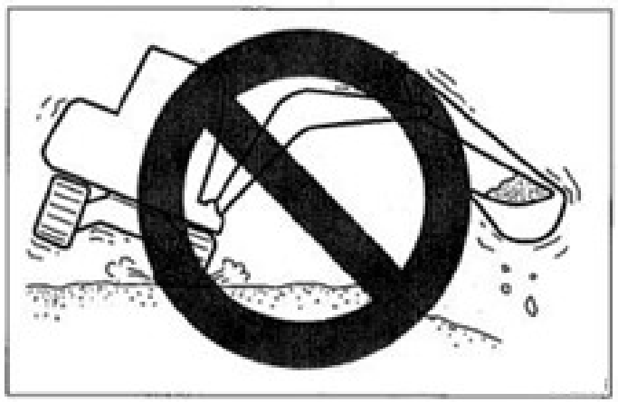
● The rubber tracks are not as stable as steel tracks, as they are completely made of rubber. Take special cautions during the lateral slewing and swing.

Guard against Falloff of Rubber Tracks
Abide by the following precautions to prevent the falloff of tracks:
● Always maintain an appropriate tension for the tracks.
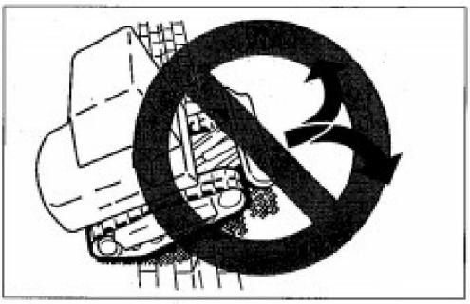
● When driving over pebbles or large steps (≥20cm in depth, such as large rocks), climb on the steps in right angle and do not change route on steps.
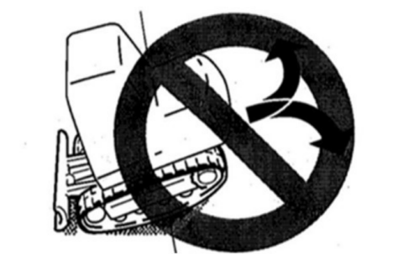

● While reversing up a slope, do not change direction at the start point of slope.

3-31

Operations
Handling of Rubber Tracks

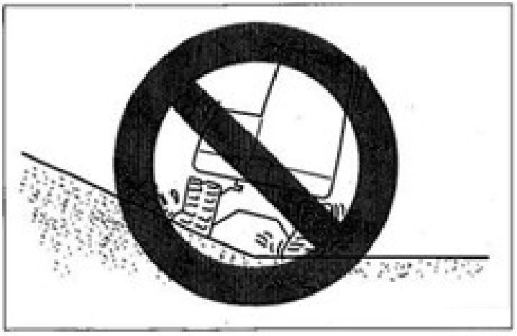
● Please avoid driving the machine with one track on a slope or protrusion and the other track on level surface (In such case, this
machine is inclined by 10° or more).
Please drive the machine with both tracks on level surface.
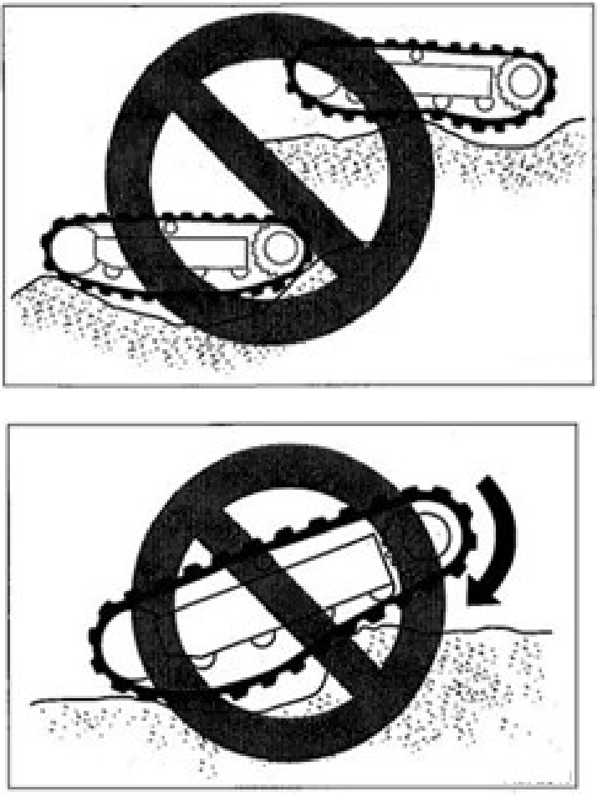

● Do not change the direction when the
tracks are loose as shown in the diagram.
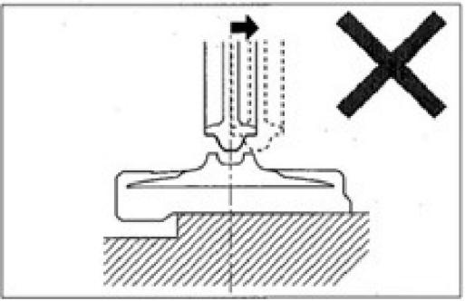
● In such case, the rubber tracks will fall off if the machine drives backward.
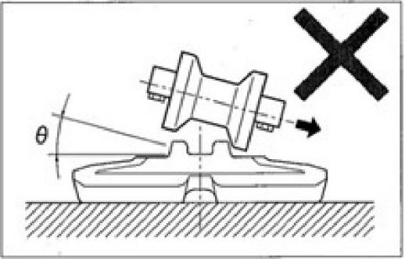
● In such case, the rubber tracks will fall off if the machine slews.

3-32

Transportation

4-1

Transportation
Loading and Unloading

Loading and Unloading

ΔWarning

The machine will probably roll over or fall off during unloading. Ensure to take the following safety measures:
● Select a solid and level ground and keep a sufficient spacing from the road curb.
● Fix the ramps of sufficient strength and dimensions to the cargo body of truck. The inclination of the ramps shall not exceed 15°. If the ramps deflect
downward excessively, please support the ramps by supports or cushion
blocks.
● Do not load or unload the machine by working device. Otherwise, it will
probably result in rollover or falloff of machine.
● Keep the truck cargo body and the
ramps clean without oil, sand, ice/snow, or other impurity, in order to prevent the side slip of machine. Clean the
tracks.
● Block the wheels of transport truck by wedges to prevent movement.
● While loading or unloading the machine, drive the machine slowly in 1st gear (low speed) as per the signals of the signaler.
● Do not change direction on ramps.

● Do not slew/swing on ramps. Otherwise the machine will probably roll over.
● Slewing/swinging the machine on the
cargo body of truck will probably result in unstable legs of machine. Therefore, operate slowly.
● If possible, lock the cab doors after loading. Otherwise the cab doors will probably open during the transport.
● Plug securely the tracks by wedges and then fix the machine to the truck cargo body securely by ropes or chains.

During the loading or unloading of machine, please ensure to use ramps or platform and abide by following procedures.

Fix to suspension parts
Distance between
Stop block
15°or less
Ramp
1. Securely apply the parking device of
transport truck and block the wheels by wedges.
2. Place the ramps securely onto the truck
cargo body. The inclination of the ramps shall not exceed 15°.


4-2

Transportation
Loading and Unloading
3. Align the center of truck cargo body with
the center of machine and align the center of ramps with center of tracks.
4. Ensure that the bulldozing blade will not
touch the ramps.
5. Lower the bucket working device as low
as possible and take cautions not to impact it with the transport truck.
6. Reduce engine speed.
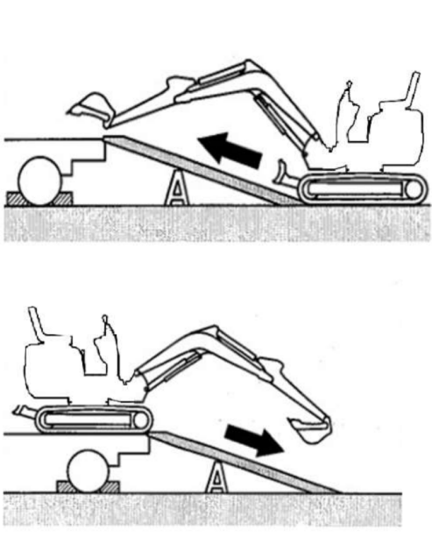
7. According to the signaler’s signals, drive
the machine straightly up or down along the ramps in 1st gear (low speed).
8. Load the machine to designated position of
transport truck. Refer to “Transport Status” in page 4-6 for details.
4-3

Transportation
Lifting of Machine

Lifting of Machine

ΔWarning

● Master and use the correct lifting signals.
● Daily check the lifting device for
damaged and missing parts and when necessary replace.
● Please use the ropes of sufficient
capacity for the machine weight during lifting.
● Lift the machine as per the procedure
described below. Do not operate by any other method. This is really dangerous as it will probably result in imbalance of machine.
● Do not operate the lifting if there is any operator on the machine.
● Operate slowly during lifting to prevent the rollover of machine.
● During lifting, keep all personnel away from working zone. Do not move the machine over any person.

Important: This lifting method is applicable for the models with standard overall
parameters. The gravity center varies depending on the installed attachments and optional
devices.
To understand more details, please contact your Ken stone service dealer.

Lifting
1. Slew the superstructure to place the
bulldozing blade behind the machine (Adjust the superstructure to be parallel with track frame).
2. Lift the bulldozing blade to highest
position.
3. Sufficiently extend the bucket cylinder and
bucket arm cylinder and lift the boom to highest position.
4. If the boom swings leftward or rightward,
adjust it to neutral position.
5. Raise the safety lock control lever to the
locking position.
6. Stop the engine, withdraw the starter key,
and leave the machine.
7. Install the ropes as shown in diagram
below. Install the ropes and lifting
appliance and take caution to keep them away from machine body.
8. Slowly lift the machine, till it's off the
ground.
9. Stop the lifting till the machine becomes
stable and then lift the machine again.

4-4

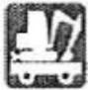
Transportation
Lifting of Machine

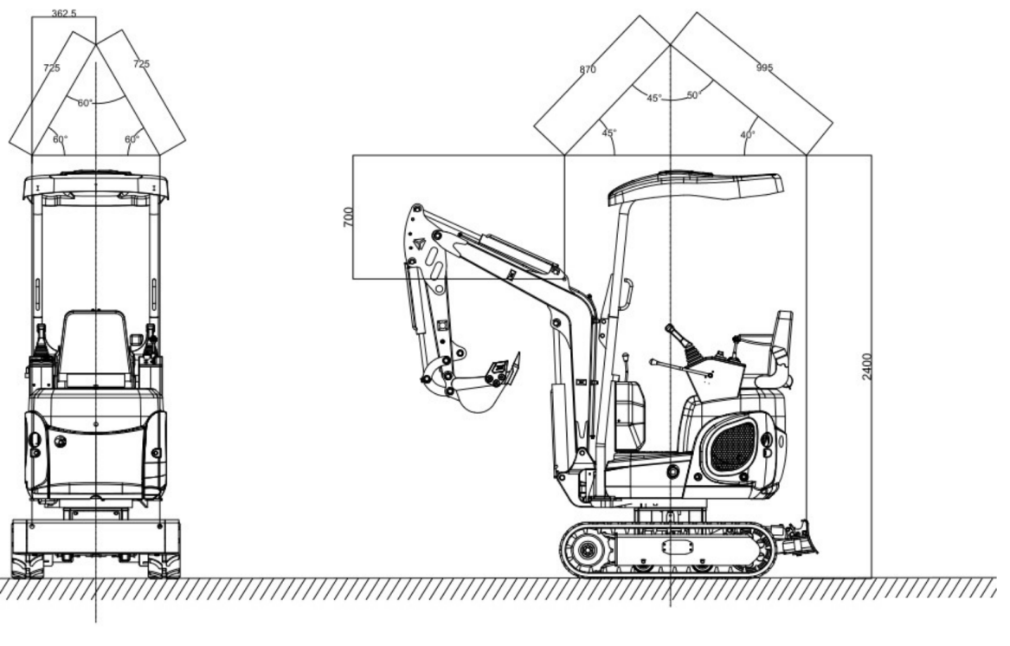

unit: mm

4-5

Transportation
Fixing of Machine
Fixing of Machine
After loading the machine to designated position, fix as per following requirements. Transport Status
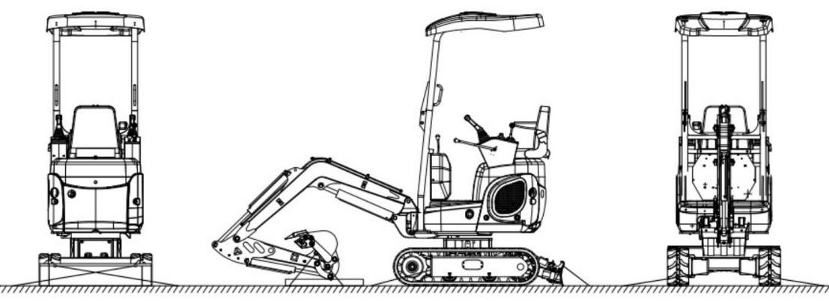

1. Lower the bulldozing blade.
2. Sufficiently extend the bucket cylinder and
bucket arm cylinder and then lower the boom.
3. Lift up the safety lock handle to the
locking position.
4. Stop the engine, withdraw the starter key,
and lock all locks.
5. Place the stop blocks (Wedges) on the
front and rear of tracks.
6. Affix chains or ropes securely to the lower
framework of machine, in order to prevent the side slip of machine.
7. Fix the bucket by chains or ropes.
Important: A wood board can be placed beneath the bucket to prevent damaging the ground by the bucket.

Safety Measures Taken during Transport

ΔWarning
● During the transport of machine, understand and abide by all applicable safety rules, vehicle codes, and traffic regulations.
● Take the length, width, height, and weight of the transport truck with loaded machine
into consideration, in order to select the best transport route.
● During the transport, do not start up or stop the transport truck suddenly or drive at high
speed. Otherwise, it will result in movement or unbalance of loaded machine.

4-6

Maintenance 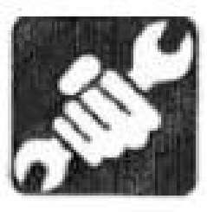

5-1

Maintenance Overview

Overview
Maintenance Overview
To maintain the good status and long-term
serviceability of the machine, please fulfill the checking and maintenance correctly and safely abide by the procedures recommended by this manual.
Based on the total operating time of the
machine, the checking and maintenance items can be divided into several groups: Every 10h (Walk-around checking and daily routine
checking), every 50h, and every 250h. Please refer to the reading of hour meter to determine the checking and maintenance timing. The
items for which the checking and maintenance intervals can’t be determined are listed in
column “As necessary” .
When the machine is operated in extremely
severe environment (Dusty or high temperature
environment), fulfill the checking and
maintenance ahead of the periods specified by maintenance schedule.
Maintenance Precautions
Do not fulfill any other checking or
maintenance item not listed in this manual. For the items not listed in this manual, please ask your sales or service dealer for help.
Keeping Machine Clean
● Clean the machine before checking and

maintenance. Keep the machine clean.
● Stop the engine before cleaning the
machine. Cover the electric parts against water ingress. The water ingress into the electric parts will probably result in short- circuit or malfunction. Do not clean the
battery, electronic control units, sensors, connector, or operating room by water or steam.
Fuel, Lubricating Oils, and Greases
● Select fuel, lubricating oils, and greases as per the “Fuel and Lubricant Table” .
● Use the water-free fuel, lubricating oil, and grease. Take cautions to eliminate the
ingress of dusts during replacement or
filling of fuel, lubricating oil, and grease.
● Store the fuel, lubricating oil, and grease in designated location and guard against the ingress of water and dusts.
Precautions for Refueling
● If the fuel filler port is installed with a filter screen, do not remove the filter screen during refueling.
● Please ensure to tighten the fuel tank cap after refueling.
● The refueled volume shall not exceed the designated fuel volume.
No Cleaning of Engine Parts by Fuel It’s prohibited to clean engine parts by fuel. Use


5-2

Maintenance Overview

non-inflammable detergent.
Guard against Ingress of Dusts
The installation and disassembling of parts shall be operated in a dust-free place. Clean the
working area and clean the parts to guard against ingress of dusts.
Cleaning of Mounting Surfaces
Keep clean the contact surface of parts during the installation and disassembling. If the sealing grooves of the contact surfaces are damaged,
please contact your sales or service dealer for repairs or breakup.
Seal Rings and Split Pins
● Ensure to replace all disassembled seal rings and split pins with new ones.
● Take cautions not to damage or twist any seal ring during installation.
Seal Rings
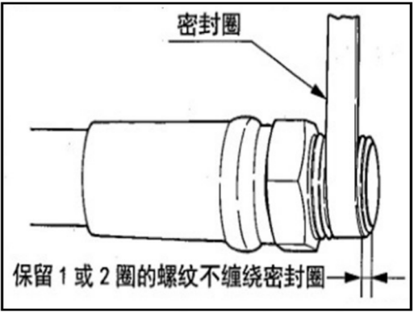
Leave 1~2 turns of threads not wrapped with seal ring.
Seal rings
● While wrapping the screw plug with seal ring tape, thoroughly remove the used seal ring tap from the threads and clean the
threads.

● Wrap the threads with seal ring and notice to leave 1~2 end threads of screw plug not wrapped with seal ring.
Waste Disposal
● Ensure to collect the drained oil of
machine into a container. The improper treatment of waste oil will pollute the environment.
● While disposing harmful objects,
including lubricating oil, fuel, coolant, filter, and battery, please abide by the applicable laws and regulations.
Checking after Maintenance
● Accelerate the engine speed gradually from idling speed to fastest speed and check for leakage of oil or water from repaired parts.
● Operate all joysticks and check machine for normal operations.
Precautions for Wire Connections of Battery
● Before operating the electronic system or performing electric welding, disconnect
the wires from both electrodes (+ and -) of the battery.
● Ensure to disconnect it from the grounding electrode (-). Finally connect the
grounding electrode during connection.
● Do not disconnect the battery wires during the normal running of engine. Otherwise, the rotary converter circuit or other parts will probably be damaged.

5-3

Maintenance
Service Data
Service Data
Fuel and Lubricant Table
Please refer to following table to select appropriate fuel, lubricating oil, and grease based on the temperature.
● Regardless of the specified periods, replace the oil when the oil is too dirty or already deteriorated.
● Never mix the oils of different trademarks while adding fuel/oil. To replace with fuel/oil of other trademark, please replace completely.
Fuel
Specified fuel
The diesel shall meet the following specification. This table lists some diesel specifications available
in the world.
Diesel specification | Region | Diesel specifications | Region
GB252 | China | JIS K2204, grade 2 | Japan
ASTM D975  No. 1-D, S15 No. 2-D, S15 | USA Canada | ISO 8217DMX | Worldwide
Bio-diesel  Bio-diesel mixture B5 ASTM D6751, D7467 | USA Canada | ISO 8217DMX | Worldwide
EN590 : 2009 | EU | BS2869-A1 or A2 | UK
Bio-diesel  Bio-diesel mixture B5 EN14214, EN590 | EU | BS2869-A1 or A2 | UK

5-4

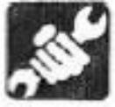
Maintenance
Service Data

Fuel tank | Diesel | To maintain the performance and life of engine, please always use clean and high-quality fuel.  ● To prevent freezing in cold weathers, please choose diesel still suitable when the actual temperature is less by at least 12℃ than the expected minimum outside temperature.  ● Please use diesel with cetacean number at 45 or higher. During the operations in low temperature or high altitude regions, use fuel of higher cetacean number.  ● Use fuel with sulfur content (volume ratio) at <0.5%.  Use ultra-low sulfur fuel especially in U.S. and Canada.  The use of fuel with high sulfur content can probably result in sulfur acid corrosion in engine cylinders.  ● Do not mix the diesel with kerosene, used engine oil, or residual fuel. It’s prohibited to use kerosene.  ● The low quality fuel will reduce the engine performance and/or damage the engine.  ● It’s not recommended to use fuel additives. Some fuel additives will deteriorate the engine performances.
Fuel tank | Diesel | Safety measure for use of bio-diesel  The warranty regulation of the engine manufacturer is void for the engine using disqualified or deteriorated bio-diesel.

5-5

Maintenance
Service Data
Lubricant

Position | Type | Type depending on  temperature  -20 -10 0 10 20 30 40℃ |  |  |  |  |  |  |  |  |  |  |  | Replacement period
Oil sump | Diesel engine fuel  API: grade CD  ACEA:E-3,E-4 or E-5 |  | SAE 10W-30 |  |  |  |  |  |  |  |  |  |  | First 50h *  Afterwards every 250h
Oil sump | Diesel engine fuel  API: grade CD  ACEA:E-3,E-4 or E-5 |  |  | SAE 15W-40 |  |  |  |  |  |  |  |  |  | First 50h *  Afterwards every 250h
Hydraulic oil tank | Anti-wear hydraulic oil |  |  |  |  |  |  |  |  |  |  |  |  | Every 2000h ***
Hydraulic oil tank | Anti-wear hydraulic oil |  | ISO VG32 |  |  |  |  |  |  |  |  |  |  | Every 2000h ***
Hydraulic oil tank | Anti-wear hydraulic oil |  |  |  |  | ISO VG46 |  |  |  |  |  |  |  | Every 2000h ***
 |  |  |  |  |  |  |  | ISO VG68 |  |  |  |  |  | Every 2000h ***
Cooling system | Coolant (Water + coolant) **  SAE: J814C or J1034 |   50% coolant mixture |  |  |  |  |  |  |  |  |  |  |  | Every 1000h
Cooling system | Coolant (Water + coolant) **  SAE: J814C or J1034 |  |  |  | 30% coolant mixture |  |  |  |  |  |  |  |  | Every 1000h
Traveling reducer gear | Gearbox  API: GL-4 | SAE 90 |  |  |  |  |  |  |  |  |  |  |  | First 250h *  Afterwards every 1000h
Slewing motor gear | Lithium-base grease EP-2  MLGI 2# | -- |  |  |  |  |  |  |  |  |  |  |  | Every 50h
Slewing bearing | Lithium-base grease EP-2  MLGI 2# |  |  |  |  |  |  |  |  |  |  |  |  | Every 50h
Working device | Lithium-base grease EP-2  MLGI 2# |  |  |  |  |  |  |  |  |  |  |  |  | Daily or every 10h
Arm | Lithium-base grease EP-2  MLGI 2# |  |  |  |  |  |  |  |  |  |  |  |  | As necessary
*: If the traveling time accounts for a high ratio of the total operating time, replace the gear oil ahead of the specified periods.
**: Use running water (soft water). Do not use well water or river water. If the outside temperature is <0℃, add coolant (antifreeze). Determine the mixture ratio as per the coolant manufacturer’s
instructions.
***: The replacement period of hydraulic oil depends on the type of hydraulic oil in use. The new
machine is filled with Ken stone genuine hydraulic oil 46 at the time of delivery and the
hydraulic oil replacement periods described in this manual are based on the use of Ken stone
genuine hydraulic oil 46. When common anti-wear hydraulic oil is used, replace the hydraulic oil once every 2,000h.
API: American Petroleum Institute
ACEA: Association eds Constructors Europeans SAE: Society of Automotive Engineers
5-6

Maintenance
Service Data

Periodical Replacement of Hydraulic Oil
With installed hydraulic breaking hammer, the hydraulic oil deteriorates faster than the
common digging operations. Ensure to replace
the hydraulic oil and oil return filter element.
● The failure to replace timely will result in damage of machine and breaking hammer hydraulic system. To prolong the lives of hydraulic devices, please timely replace the hydraulic oil and oil return filter
element as per the table below.
● During the replacement of hydraulic oil, clean the oil suction filter screen.
Replacement period (Hour)

Item | Hydraulic oil | Filter element
1st time | -- | 25
2nd time | -- | 100
Periodic | 1200(600) | 200
By taking the breaking hammer operating ratio of 100% for instance. Refer to “Hydraulic
Breaking Hammer” in page 8-6 for details.

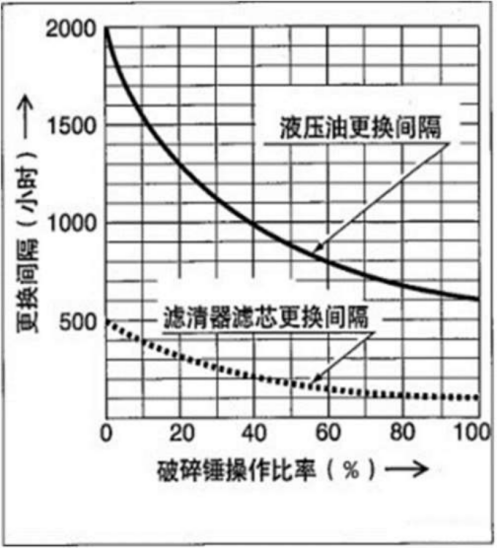
Replacement period (Hour)
Hydraulic device replacement period

Filter replacement period

Breaking hammer operating ratio (%)
( ): For the use of common anti-wear hydraulic oil.

5-7

Maintenance
Service Data
List of Wearing Parts
Periodically replace the wearing parts, including filters and filter elements, as per the table below.

System | Item | Part name | Replacement period
Hydraulic system | Return oil filter |  | First 50 hours for new machine or every 500 hours
Hydraulic system | Ventilator |  | Every 1000 hours
Engine lubrication system | Engine oil filter | Filter cartridge | Replace after first 50 hours, then every 250 hours
Fuel system | Fuel filter | Filter cartridge | Every 250 hours
Fuel system | Water separator | Filter cartridge | Every 250 hours
Fuel system | Water separator | filter | Every 250 hours
Fuel system | Water separator | filter | Every 500 hours
Air filter system | Air filter | Primary (Outer) filter element | Every 1,000h or 6 cleaning cycles (Whichever comes first)
Air filter system | Air filter | Secondary (Inner) filter element | At replacement of primary filter element

5-8

Maintenance
Service Data
List of Tools (If installed)

List of tools
S/N 1 | Name and specification Tool box | Unit PCs | Quantity 1 | Remark
2 | Socket hex. wrench (4mm) | Piece | 1
3 | Socket hex. wrench (5mm) | Piece | 1
4 | Socket hex. wrench (6mm) | Piece | 1
5 | Socket hex. wrench (8mm) | Piece | 1
6 | Socket hex. wrench (10mm) | Piece | 1
7 | Socket hex. wrench (12mm) | Piece | 1
8 | Stud dead spanner22*24 | Piece | 1
9 | Stud dead spanner 27*30 | Piece | 1
10 | Stud dead spanner 30*32 | Piece | 1
11 | Stud dead spanner 36*41 | Piece | 1
12 | Combination wrench, 8mm | Piece | 1
13 | Combination wrench 10mm | Piece | 1
14 | Combination wrench 12mm | Piece | 1
15 | Combination wrench 13mm | Piece | 1
16 | Combination wrench 14mm | Piece | 1
17 | Combination wrench 15mm | Piece | 1
18 | Combination wrench 16mm | Piece | 1
19 | Combination wrench 17mm | Piece | 1
20 | Combination wrench 18mm | Piece | 1
21 | Combination wrench 19mm | Piece | 1
22 | Socket head, 10mm | Piece | 1
23 | Socket head 11mm | Piece | 1
24 | Socket head 12mm | Piece | 1
25 | Socket head 13mm | Piece | 1
26 | Socket head 14mm | Piece | 1
27 | Socket head 15mm | Piece | 1
28 | Socket head 16mm | Piece | 1
29 | Socket head 17mm | Piece | 1
30 | Socket head 18mm | Piece | 1
31  32 | Socket head 19mm Socket head 21mm | Piece Piece | 1  1 | Extended socket head
33 | Socket head 22mm | Piece | 1
34 | Socket head 24mm | Piece | 1
35 | Socket head 27mm | Piece | 1
36  37  38  39 | Socket head 30mm  Curved extension rod, 12.5mm Short extension rod, 12.5mm Wire cutter, 200mm | Piece Piece Piece Piece | 1  1  2  1 | Changed to 30mm  One long and one short each
40 | Nipper pliers, 200mm | Piece | 1
41 | Ratchet wheel handle, 12.5mm | Piece | 1
42 | Adjustable wrench, 300mm | Piece | 1
43 | Ball hammer, 1.5pon | Piece | 1
44 | Straight screwdriver, 200mm*8mm | Piece | 1
45 | Phillips screwdriver, 200mm*8mm | Piece | 1
46 | Grease gun, 400g | Piece | 1
47 | Belt wrench, 60-140mm | Set | 1

5-9

Maintenance
Service Data
Table of Tightening Torques Nuts and Bolts (Grade ISO10.9)
Unless otherwise specified, tighten the nuts and bolts to the torques listed in table below.
● The tightening torques for installation of plastic caps are not listed in the table below. To understand more details, please consult with your sales or service dealer. The excessive tightening torque will cause damages.
● If the replacement is required, replace with nuts and bolts of same dimensions and specifications.
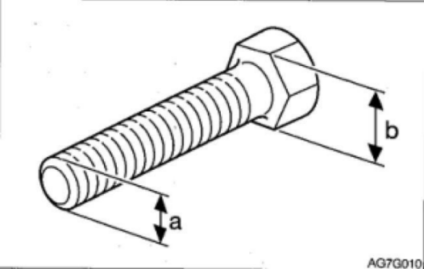
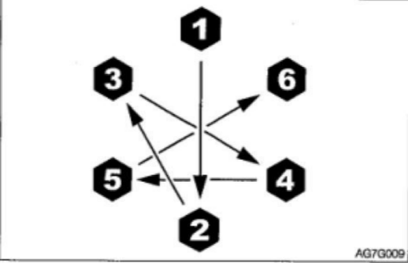

Category | Width across flats  (b) | Dimension (a) X pitch | Tightening torque
Category | Width across flats  (b) | Dimension (a) X pitch | Common connection
Category | mm | mm | N·m | Ft-lb
Coarse thread | 10 | M6 X 1.0 | 9,8 ± 0,5 | 7, 2±0,4
Coarse thread | 12, 13 | M8 X 1.25 | 22,6±1,1 | 16,6±0,8
Coarse thread | 14, 17 | M10 X 1.5 | 47,1±2,4 | 34, 7 ±1,7
Coarse thread | 17,19 | M12 X 1.75 | 83,4±4,1 | 61,5±3,0
Coarse thread | 19, 22 | M14 X 2,0 | 134,4±6,7 | 99,1±4,9
Coarse thread | 22, 24 | M16 X 2.0 | 207,9±10,4 | 153, 3 ± 7,7
Coarse thread | 27, 30 | M20 X 2, 5 | 410,9±20,5 | 303,1 ± 15,1
Fine thread | 12, 13 | M8 X 1.0 | 24,5±1,2 | 18,1±0,9
Fine thread | 14, 17 | M10 X 1.25 | 50±2, 5 | 36,9±1,8
Fine thread | 17, 19 | M12 X 1.5 | 87,3±4,3 | 64,4 ± 3,2
Fine thread | 19, 22 | M14 X 1.5 | 135, 3±6,8 | 99,8±5,0
Fine thread | 22, 24 | M16 X 1.5 | 220,6±11 | 162,7 ± 8,1
Fine thread | 27, 30 | M20 X 1.5 | 452, 1 ±22,6 | 333,4 ± 16,6

5-10

Maintenance
Critical Safety Parts
Critical Safety Parts
To operate the machine safely, please fulfill the periodical checking and maintenance. The following critical safety parts shall be replaced periodically to improve safety. These parts can cause serious
injuries or fire accident if they are damaged. List of Critical Safety Parts

Vehicle body |  | Periodically replaced critical safety part | Replacement period
Fuel system |  | Fuel pipes | Every 2 years
 |  | Packing on fuel tank cover | Every 2 years
Heater |  | Heater hoses | Every 2 years
Cooling system |  | Rubber hoses | Every 2 years
Hydraulic system | Main  machine | Hydraulic pipe (Pump outlet) | Every 2 years
Hydraulic system | Main  machine | Hydraulic pipe (Pump oil suction port) | Every 2 years
Hydraulic system | Main  machine | Hydraulic pipe (Slewing motor) | Every 2 years
Hydraulic system | Main  machine | Hydraulic pipe (Traveling motor) | Every 2 years
Hydraulic system | Working device | Hydraulic pipe (Boom cylinder pipeline) | Every 2 years
Hydraulic system | Working device | Hydraulic pipe (Bucket arm cylinder pipeline) | Every 2 years
Hydraulic system | Working device | Hydraulic pipe (Bucket cylinder pipeline) | Every 2 years
Hydraulic system | Working device | Hydraulic pipe (Swing cylinder) | Every 2 years
Hydraulic system | Working device | Hydraulic pipe (Bulldozing blade cylinder) | Every 2 years
Hydraulic system | Working device | Hydraulic pipe (Span cylinder) | Every 2 years
Hydraulic system | Working device | Hydraulic pipe (Pilot valve) | Every 2 years
Hydraulic system | Working device | Hydraulic pipe (Auxiliary pipeline) | Every 2 years
 |  | Seat Belt | Every 3 years
 |  | Anti skid plate | Every 3 years

5-11

Maintenance
Critical Safety Parts

The materials of the above-mentioned critical safety parts will deteriorate along with time to cause
wear or deteriorated performance. It’s difficult to determine the deterioration extent during periodical checking. Therefore, such parts shall be replaced with new ones to guarantee stable performance, even if such parts are still working well. Please be noted that, regardless of the replacement schedule, any part with wear symptom must be replaced immediately. Upon detection of any deformed or cracked
pipe clamp, immediately replace it together with hose. Please consult with your sales or service dealer for the replacement of safety parts.
Except the critical safety parts, check and tighten the hydraulic pipes and when necessary replace. During the replacement of hydraulic pipes, replace the O-ring and seal ring as well.
Check the fuel and hydraulic pipes as per the schedule specified by the following table. Refer to “Maintenance” .

Checking type | Checking item
Daily routine checking | Leakage of hydraulic or fuel pipe connector
Monthly checking | Leakage of hydraulic or fuel pipe connector  Damage (Cracking, wear, and tear) of hydraulic or fuel pipe
Yearly checking | Leakage of hydraulic or fuel pipe connector  Aging, distortion, and damage (Cracking, wear, and tear) of hydraulic or fuel pipe and/or status of hose in contact with other machine parts

5-12

Maintenance
Maintenance List
Maintenance List

Checking and maintenance item | Page
Walk-Around Checking
Opening of engine hood and machine hood for checking | 5-16
Walk-around checking of machine | 5-16
Checking in driver seat | 5-16
Daily routine checking (Every 10h)
Checking and adding of coolant | 5-17
Checking and adding of engine oil | 5-18
Checking of fuel level | 5-18
Checking of hydraulic oil tank oil level and adding of oil | 5-19
Lubrication of Working Device | 5-21
After first 50h (For new machine only)
Checking and adjustment of fan belt | 5-23
Replacement of hydraulic oil return filter | 5-24
Every 50h
Checking and adjustment of track tension | 5-25
Lubricate slewing support and slewing motor gears | 5-26
Water drainage from fuel tank | 5-27
Checking of battery electrolyte level and adding of electrolyte | 5-28
Every 250h
Checking and adjustment of fan belt | 5-30
Replacement of engine oil and filter | 5-30
Cleaning of air filter | 5-31
Checking of accelerator control system | 5-32
Cleaning of radiator fins and oil cooler fins | 5-32
Replacement of fuel filter | 5-33
Every 1000h
Replace the air filter | 5-35
Check and adjust the engine valve clearance | 5-35
Clean the engine cooling system | 5-36
Every 1500h
Check and clean the engine fuel injector | 5-39
Check the crankcase vent system | 5-39
Every 2000h
Overlap engine valve seat | 5-40
Replace hydraulic oil and clean suction filter | 5-40

5-13

Maintenance
Maintenance List
Maintenance List

Checking and maintenance item | Page
when needed
Replace the teeth | 5-42
Replace the bucket | 5-43
Lubricate Joysticks | 5-44
Check the rubber track | 5-45
Replace the rubber track | 5-47

5-14

Maintenance
Walk-around Checking
Walk-Around Checking
Fulfill the following checking before the first start of engine each day.

Warning
● Before operations, fulfill the walk-around checking and when necessary repair immediately.
● Before operations within the machine, please securely fix the engine hood or machine hood. Keep the engine hood and machine hood closed under windy weather or while parking the machine on a slope.

Before starting the engine, patrol around the machine and remove any combustible materials
around the engine. At the same time, check the machine for oil or water leakage, as well as loose or damaged nuts, bolts or wires.

5-15

Maintenance
Walk-around Checking
Opening of engine hood and machine 7. Check traveling motor for oil leakage.
hood for checking 8. Check shelter and guard plates for damage
1. Check for presence of branches, leaves, oil, and check for loose nuts and bolts.
and other inflammable around the engine 9. Check exterior and interior rear view
and battery. mirrors for contamination and damage and
2. Check for presence of lubricating oil and when necessary adjust.
coolant leakages around the engine. 10. Check labels for presence of dusts and
3. Check hydraulic oil pipes, hydraulic damage.
devices, hoses, and connectors for oil Checking in Driver Seat
leakage. 1. Check seat and seat belt for presence of
Walk-around checking of machine dust and damage.
1. Check lamps for presence of dusts and 2. Check driver seat for presence of dust, oil
damages and check lamp bulbs for dirt, and other inflammable.
burnout. 3. Check monitor, electric devices, and
2. Check hydraulic accessories and hoses for switches for oil dirt, dust, and damage.
damage.
3. Check bucket, bucket teeth, and side teeth
for wear, damage, and looseness.
4. Check hook, anti-slip stop block, and hook
seat on bucket for presence of damage. (Optional)
5. Check handrails, footplates, and anti-slip
surfaces for damage and check for any loose bolt.
6. Check tracks and track shoes for presence
of slip, check track carrier rollers, idling device, and sprocket for presence of
damage and wear, and check for loose bolt.
5-16

Maintenance
Daily routine checking (Every 10h)

Daily routine checking (Every 10h) Fulfill the following checking before the first
start of engine each day.

Warning

● Before operations, fulfill the daily
routine checking and when necessary repair immediately.
● Before operations within the machine, please securely fix the engine hood or machine hood. Keep the engine hood and machine hood closed under windy weather or while parking the machine on a slope.

Checking and adding of coolant

ΔWarning

● Do not disassemble the radiator cap or drainage plug when the coolant is hot.
Stop the engine, wait for the engine and radiator to cool down, and then slowly loosen and take out the radiator cap and drainage plug.
● While handling the coolant (antifreeze), ensure to wear goggles and gloves. In
event of splashing of coolant (antifreeze) into your eyes or onto your skin, clean by clean water immediately. Otherwise
it will cause injuries.

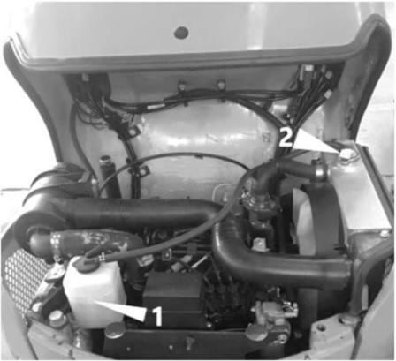
1. Open the engine hood.
2. Check the coolant level in the water tank
(1). The coolant level shall be within upper limit and lower limit. If below the lower limit, add coolant.
Adding
1. Take out the cap of water tank (1).
2. Add coolant, till the coolant level reaches
upper limit of water tank (1).
Upon detection of empty water tank (1)
during checking, check for presence of
water leakage and then check water level of radiator (2). When necessary, add water to the radiator (2) and then add water to
the water tank (1).
3. Install the cap (1).
Note: Add clean water (soft water) only to
compensate the lost coolant due to evaporation. Add the coolant (antifreeze) and clean water
(soft water) of specified mixing ratio only to

5-17

Maintenance
Daily routine checking (Every 10h)

compensate the lost coolant due to leakage. Checking and adding of engine oil

ΔWarning

Please stop the engine and wait for the
machine to cool down before maintenance. .
Checking

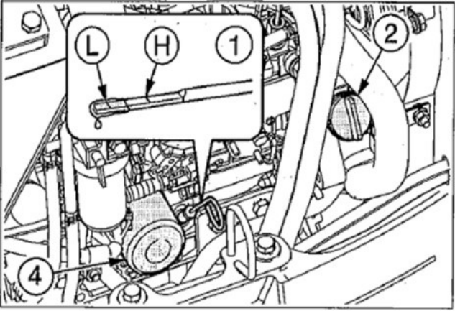
1. Open the engine hood.
2. Withdraw the engine oil dipstick (1) and
wipe it dry by a rag.
3. Insert the oil dipstick (1) to the end and
then withdraw again.
4. Check the oil on the oil dipstick (1). The
oil level shall be within upper limit and
lower limit. If below the lower limit, add oil.
Adding
1. Take out the oil filler cap (2).
2. Add oil till the oil level is within upper
limit and lower limit of oil dipstick (1). Both excessive and insufficient oil levels will cause malfunction.

3. Tighten the oil filler cap (2).
4. Start the engine, run at low idling speed
for 5min, and then stop the engine.
5. Check the oil level after approximately
10min.
Checking of fuel level

ΔWarning

● Do not smoke or use open fire while handling fuel or performing the
operations of fuel system.
● Do not disassemble the fuel tank cap or refuel while the engine is running or is not cooled down. Do not splash fuel to any high temperature surface of
machine.
● Refuel the fuel tank in a well-ventilated place.
● Any overflown fuel shall be wiped away immediately.
● Do not top up the fuel tank. Leave an expansion space for the fuel.
● Tighten the fuel tank cap securely.
● Use correct fuel grade based on the
season.

5-18

Maintenance
Daily routine checking (Every 10h)

Add fuel
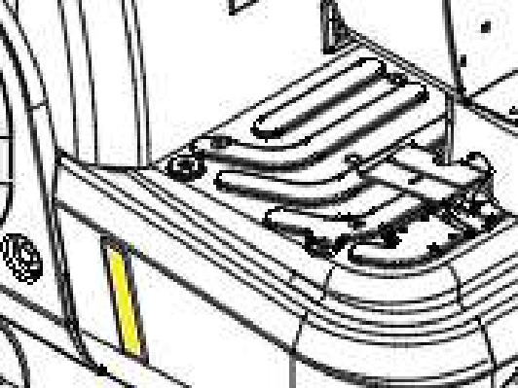
1. Check the fuel level by fuel gauge .
2. If the fuel level is low, open the fuel tank
cap and add fuel.
Checking of hydraulic oil tank oil level and adding of oil

ΔWarning

Disassembling cap or filter or disconnecting pipeline before the pressure relief of
hydraulic system will probably result in out- spray of hydraulic oil.
● Slowly loosen the ventilation plug to relieve the internal pressure of tank.

Checking
The oil level varies along with the oil
temperature. Maintain the machine and check the fuel status by the posture shown in the
diagram below.
● Posture of machine for checking of hydraulic oil level

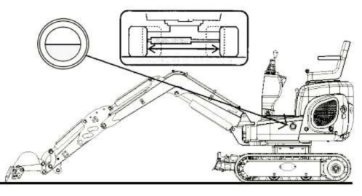
1. Start the engine and run at low speed.
2. Fully extend the track width.
3. Fully retract the cylinders (Bucket arm and
bucket cylinders) and lower the bucket onto the ground.
4. Lower the bulldozing blade and then stop
the engine.
5. Check the oil level by level gauge.
When the oil temperature is approximately
20℃: The oil level shall be within upper limit and lower limit. If below the lower limit, add oil.
When the oil temperature is approximately
50~80℃: The oil level shall be slightly lower than upper limit.

5-19

Maintenance
Daily routine checking (Every 10h)
Add hydraulic oil Pressurization of Hydraulic Oil Tank

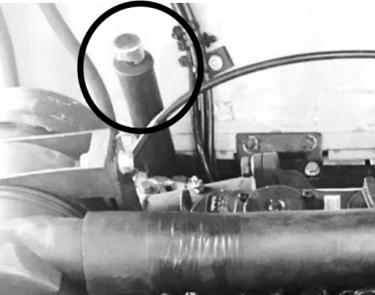
Important: While adding oil, the oil level shall not be above the upper limit. Otherwise it will damage the hydraulic circuit or cause oil spray. If the oil level is too high due to carelessness, stop the engine, wait for the hydraulic oil to
cool down, and drain the excessive oil from oil drainage port.
Important: Do not forget applying pressure to the hydraulic oil tank, in order to prevent the damage of pump due to air inhalation. (If no ventilator is installed.)
1. Open the engine hood.
2. Slowly loosen the bleeding plug (2) to
relieve the internal pressure and then take out the plug.
3. Add hydraulic oil, till the oil level is in the
middle of level gauge (1).
4. Pressurize the hydraulic oil tank as shown
in diagram below.

1. Start the engine and run at low speed.
2. Disassemble the bleeding plug (2) and set
the safety lock handle to unlocking position.
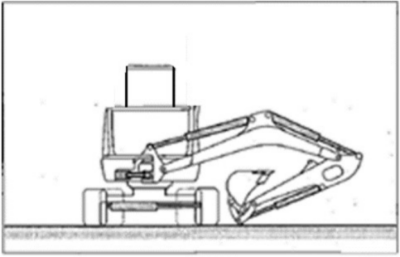

3. Fully extend the bucket, bucket arm, boom,
swing, and span cylinders.
4. Stop the engine and lift up the safety lock
handle to locking position.
5. Tighten the bleeding plug and then
pressurize by retracting cylinders.

Note: For machines equipped with a
ventilator, there is no need to pressurize.
5-20

Maintenance
Daily routine checking (Every 10h)
Lubrication of Working Device
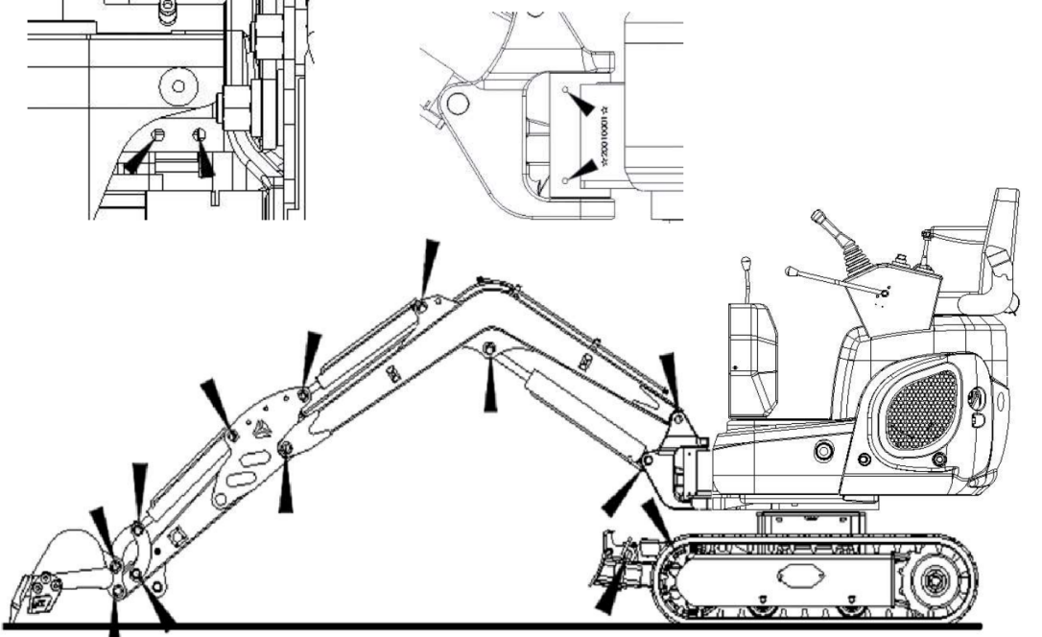
1. Maintain the machine under the status shown in above diagram, lower the working device to the
ground, and then stop the engine.
2. Lubricate the grease fitting by a grease gun.
3. Wipe away excessive grease.

5-21

Records

5-22

Maintenance
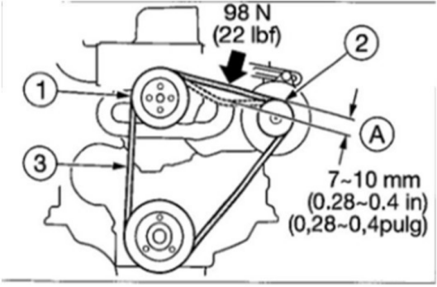
After first 50h(for new machine only)
After first 50h (For new machine only) Checking and adjustment of fan belt

Warning
Please stop the engine and wait for the
machine to cool down before maintenance. .
● The engine, exhaust pipe, radiator,
hydraulic pipes, sliding parts, and many

other machine parts are really hot when the engine is just stopped. Touching
such parts can cause scalding.

Important: A loose belt can cause poor
charging of battery, overheating of engine, or earlier wear of belt. The over-tight belt will damage the water pump or bearing and
alternator drive belt.
Important: Keep the belts away from all greases.
Checking
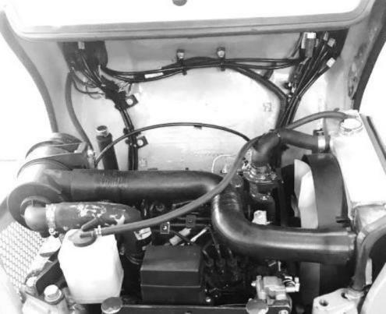
1. Lift up and open the machine
cover.

2. Check the tension (Approximately 98N)
based on the centers of fan pulley (1) and alternator pulley (2).
3. Check the fan belt (3). Upon detection of
any of following conditions, replace.
● Rupture or cracking.
● The belt is worn to touch the bottom of pulley V-grooves.
● The belt is stretched loosely and is non- adjustable.
Adjustment
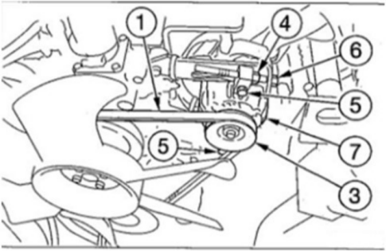
1. Loosen bolt (5) and lock nut (4).
2. Rotate the adjustment bolt (6) to move the

5-23

Maintenance
After first 50h(for new machine only)
alternator (7) and adjust the tension of fan belt (1).
Increase tension: Clockwise
Reduce tension: Counter-clockwise
3. Tighten bolt (5) and lock nut (4).
Note: After the replacement with new belt, run the engine at low idling speed for
approximately 3~5min to run in new belt and then adjust the tension.

Replacement of engine oil and filter Refer to page 5-30“Replacement of engine oil and filter ” .

5-24

Maintenance Every 50h

Maintenance Every 50h

Every 50h
Check and adjust track tension

ΔWarning
● If it’s necessary to operate beneath the lifted machine or working device,
always use cushion woods, jack, or
other firm and stable supports. Do not access the area beneath the machine or working device before it’s firmly
supported. This operation is especially important for the hydraulic cylinder operations.
● Guard against high pressure grease.
● In the track pensioner, the grease is
injected under high pressure. If the
tension is not adjusted by the following designated procedure, the grease relief valve will probably fly out to cause
injuries.
● Never loosen the grease pipe fittings.
● Slowly loosen the grease relief valve. Do not rotate it for >1 turn.
● Do not place your face, arms, legs, or body in front of the grease relief valve.
● If no grease flows out when the grease relief valve is loosened, the valve is
malfunctioned. Please contact a Ken stone Heavy Machinery service dealer for repairs.

Checking
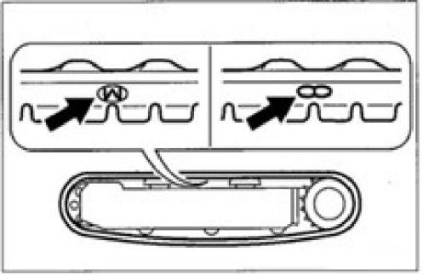

1. For rubber tracks, adjust the marking “M” at
the joints to the top center of track frame.
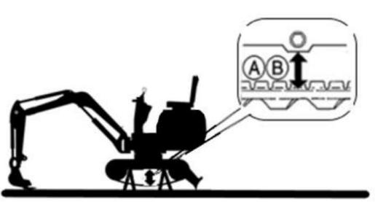
2. Lift the machine body by working device.
Slowly operate the joysticks.

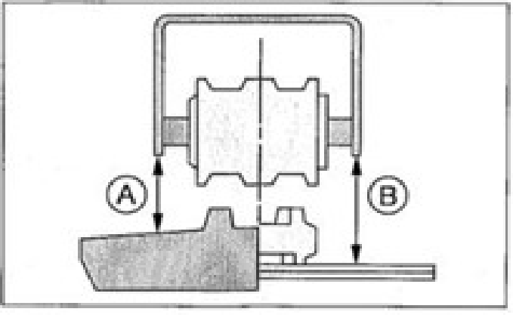

5-25

Maintenance Every 50h

3. Check the clearance (A or B) between the
frame bottom face and track top face in the middle of track frame. The clearance (A or
B) shall be within following range: (A)Rubber tracks
59~64mm
(B)Steel tracks 95 to 110mm
Adjustment
Increasing of Tension
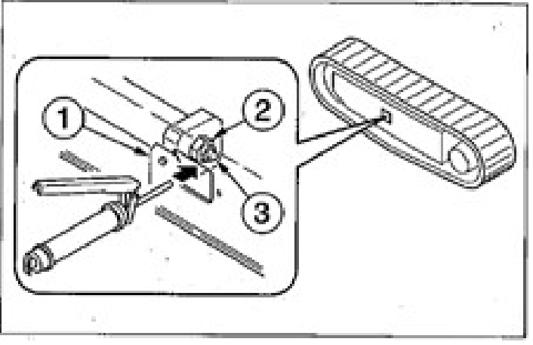
1. Take out the cover plate (1).
2. Use a grease gun to inject lubricating grease
via the grease fitting (3) of grease relief valve (2).
3. Check the track tension.

Reduce tension
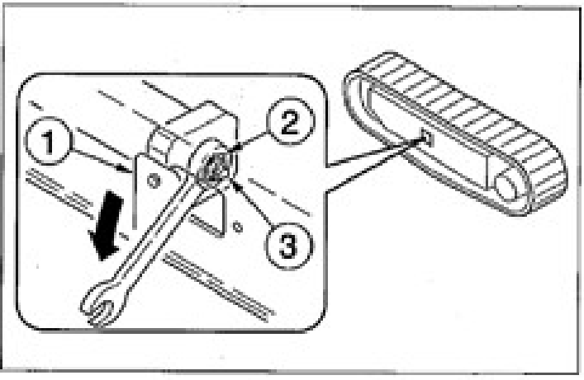
1. Remove the cover plate.
2. Slowly loosen (by one turn) the grease
relief valve (2) by a wrench to drain the grease. If it’s difficult to drain the grease, drive the machine back and forth.
3. Tighten the grease relief valve (2).
• Tightening torque: 177 N˙M

Lubricate slewing support and slewing motor gears

Δ Warning

Do not slew during lubrication. Otherwise, you will probably be entangled into the
machine, which is really dangerous.

5-26

Maintenance Every 50h

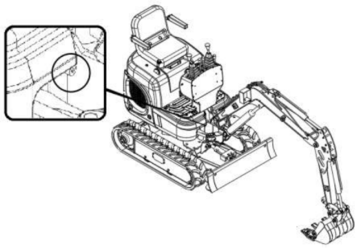

ΔWarning

1. Stop the machine as per the posture shown
in above diagram and stop the engine.
2. Lubricate the grease fitting by a grease
gun.
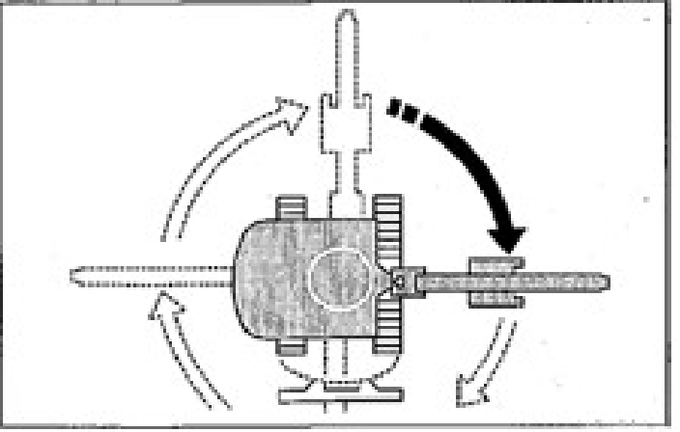
3. Start the engine, lift the bucket, and rotate
clockwise for 90°.
4. Lower the bucket onto the ground and then
stop the engine.
5. Repeat above steps 2~4 for 3 times.
6. Wipe away the grease drained from the
slewing bearing and grease pipe.

Water drainage from fuel tank

● Do not smoke or use open fire while handling fuel or performing the
operations of fuel system.
● Do not disassemble the fuel tank cap or refuel while the engine is running or is not cooled down. Do not splash fuel to any high temperature surface of
machine.
● Refuel the fuel tank in a well-ventilated place.
● Do not top up the fuel tank. Leave an expansion space for the fuel.
● Any overflown fuel shall be wiped away immediately.
● Tighten the fuel tank cap securely.
● Use correct fuel grade based on the season.
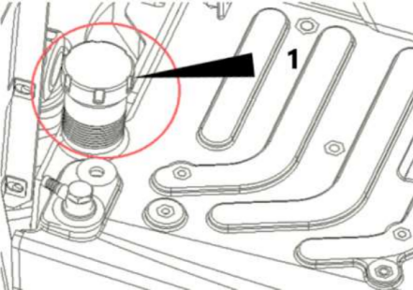

5-27

Maintenance Every 50h

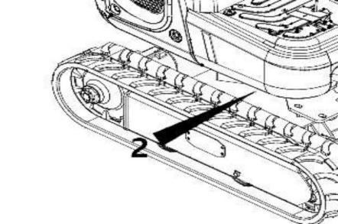
Start the machine only after draining.
1. Slew the upper frame to a position easy for
water drainage.
2. Lift up and open the hood, Take out the fuel
tank cap (1).
3. Place a box beneath the water drainage
plug (2).
4. Loosen the water drainage plug (2) to fully
drain the water and the deposits from the tank.
5. Tighten the water drainage plug (2).
6. Tighten and lock the fuel tank cap (1).
7. Exhaust air.
Air exhausting of Fuel System
Refer to page 6-8“Air exhausting from Fuel System ”.
Note: The air content in the fuel system will cause start failure or start difficulty of engine. Bleed the air by same procedure described
above when the fuel tank is empty.

Checking of battery electrolyte level and adding of electrolyte

Δ Danger

● Do not use the battery when the
electrolyte level is below the lower limit. Otherwise it will speed up the internal aging and shorten the life of battery. In addition, it can lead to burst (explosion).
● The battery can generate inflammable hydrogen to probably cause explosion. Keep away from fire sources including open fire, spark, and ignited cigarette.
● Clean the area above electrolyte level
marking by a wet cloth and check the
level. Do not clean by a dry cloth,
otherwise it can cause electrostatic
accumulation and combustion or explosion.

ΔWarning

● During the operations of battery, wear goggles and protective clothing.
● Do not fill the distilled water till the
level is above the upper limit. Otherwise the electrolyte will leak out. The contact with such electrolyte can harm your
skin or corrode the machine parts.
● The battery contains sulfur acid. The
accidental touch will harm your eyes or

5-28

Maintenance Every 50h

skin.
• In event of accidental contact with eyes, immediately flush by clean water and quickly seek for medical treatment.
• In event of accidental swallowing, drink a lot of water or milk and immediately seek for medical treatment.
• If the sulfur acid comes into contact with your skin or clothing, immediately flush by a lot of water.

Checking
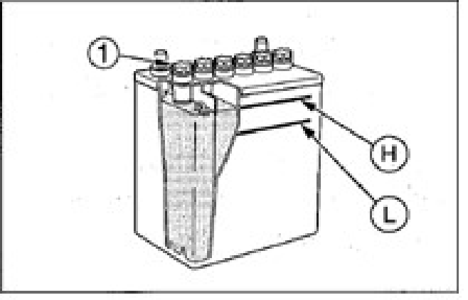
1. Open the maintenance cover.
2. Check the fluid level. The fluid level must
be between upper limit (H) and lower limit (L). If not, add distilled water till the fluid level reaches upper limit (H).
3. Check terminals for looseness and
contamination.

Adding
If the adding of distilled water is required, add water before start of operations, in order to
prevent freezing.
1. Take out the cap (1) and add distilled
water till the upper limit (H) is reached.
2. Clean the ventilation port on the cap and
securely tighten the cap (1).

5-29

Maintenance Every 250h

Every 250 hour
Checking and adjustment of fan belt Refer to page 5-23 “Checking and adjustment of fan belt ”.
Replacement of engine oil and filter

Warning

Please stop the engine and wait for the
machine to cool down before maintenance. .
● The engine, exhaust pipe, radiator,
hydraulic pipes, sliding parts, and many other machine parts are really hot when the engine is just stopped. Touching
such parts can cause scalding.
● The engine oil is really hot. Take
cautions not to touch the hydraulic oil while loosening engine hood or
connector. Operating the machine in such case will cause scalding and
injuries.

1. Open the engine hood and take out the oil
filler port (2).

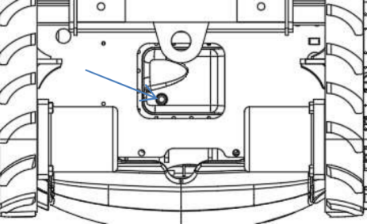

3
1. Open the engine cover and remove the fuel filler opening (2).
2.Place a tray under the drain plug (3) for the waste oil.
3.Remove the oil drain plug (3) to drain the oil. Important: Check for metal powder in the waste oil. If it
contains a large amount of metal powder, please consult your sales or service agent.
4.Press the oil drain plug (3) and tighten it with a wrench.
5.Use the oil filter wrench to turn the filter (4) counterclockwise to remove it.
6.Clean the installation surface of the filter housing.
7.Apply a small amount of oil to the gasket of the new filter.
8.Install the new filter manually.
9.After the filter gasket touches the mounting surface, tighten one more turn (use an oil
filter wrench). (Tightening torque with an

5-30

Maintenance Every 250h

oil filter wrench: 19.6 to 23.5N·m).
10. Add lubricating oil between the upper
limit (H) and lower limit (L) of the oil dipstick (1). If the oil level is too low or too high, it will cause problems.
11. Tighten the fuel filler cap.
12. Start the engine, run it at a low idle speed
for 5 minutes and turn off the engine.
13. After about 10 minutes, check the oil level. Cleaning of Air Filter

ΔWarning

● Please stop the engine and wait for the machine to cool down before
maintenance.
• The engine, exhaust pipe, radiator, and many other machine parts are really hot when the engine is just stopped.
Touching them will cause scalding.
● While using compressed air, please wear necessary protection appliances,
including goggles and filtration mask, as the metal fragments and other objects
will splash to cause accidents of serious harms.

Important: Take cautions not to scratch the filter element. Do not use any damaged filter element.

Important: During the operations under dusty environment, please daily fulfill the checking and maintenance for the machine.
Important: Ensure to steadily install the filter element and dust cover. Otherwise, the ingress of dusts into the cylinders will damage the
engine.
1. Open the engine hood.
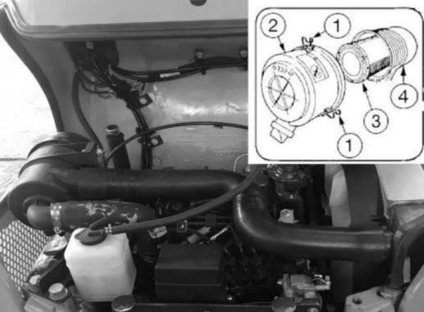
2. Loosen the clamp (1) and take out the dust
collector (2).
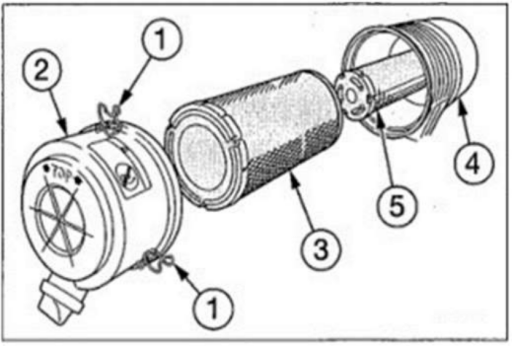
3. Clean the inside of dust collector (2).
4. Take out the primary filter element (3).
5. Cover the inlet and outlet on the back of

5-31

Maintenance Every 250h

body (4) by cloth or tape to guard against ingress of dusts.
<If the secondary filter element is installed>
To prevent the ingress of dusts into engine, do not take out the secondary filter element (5).
6. Clean the inside of housing (4).
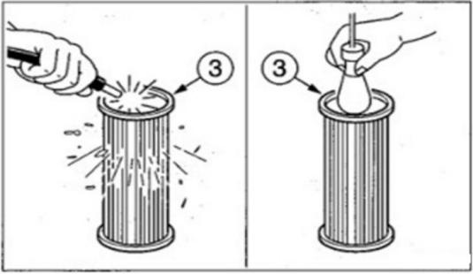
7. Clean primary filter element (3) by dry
compressed air (294~490kPa). Firstly,
blow along the wrinkles from the inside of filter element. Then blow from outside and finally blow from inside.
8. Illuminate the inside of primary filter
element (3) by a lamp to check. Upon detection of any pinhole or dirt, replace.
9. Remove the cloth or tape used in step 5.
10. Install the primary filter element (3).
11. Install the dust collector (2) by facing
upward the “↑TOP↑” and then secure it by clamp (1).

Checking of accelerator control system
● The accelerator joystick and the speed
regulator on the engine side are connected by wiring. Check the wires at their fixing positions for presence of stretching and
looseness.
● If the wires at their fixing positions are stretched or loose, there probably has a malfunction.
● The replacement and adjustment of wires
require experiences. Please ask your sales or service dealer for operations.
Cleaning of radiator fins and oil cooler
ΔWarning
While using compressed air, please wear necessary protection appliances, including goggles and filtration mask, as the metal fragments and other objects will splash to cause accidents of serious harms.

Important: Take cautions not to damage the radiator fins during cleaning.
● While using compressed air or high
pressure water, ensure that the pressure is no higher than 200kPa and keep the air nozzle from the radiator for a
sufficient spacing.
Important: While cleaning by water, please cover the electric system against water

5-32

Maintenance Every 250h

ingress.
Important: During the operations under dusty environment, please daily fulfill the checking and maintenance for the machine.

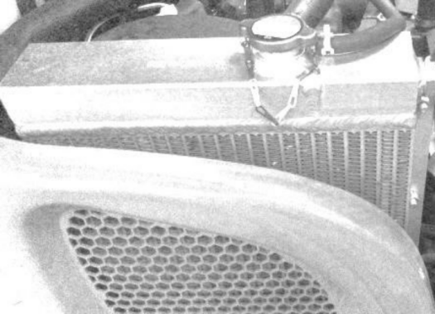
1. Open the engine cover..
2. Blow compressed air towards the radiator
fins to remove the adhered dusts and mud. Replacement of Fuel Filter

ΔWarning

● Do not smoke or use open fire while handling fuel or performing the
operations of fuel system.
● Stop the engine in a well-ventilated
place and wait for the machine to cool down before maintenance.
● Any overflown fuel shall be wiped away immediately.

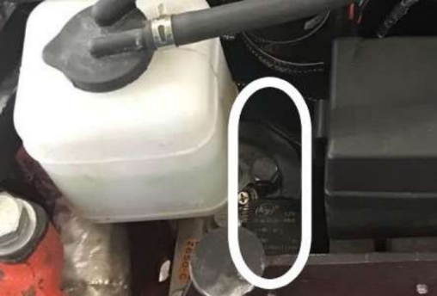

1
1. Open the engine hood.
2. Rotate the filter (1) counter-clockwise by a
filter wrench to take it out.
3. Clean the mounting surfaces of filter
housing.
4. Apply a thin film of fuel to the washer of
new filter housing.
5. Manually install new filter.
6. After the filter washer comes into contact
with the mounting surface, tighten the filter further for one turn.
(Tightening torque by filter wrench:
20~24N.m).
7. Exhaust the air.
Refer to page 6-8“Air Exhausting from Fuel System ”.

5-33

Records

5-34

Maintenance
Every 1000h

Every 1000h
Replace the air filter

ΔWarning

Please stop the engine and wait for the
machine to cool down before maintenance. .
● The engine, exhaust pipe, radiator, and many other machine parts are really hot when the engine is just stopped.
Touching such parts can cause scalding.

Important: Do not use a wrinkled filter element or a filter element with damaged washer or seal ring.
Important: Ensure to steadily install the filter element and dust cover. Otherwise, the ingress of dusts into the cylinders will damage the
engine.
1. Open the engine hood.
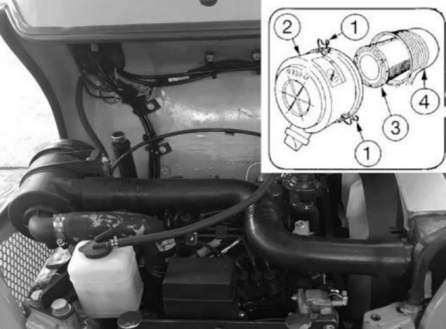
2. Loosen the clamp (1) and take out the dust
collector (2).
3. Clean the inside of dust collector (2).

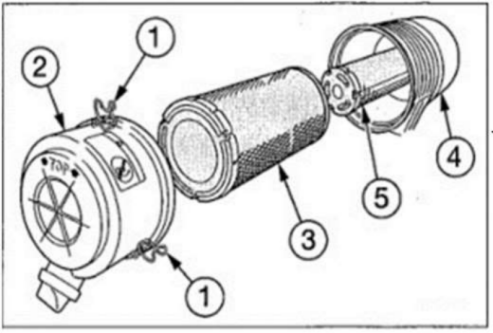
4. Take out the primary filter element (3).
5. Cover the inlet and outlet on the back of body (4) by cloth or tape to guard against ingress of dusts.
6. Clean the inside of housing (4).
7. Remove the cloth or tape used in step 5.
8. Install new filter element.
9. Install the dust collector (2) by facing
upward the “↑TOP↑” and then secure it by clamp (1).

Checking and Adjustment of Engine Valve Clearance
These operations require experiences. Please ask your sales or service dealer for operations.

5-35

Maintenance
Every 1000h

Cleaning of Engine Cooling System

ΔWarning

● Please stop the engine and wait for the machine to cool down before
maintenance. .
• The engine, exhaust pipe, radiator, and many other machine parts are really hot when the engine is just stopped.
Touching such parts can cause scalding.
• The engine coolant is also under high
temperature and high pressure when
the engine is just stopped. Take special cautions while loosening the cap or plug. Operating the machine in such case will cause scalding and injuries by splashing high temperature coolant.
● If the maintenance requires the running of engine, assign two operators for
teamwork and keep contact with each other.
• One operator must sit in the driver seat to get ready to stop the engine
immediately when necessary. This
operator must pay special attention not to touch any joystick or pedal, unless it’s absolutely necessary.
• The other operator for the maintenance must keep the body and clothing away from motion parts of machine.

● While the engine is running, it’s really dangerous standing behind the machine, as the machine probably moves
suddenly. While the engine is running, never stand behind the machine.
● Do not disassemble the radiator cap or drainage plug when the coolant is hot.
Stop the engine, wait for the engine and radiator to cool down, and then slowly loosen and take out the radiator cap and drainage plug.

During cleaning, if the coolant temperature is low, the thermostat will be closed and the
coolant will not flow within the radiator. Before cleaning, heat up the coolant to at least 90℃ .
1. Open the engine hood.
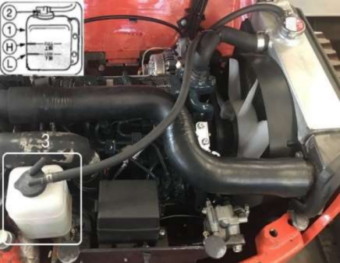
2. Slowly loosen the radiator cap (3) to relieve
the internal pressure and then take out the cap.

5-36

Maintenance
Every 1000h

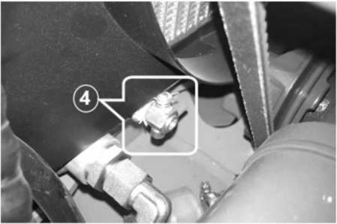
3. Place a tray beneath the water drainage
plug (4) to collect the used coolant and
then loosen the water drainage plug (4) to drain the coolant.
4. Tighten the water drainage plug (4).
5. Add running water through the water filler port into the radiator, till the water level
reaches the top of filler port. Add the water slowly and easily to prevent the ingress of air into radiator.
6. Install the radiator cap (3).
7. Start the engine and run the engine at a
speed slightly higher than the low idling speed. Heat up the water temperature to at least 90℃, open the thermostat, and then run the engine for approximately 10min.
8. Stop the engine, wait for the coolant to
cool down, and then take out the drainage plug (4) to drain the water.
9. After water drainage, clean the cooling
system by detergent. Use the detergent as per the attached operation instructions of

the detergent.
10. Repeat steps 4~8 to clean the cooling
system.
11. Tighten the water drainage plug (4).
12. Add new coolant (Mixture of antifreeze
and running water) through filler port to
the radiator, till the radiator is full. Add the coolant slowly and easily.
13. Install the radiator cap (3).
14. Warm up the engine. Use instruments to
check the cooling system for presence of abnormality.
15. Increase the water temperature to at least
90℃ . Then, open the thermostat and run the engine for approximately 10min.
16. Stop the engine, wait for the coolant to
cool down, and then check the coolant level in the radiator.
17. Install the radiator cap (3).
18. Clean the inside of water tank (1) and add
coolant, till the water level reaches upper limit (H).
19. If the coolant is replaced, re-check the
coolant level after the operations of machine.
Once the machine starts operations, the coolant is distributed to the whole system so that the coolant level drops.
Add the coolant to compensate the consumed coolant.

5-37

Records

5-38

Maintenance
Every 1500h
Every 1500-hour
Checking and Cleaning of Engine Fuel Injector Nozzles
These operations require experiences. Please ask your sales or service dealer for operations.

Checking of Crankcase Ventilation Hole System
These operations require experiences. Please ask your sales or service dealer for operations.

5-39

Maintenance
Every 2000h

Every 2000h
Connection of Engine Valve Seats
These operations require experiences.Please ask your sales or service dealer for operations.
Replacement of Hydraulic Oil and
Cleaning of Oil Suction Filter Screen

ΔWarning

● Please stop the engine and wait for the machine to cool down before
maintenance. .
• The engine, hydraulic system and most of parts are very hot when the engine stalls. You may get scalded if you touch them.
• The hydraulic oil is also under high
temperature and high pressure. Take
cautions not to touch the hydraulic oil
while loosening engine hood or
connector. Operating the machine under such condition will cause out-spray of
hot oil to result in scalding and
● Disassembling cap or filter or
disconnecting pipeline before the
pressure relief of hydraulic system will probably result in out-spray of
hydraulic oil.
• Slowly loosen the bleeding plug to relieve the pressure of oil tank.

• While disassembling connector or plug or disconnecting hose, stand on one side, loosen slowly to gradually relieve
internal pressure, and then take out.

1. Adjust the machine to the hydraulic oil
level checking status.
Refer to page 5-19“Checking of hydraulic oil tank oil level and adding of oil ”.
2. Lift up the safety lock handle to the
locking position.
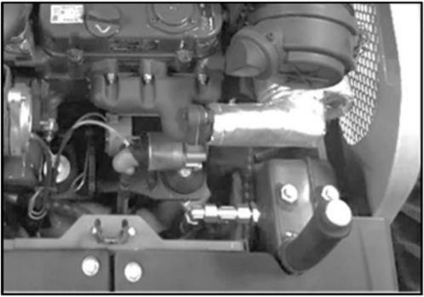
3. Lift up and open the engine cover.
4. Slowly loosen the air plug (7) to reduce the internal pressure, and then lower the plug.
5. Place a tray under the drain plug (3) for waste oil.
6. Loosen the oil plug (3) and drain the hydraulic oil.
7. Loosen the hose strap and remove the hose from the flange (1).
8. Loosen the bolts and take out the flange (1).

5-40

Maintenance
Every 2000h

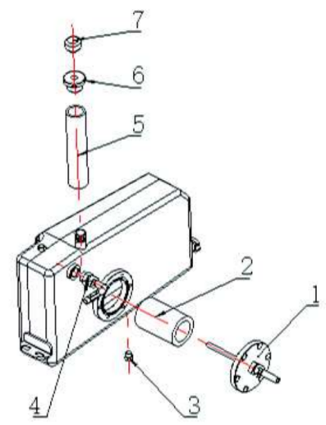
9. Loosen the bolt, remove the suction filter element (2), and clean it.
10. Clean the inside of the hydraulic oil tank. 11. Replace the bleed plug (7) (if equipped). 12. Install the suction filter element (2) on the flange (1).
13. Install the flange (1) back to its original position.
14. Tighten the oil drain plug (3).
15. Remove the rubber plug (6).
16. Fill the rubber tube (5) with hydraulic oil to the center of the round oil mark.
17. Install the hose back to the original position of the flange (1) and tighten it.
18. Pressurized hydraulic oil tank. (If not equipped with a breather, please refer to
"Pressurized Hydraulic Oil Tank" on page 5-20)

19. Install the rubber plug (6), and then install the bleed plug (7).
20. Exhaust the air from the hydraulic oil circuit as described in the "Exhaust" section below.
21. Adjust the machine to the hydraulic oil level check posture, and check the oil level after the oil temperature drops.
(For details, please refer to "Checking of
hydraulic oil tank oil level and adding of oil " on page 5-19)
Air Exhausting
Important: After the replacement of hydraulic oil, bleed the air from hydraulic pipelines and hydraulic devices. Otherwise, the hydraulic
devices will probably be damaged.
Cylinders
1. Start the engine and run at low idling
speed for 10min.
2. Keep the engine running at low idling
speed, extend and retract all cylinders for 4~5 times, but take caution not to
telescope any cylinder to the end.
3. Run the engine at high speed, extend and retract all cylinders for 4~5 times, but take caution not to telescope any cylinder to the end.
4. Restore the engine to low idling speed,
extend and retract all cylinders for 4~5 times, and always telescope to the end.

5-41

Maintenance
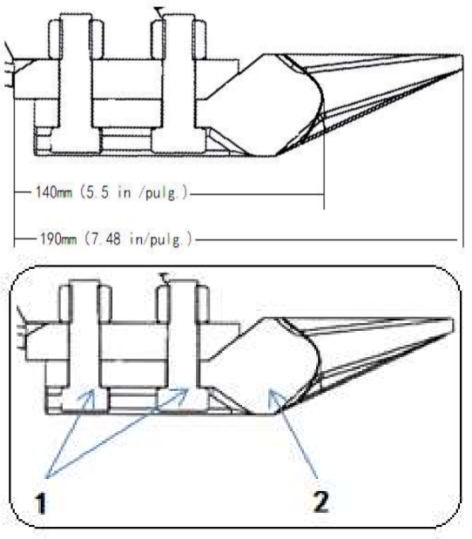
As Necessary
As necessary
Replace bucket teeth
Replace the bucket teeth when the tooth sleeves are worn. Do not wait for the bucket to be
damaged before replacement.

Warning
● Before the maintenance or repairs
beneath the machine, lower all movable working devices onto the ground or
lowest position.
● During the repairs and replacements of bucket teeth or side teeth, to prevent the accidental movement of machine,

securely fix the working device.
• During the use of hammer, the pins and the metal fragments will probably fly out. It
will probably cause serious personal harms.
• While hammering hard metal parts such as tooth pins, bucket teeth, side teeth, and
bearings, please wear protective articles including goggles and gloves.
• While hammering tooth pins and bucket teeth, ensure there is no person in
surrounding area.
● During operations, the non-authorized
personnel are prohibited to access the
working zone.

If the teeth are worn down to 140 mm, replace them.
Disassemble
1. Clean the bucket and park the machine on a flat, firm and safe ground.
2. Lay the bottom of the bucket flat, and pad the bottom with spacers to take out the bolts (1).
3. Remove the starting key, and then check whether the bucket is stable.
4. Remove the bolt (1).
5. Replace the bucket teeth (2).

Installation
1. Clean the area for installation of bucket

5-42

Maintenance
As Necessary

tooth. If there is any soil or mud in this area, the bucket tooth and tooth sleeve probably can’t be inserted completely.
2. Place the bucket tooth into the bucket.
3. If the bucket toothis insecure, please insert a shim to reduce the gap.
4. Insert the bolt from outer side of bucket
and tighten by nut.
• Tightening torque: 102 N.m.
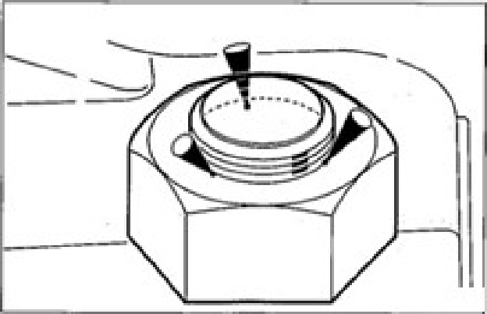

5. Rivet the bolt by a press or perform three-
point welding at the threaded portion (Nut end).
Replacement of Bucket

ΔWarning

● Before the maintenance or repairs
beneath the machine, lower all working devices onto the ground or lowest
position.
● If the maintenance requires the running of engine, assign two operators for
teamwork and keep contact with each

other.
• One operator must sit in the driver seat to get ready to stop the engine
immediately when necessary. This
operator must pay special attention not to touch any joystick or pedal, unless it’s absolutely necessary.
• The other operator for the maintenance must keep the body and clothing away from motion parts of machine.
● During the use of hammer, the pins and the metal fragments will probably fly out. It will probably cause serious
personal harms.
• While hammering hard metal parts such as tooth pins, bucket teeth, side teeth, and bearings, please wear
protective articles including goggles and gloves.
• While hammering tooth pins and bucket teeth, ensure there is no person in
surrounding area.
● While aligning pinholes, always check
by visual observation. Do not insert your finger into pinholes, otherwise
your finger will probably be lost.

5-43

Maintenance
As Necessary

Disassembling

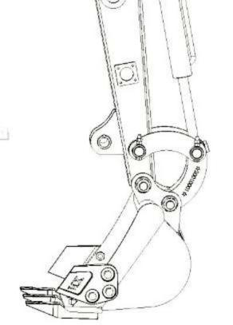
1. Lower the bucket steadily onto the ground as
shown in above diagram.
Note: While disassembling the tooth pin, adjust the bucket position in such manner that the
bucket barely comes into contact with the
ground. If the bucket is steadily on the ground, the resistance will be really high so that it’s
difficult to disassemble the tooth pin.
2. Place the safety lock handle to locking
position and stop the engine.
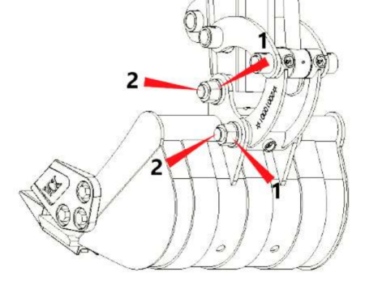
3. Unfasten the fastening nut (1) and remove it.
4. Use a hammer to knock the tooth pin (2) off
the bucket.
5. Remove the bucket.

Installation

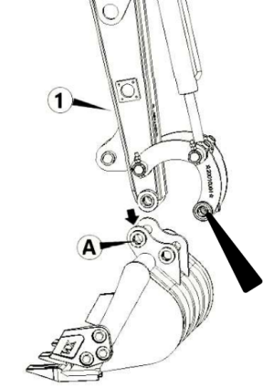
②
Ⓑ
1. Align the pin hole (A) on the bucket with
the pin hole on the stick ①, install the tooth pin and the fastening nut.
2. 2. Operate the cylinder, align the pin hole
(B) on the bucket with the pin hole on the connecting rod ②, and install the tooth pin and the fastening nut.

Lubrication of Joysticks

Warning
Adjust the machine to stop status, stop the engine, and withdraw and properly preserve the starter key. Otherwise, the machine will probably move suddenly to cause serious
injuries or deaths.

In event of inflexible operation of any joystick, please add oil for lubrication.

5-44

Maintenance
As Necessary
Joysticks

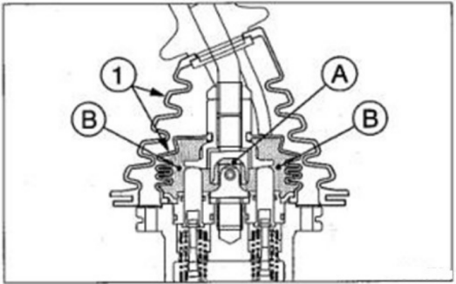

1.Remove the lower base part of the sheath (1)
and turn it up.
2.Wipe off the old grease.
3.Spray grease to points (A) and (B). 4.Put the sheath (1) back in place.

5-44

Maintenance
As Necessary

Checking of Rubber Tracks · If the status of rubber tracks is as shown in the diagram below, please repair or replace. For detailed repair or replacement, please consult with your sales or service dealer.
Rubber Tracks
If any track is stretched and non-adjustable, please replace the track.
(1) Rubber bump
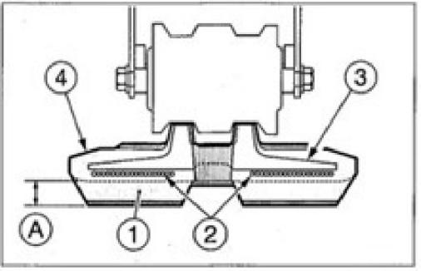
If the height (A) is ≤5mm, replace.
(2) Wire rope
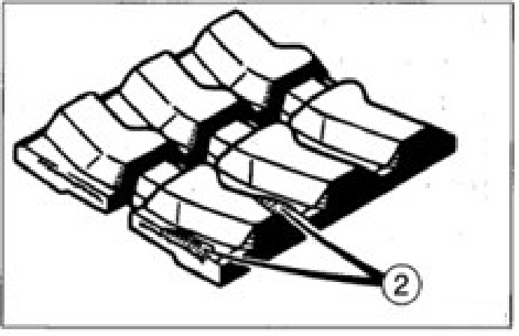

If two or more segments of the wire rope are exposed, please replace.
If more than half of the side face of wire rope is cut, please replace.
(3) Metal core
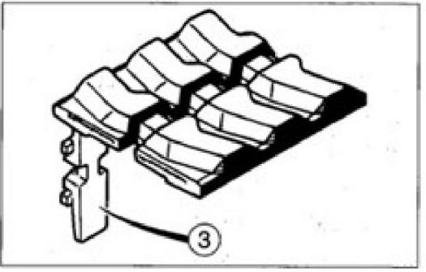

Replace even if only one metal core falls off.
(4) Rubber
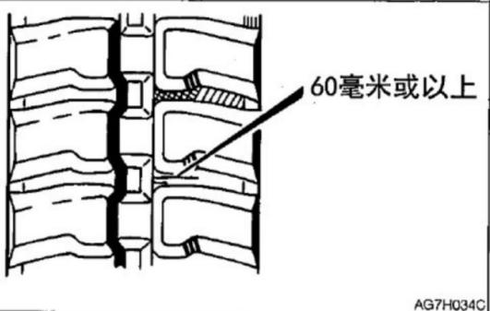
If the cracking length is ≥60mm, repair. If the wire rope is visible, repair as soon as possible, regardless of the cracking length.
≥60mm

5-45

Maintenance
As Necessary

Replacement of Rubber Tracks

Δ Warning
● If it’s necessary to operate beneath the
lifted machine or working device,
always use cushion woods, jack, or other · firm and stable supports. Do not access the area beneath the machine or
working device before it’s firmly supported.
● If the maintenance requires the running of engine, assign two operators for
teamwork and keep contact with each other.
• One operator must sit in the driver seat to get ready to stop the engine
immediately when necessary. This
operator must pay special attention not to touch any joystick or pedal, unless it’s absolutely necessary.
• The other operator for the maintenance must keep the body and clothing away from motion parts of machine.

Disassembling
1. Completely loosen the tension of rubber
tracks.
Refer to page 5-25 “Check and adjust track tension” .

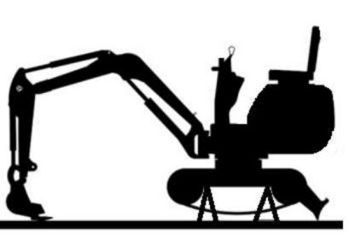

2. Lift the machine body by working device.

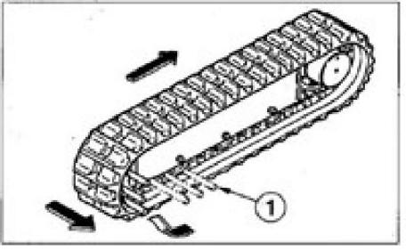

3. Place a steel tube (1) in the rubber track
and rotate the sprocket slowly towards opposite direction.
4. Rotate the sprocket till the steel tube (1)
closes to the pensioner and the rubber track is lifted off the pensioner and then stop the rotation of sprocket.
5. Laterally slide the rubber track to take out
it from track frame. Take out the other rubber track by same procedure.

5-46

Maintenance
As Necessary
Installation
1. Lift the machine body by working device.
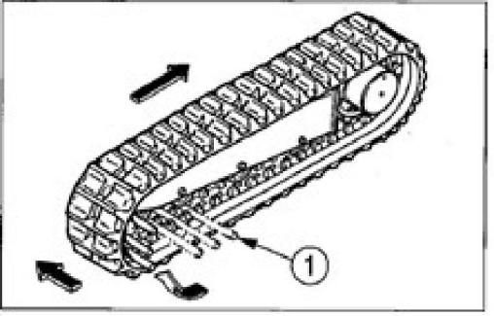

2. Place rubber track on the sprocket.
3. Place a steel tube (1) in the rubber track and rotate the sprocket slowly towards opposite direction.
4. Rotate the sprocket till the steel tube (1)
closes to the pensioner and the rubber track is lifted off the pensioner and then stop the rotation of sprocket.
5. Slide inward the rubber track to install it
onto the pensioner and then pull out the steel tube.
6. Check rubber track for secure installation
on sprocket and pensioner.
7. Tension the rubber track to standard
tension.
Refer to the “Checking and adjustment of track tension” in page 5-25 for details.
8. Install the other rubber track by same
procedure.
5-47

Maintenance
Maintenance during Long-Time Parking

Maintenance during Long- Time Parking
Parking Procedure
If it’s necessary to park the machine for ≥30 days, please park the machine indoors. If it’s necessary to park outdoors, please park the
machine on a wood-paved level ground and cover the machine by water-proof cap to keep
dry.
1. Clean the machine.
2. Check for oil/water leakage and cracking
and check for any loose nut or bolt.
3. Refuel and replace hydraulic oil and
lubricating oil.
4. To prevent rusting and freezing, replace
the engine coolant with long-life coolant (LLC).
Refer to page 5-35 “Cleaning of radiator fins and oil cooler fins” .
5. Lubricate the grease fitting by a grease
gun.
6. Fully retract the bucket and bucket arm
cylinders and lower the bucket and bulldozing blade onto the ground.
7. Apply anti-rusting oil to the hydraulic
cylinders.
8. Disconnect the negative cable of battery
and cover the battery to guard against freezing.

During Parking

ΔWarning

● Do not operate the machine in an
enclosed place with poor ventilation.
● If the natural ventilation is not possible, install ventilation fan, fan, extended
exhaust pipe, or other ventilation device.

1. To prevent rusting, operate the machine
once a month to circulate the oil throughout whole system.
2. Check the battery and when necessary
charge the battery. Please ask your sales or service dealer for charging.
Start of Machine after Parking
Important: If the above-mentioned
“Parking procedure” is not followed during the long-time parking of machine, please consult
with your sales or service dealer before restarting the machine.
1. Wipe away the lubricating oil from the
piston rods of the hydraulic cylinders.
2. When necessary, add lubricating oil or
grease.
Reuse of Engine
1. Fulfill the daily checking.
2. Pte-lubricate the engine before start.
a. Crank the engine for 15s and notice to
keep the fuel system closed to prevent start of engine.

5-48

Maintenance
Maintenance during Long-Time Parking

b. Stop for 30s.
c. Repeat this procedure, till the engine is already cranked for 1min in total. This can enable the sufficient oil
circulation throughout the lubrication system of engine.
2. Get ready the fuel system.
3. Start the engine. Idle the engine for
approximately 15min and then:
• Check for normal oil pressure.
• Check for leakage of fuel, engine oil, and coolant and check indicator lamps and/or level gauge for normal functioning.
5. Avoid operating for a long time at minimum or maximum engine speed or operating the loaded residue within the first loading
hour.

5-49

Troubleshooting 

6-1

Troubleshooting
Symptoms that are not malfunctions

Symptoms that are not malfunctions
The following symptoms are not malfunctions. ·
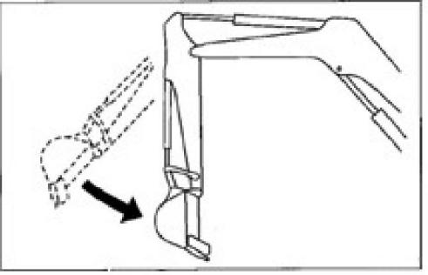
● With engine running at low speed, when the arm reaches a nearly vertical position, its retraction speed will drop shortly.

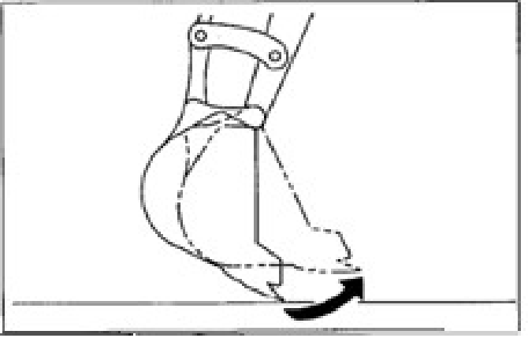
● With engine running at low speed, when the bucket teeth reach a nearly horizontal
position, its movement speed will drop shortly.
● A noise of slewing motor can be heard at the start and end of slewing.

● A noise of traveling motor can be heard when the machine stops suddenly during high speed traveling.
● A noise of control valve can be heard when the working device is subject to excessive external force or moves to the end of travel.
● The operations of the machine are more labor some when an attachment heavier than the standard bucket arm or bucket is installed.



6-2

Troubleshooting
Engine Overheating

Engine Overheating

ΔWarning

● If the steam overflows from the engine, do not open the engine hood or machine hood. The steam or hot water will
probably spray out to cause scalding.
● Do not disassemble the radiator cap or drainage plug when the coolant is hot. Stop the engine, wait for the engine and radiator to cool down, and then slowly loosen the radiator cap to relieve the
internal pressure.
● Please stop the engine and wait for the machine to cool down before
maintenance.

The following symptoms indicate overheating.
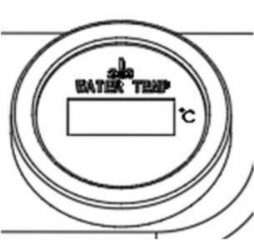
● Engine water temperature should be <105℃
● Steam came out of the engine room.

Remedy procedure
1.Park the machine on a safe place.
2.Check whether the steam overflows from the closed engine hood or machine hood. 3.If the steam overflows from engine
compartment, immediately stop the engine and contact your sales or service dealer for repair. If no steam overflows, run the
engine at low idling speed to cool down the coolant.
4.When the water temperature is less than 105°C, turn off the engine.
5.After the engine cools down,
immediately take the following checking and remedy measures.
Loose fan belt … Refer to page 5-23 for adjustment.
Low coolant level … Refer to page 5-17 for adding of coolant.
Water leakage … Repair.
Dirty radiator fins … Refer to page 5-32 for cleaning.
Deposits in cooling system … Refer to page 5-36 for cleaning.
If the malfunction still exists after the above- mentioned remedy procedures are taken, please contact your sales or service dealers for repairs.

6-3

Troubleshooting
No Battery Power

No Battery Power
The following symptoms indicate no battery
power.
● No rotation of starter motor or start failure of engine.
● Low volume of horn.
Remedy procedure
Start the engine by the booster battery on other machine (booster machine) and jumper cable.

ΔWarning

● To start the engine by jumper cable,
ensure to connect the cable by correct procedure. The improper use of jumper cable will result in battery explosion or unexpected machine motions.
• The booster machine and the machine with depleted battery are prohibited for mutual contact.
• The positive (+) and negative (-) clamps of the jumper cable are prohibited for mutual contact.
• During connection, firstly connect the jumper cable to positive (+) terminal.
During disconnection, firstly disconnect the cable from negative (-) terminal.
• Connect the last clamp of jumper cable to a point as far as possible from the
battery.

cable to start engine.

Important: The jumper cable and clamps in use shall be suitable to the battery capacity. Do not use any damaged or corroded jumper cable or
clamp.
Important: Ensure the same capacity for the battery on the rescue machine and the battery on malfunctioned machine.
Important: Ensure to connect the cable clamps securely.
Connection of Jumper Cable
Important: Place the starter keys of both
rescue machine and malfunctioned machine to
OFF.
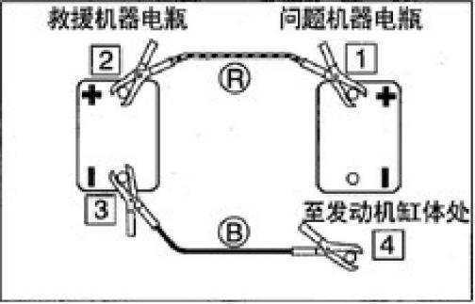
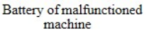
To engine block
1. Connect a clamp of jumper cable (R) to
the positive (+) pole of malfunctioned machine.
2. Connect the other jumper cable clamp (R)
to the booster (+).
3. Connect the jumper cable clamp (B) to the
charger (-).

● Always wear goggles while using jumper 4. Connect the other clamp of jumper cable
6-4

Troubleshooting
No Battery Power

(B) to the engine support of the
malfunctioned machine. Connect the
clamp to a point as far as possible from the battery.
After Start of Engine
1. Check and ensure that the wire clamps are
already connected securely to various terminals.
2. Start the engine of rescue machine and run
it at high speed.
3. Start the engine of the malfunctioned
machine.
Disconnection of Jumper Cable
After the successful start of the engine of
malfunctioned machine, disconnect the jumper cable in reverse sequence of the connection
procedure.
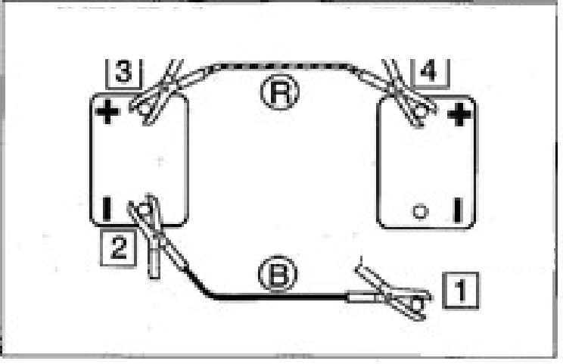

Battery of rescue Battery of malfunctioned
machine machine

To engine block

from the charger (-).
3. Disconnect the jumper cable (R) clamp
from the charger (+).
4. Disconnect the jumper cable clamp (R)
from the uncharged machine (+).
Recharging
Please ask your sales or service dealer to recharge the depleted battery.

1. Disconnect the clamp of jumper cable (B)
from the engine support of malfunctioned machine.
2. Disconnect the other jumper cable (B)
6-5

Troubleshooting
Burnout of Fuse

Burnout of Fuse
If a lamp fails to turn on or the electronic
system fails to work, the fuse is probably burnt. Check the fuse.
Checking and Replacement of Fuses

ΔWarning

If a fuse is burnt again shortly after
replacement, the electronic system is
probably malfunctioned. The improper
repair will probably cause fire danger. If the consultation is required, please contact your sales or service dealer.

1. Rotate the starter key to OFF to stop the
engine.
2. Open the engine hood.

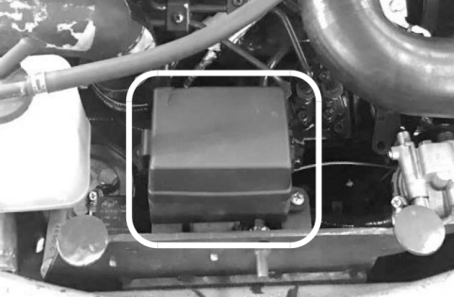

1. Open the fuse case cover (1).
2. Check fuses for burnout.

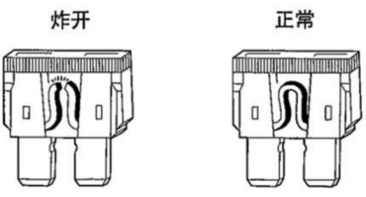
Normal
Burnout

3. If a fuse is burnt, please replace with spare
fuse of same specification.
Layout and protected circuits of fuses

Current | Circuit
20A | Rectifier
30A | Start signal
30A | Electric lock/preheat relay
10A | Working lamp
30A | Spare
10A | Spare

Current | name
12V60A | NO backup relay
12V60A | NO start relay
12V40A | NO charge relay
12V40A | NO lamp relay

6-6

Troubleshooting
Burnout of Fuse

Checking of Fuses
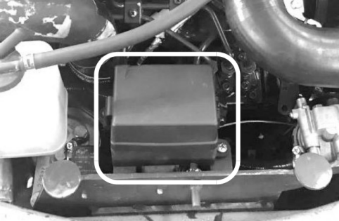
If the machine does not start after turning the start switch to the ON position, it may be that the starting power fuse has blown. Open the service cover and check. If the fuse has blown, please contact your sales or service agent.

Precautions for external
maintenance power supply

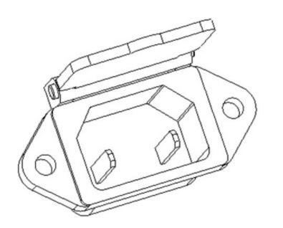

Note: The external power supply is
limited to 12V15A. Can not be charged.

Note: The fuse is a large fuse used in high
current applications. Like ordinary fuses, they function as fuses, protecting electrical
components and wiring from damage caused by excessive current.

6-7

Troubleshooting
Restart after Refueling

Restart after Refueling
Air exhausting from Fuel System
Important: Do not rotate the engine by starter motor to get ready the fuel system. This will probably cause overheating of starter motor to damage coil, pinion, and/or ring gear.
Important: If the engine stops due to shortage of fuel, please add fuel, rotate the key to ON for 60s, and then rotate it to START position.
Running the starter motor for a long time before the supply of sufficient fuel will cause start
failure of starter

2. Turn the starter key to the ON position and hold it for about 60 seconds..

Note: The air content in the fuel system will
cause start failure or other problems of engine. Ensure to exhaust when the fuel tank is empty or the fuel system contains air.

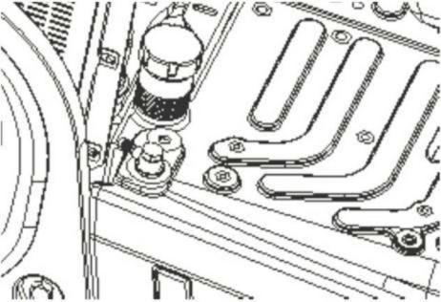
1. Add fuel.
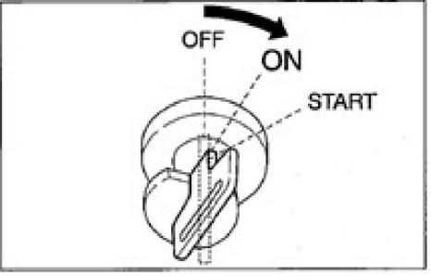

6-8

Troubleshooting
Flashing of Warning Lamps
Flashing of Warning Lamps
If a warning tone is heard or a warning lamp starts to flash during operations, park the machine in a safe place and take the following remedy measures.

Warning lamp | Lamp name | Cause and solution
 | Charging warning lamp | There is a problem with charging.  If the light continues to flash after maintenance, there may be a problem with the charger. If you need help, please consult your sales or service agent.
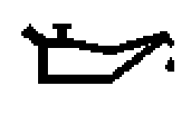 | Engine oil pressure indicator lamp | The engine lubrication system is internally malfunctioned.  Check the engine oil level.  If this lamp flashes when the oil level is normal or still flashes after adding of oil, please consult with your sales or service dealer.  Refer to page 5-18 “Checking and adding of engine oil  ”  .

6-9

Troubleshooting
Other Symptoms
Other Symptoms
For the symptoms not listed in table below or the further existed problems after appropriate solutions, please consult with your sales or service dealer.

Problem | Cause | Solutions
The left and right joysticks cannot move flexibly | ● Lack of grease on left and right joysticks | ● Lubricate the joystick
Throttle lever cannot move flexibly | ● The throttle line is loose | ● Adjust or replace (consult your sales or service agent).
Bucket, slewing or walking operations cannot be performed | ● The safety lock lever has been raised  (locked)  ● The travel lock  adjustment is faulty | ● Lower (release) the safety lock lever. Please refer to page 2-11.  ● Adjust the walking lock (consult your sales or  service agent).
Not enough digging power | ● Hydraulic oil level is too low  ● The hydraulic oil is not hot enough  ● Air filter is clogged  ● Incorrect hydraulic oil type | ● Add to the  specified liquid level. Please  refer to page 5- 17.  ● Clean the air  filter. Please  refer to page 5- 27.  ● Replace  hydraulic oil. Please refer to page 5-34.
Unable to walk or inflexible | ● Stone or foreign object stuck | ● Remove foreign objects
The machine turns right/left | ● A stone or foreign object is stuck.  ● The track tension adjustment is faulty | ● Remove foreign objects  ● Adjust the track to the  specified tension. Please refer to page 5-21.

6-10

Troubleshooting
Other Symptoms

Problem | Cause | Solutions
Can't turn or turn inflexibly | ● Insufficient grease for slewing support | ● Lubricate the bearings Please refer to page 5-23
The hydraulic oil  temperature is too high | ● Hydraulic oil level is too low | ● Add to the  specified liquid level. Please refer to page 5-17
The starter motor rotates  but the engine does not  start | ● Insufficient fuel  ● There is air in the fuel system  ● Water in the fuel system | ● Add fuel. Please refer to page 5-16.  ● Exclude air. Please refer to pages 6-8.  ● Drain the water. Please refer to pages 5-24.
Tracks fall off | ● Tracks are too loose | ● Increase the tension. Please refer to page 5-21。
The engine emits black smoke from time to time | ● Air filter is clogged | ● Clean the air filter. Please refer to pages 5-27。
Engine exhausts white or blue smoke | ● Too much oil  ● Inferior fuel | ● Adjust to the  specified liquid level. Please refer to page 5-16.  ● Change the fuel.
The engine produces  irregular noise  (combustion or  mechanical noise) | ● Inferior fuel is being used | ● Replace the fuel
 | ● overheat of engine | For details, please refer to  "If the Engine Overheats" on page 6-3.
 | ● Internal damage of exhaust pipe | ● Replace the exhaust pipe. For replacement matters,  please consult your sales or service agent。

6-11

Troubleshooting Towing

Towing

ΔWarning

During towing, the improper operations, the incorrect use of rope, or the improper
checking will cause serious injuries or deaths.
● The breakage or disengagement of rope can cause danger. Use ropes compatible with the towing force.
● Do not use any kinked, twisted, or even damaged rope.
● Do not suddenly apply heavy load onto the rope.
● Please wear safety gloves during the handling of rope.
● Ensure that an operator is assigned each on the towing machine and the towed
machine.
● Do not operate the towing operation on a slope.
● Keep all personnel away from the rope during towing.

Important: Do not tow the machine when the engine is not started or the machine is not
running. Otherwise, the towed machine will probably be damaged.
Important: Please ensure to abide by the
following procedure when the machine is towed by traction hole. The negligence of any

of following steps will probably damage the traction hole or other framework part.
Towing of Machine
Use the following procedure to drag a heavy object or a machine entrapped in mud.

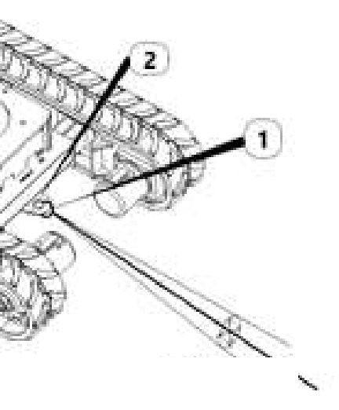
20° or less
● Permissible force: 28.2KN
1. Affix the rope to the hook ring (1).
2. Hook the hook ring (1) to the traction hole
(2).
3. Ensure that the rope maintains a 20° or
smaller angle with the traveling frame.
4. Move the machine to tension the rope.
5. Drive the machine at 2km/h or lower speed to a position (Easy for repairs)
within a short range from the site.

6-12

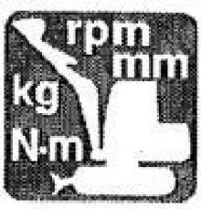

Parameter

7-1


Parameter
Basic Parameter
Applicable models: HFT11

HFT11 | Technical parameters | Unit
Overall weight |  | kg | 1123 | 1130
Bucket capacity |  | m3 | 0.02 | 0.02
Type of working device |  |  | Backhoe | Backhoe
Engine | Model |  | Kubota D902 | Yanmar3TNV74
Engine | Displacement | L | 0.898 | 0.993
Engine | Rated output power/speed | kw/r/min | 11.8/2300 | 11.2/2400
Engine | Maximum  torque/rotating speed | N.m/r/min | 51.3/1800 | 51.8/100
Speed | Maximum traveling speed (High/low) | km/h | 1.5 | 1.3
Speed | Slewing speed | rpm | 11 | 11
Speed | Maximum grade ability |  | 30% | 30%
Track sub assembly | Ground pressure | k Pa | 34.64 | 29.9
Track sub assembly | Material |  | Rubber | Rubber
Track sub assembly | Tension control type |  | Tightening cylinder | Tightening cylinder
Type of pump |  |  | gear pump | gear pump
Fuel/oil/fluid  pressure and  capacity | Working pressure | Mpa | 16 | 16
Fuel/oil/fluid  pressure and  capacity | Flow | (L/min) | 18.4 | 19
Fuel/oil/fluid  pressure and  capacity | Hydraulic oil tank capacity | (L) | 16 | 15
Fuel/oil/fluid  pressure and  capacity | Fuel tank capacity | (L) | 11 | 11

All ratings of the machine are obtained when the machine is operating on a solid horizontal support surface. If the working environment conditions of the machine differ from the above-mentioned reference conditions (Such as the operations on uneven ground and slope), the operator shall take these conditions into consideration.

7-2

Parameter
Overall Dimensions of Machine
Applicable models: HFT11

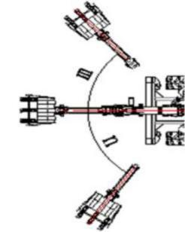
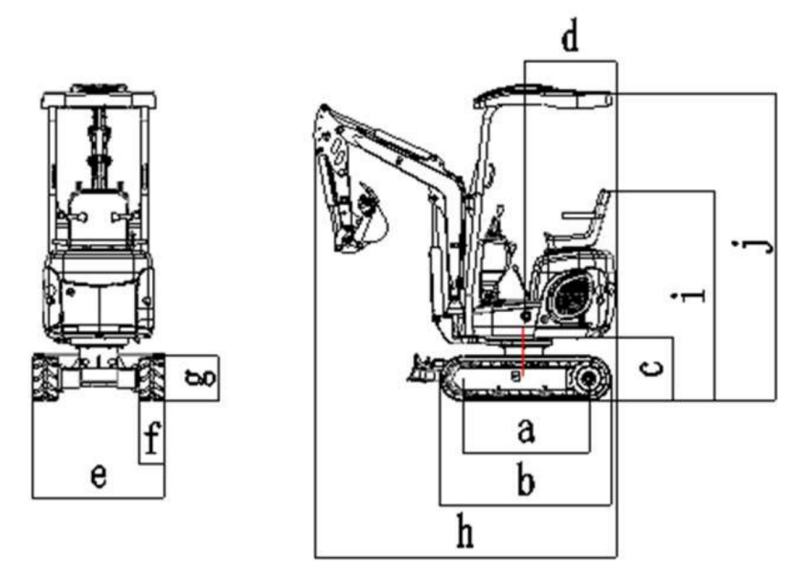

 | Overall dimensions | Unit: mm
a | Wheel track | 910
b | Overall length of crawler | 1235
c | Ground clearance of platform | 460
d | Tail slewing radius of platform | 660
e | Chassis width | 800-950
f | Track width | 180
g | Track height | 320
h | Transport length | 2170/2850
i | Ground clearance of seat | 1520
j | Overall height | 2270
m | Boom slewing - right | 50。
n | Boom slewing – left | 55。
7-3

Parameter
Operating Range
Applicable models: HFT11
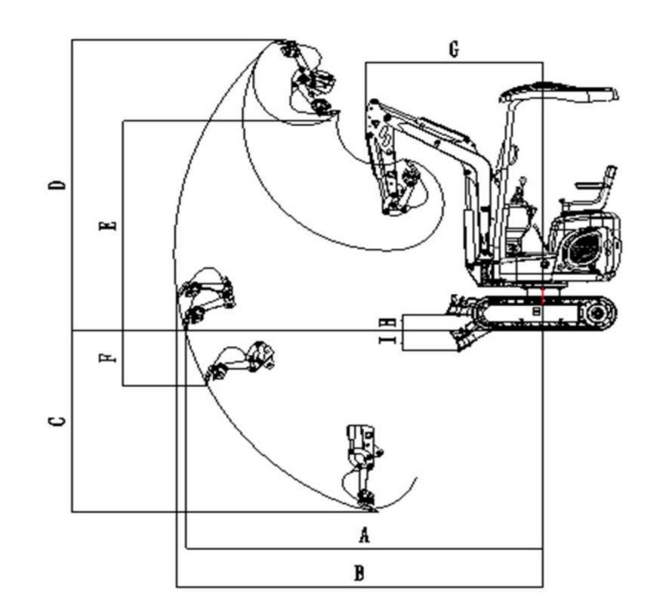

Working range Unit: mm

A | Ground maximum digging radius | 3040
B | Maximum digging radius | 3135
C | Maximum digging depth | 1580
D | Maximum digging height | 2620
E | Maximum Dump height | 2000
F | Maximum vertical digging depth | 1580
G | Minimum slewing radius | 1510
H | Maximum lifting height of bulldozing blade | 140
I | Maximum digging depth of bulldozing blade | 200

7-4

Accessories 

8-1

Accessories
General Safety Measures

General Safety Measures Safety Measures

ΔWarning

Please take the following safety measures
while disassembling or installing attachments.
● Please consult with Ken stone Heavy Machinery before installing optional products.
● Do not use any attachment not
approved by Ken stone Heavy
Machinery. Otherwise it will probably cause safety issues or cause adverse
influence on operations or life of machine.
● Ken stone Heavy Machinery will not be liable for any injury, accident, or
product damage arising from the use of non-approved attachments.
● Select a stable and level working zone. Ensure to park the machine in a well- ventilated place.
● Remove obstacles and dangerous objects and immediately clear any splashed fuel.
● During lifting, ensure to assign one
person as signaler. For detailed
procedure and measures, please follow the instructions of the signaler.

● If it’s necessary to place temporarily
heavy weights or accessories onto the
ground during disassembling or
installation, please ensure to place them in a steady place.
● During lifting, keep all personnel away from working zone. There is probably a danger of object falling or contact with personnel in the working zone.
● Use a crane to move heavy weights (≥25kg).
● Ensure to properly support the heavy weights before movement. While lifting a load by a crane, notice the gravity
center of the load and keep balance the machine.
● Do not operate the machine when a load is lifted by a crane.
● Follow the correct procedures to install boom and bucket arm, otherwise it will probably result in serious injuries. If the help is needed, please consult with your sales or service dealer.
Precautions for Installation of Working Device
Ensure to fulfill commissioning after the
replacement with optional product or other special attachment. Check the hydraulic oil level and if necessary add oil. For detailed

8-2

Accessories
General Safety Measures

installation/disassembling procedures of
attachments, please consult with your sales or service dealer.
Precautions for Operations of Attachment

ΔWarning
The extended attachment will deteriorate the machine stability. While the machine is
traveling or slewing on a steep slope, the
imbalance will probably result in rollover. Do not take the following operations, otherwise it will be extremely dangerous.

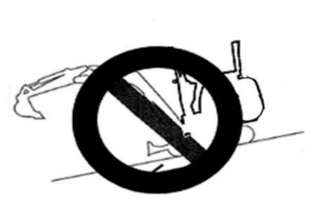

Driving down a steep slope with attachment lifted

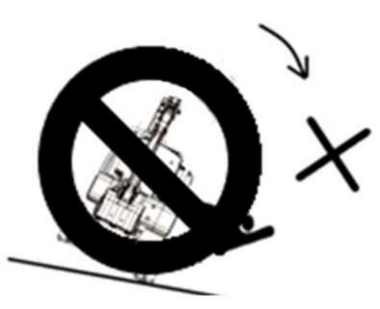

Driving laterally on a steep slope

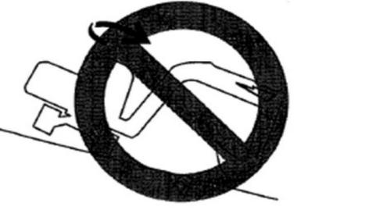
Slewing on a steep slope

If a heavy attachment is installed, while
stopping the machine, the impulsion force of the machine will be larger than usual value before the complete stop. Please carefully
take the distance into consideration to
prevent impact against surrounding objects. Keep a safe distance from surrounding
obstacles.
If a heavy attachment is installed, the gravity lowering (Slow lowering of attachment under the action of dead weight when the

8-3

Accessories
General Safety Measures
attachment is stopped in the air) will speed up.
The machine is more vulnerable to rollover in lateral direction than longitudinal
direction.
(1) Do not slew laterally when the bucket working device is heavily loaded.
Especially, do not slow laterally on a slope.
(2) For a machine with installed breaking hammer or grinder, the attachment is heavier than the installed standard
bucket. Do not operate this machine laterally, especially during the down slope digging.
Please carefully take the distance into
consideration to prevent impact against
surrounding objects of machine and keep a safe spacing from surrounding obstacles.

8-4

Accessories
Precautions
Precautions for Operations of Attachment

ΔWarning
● Please consult with Ken stone Heavy Machinery before installing optional products.
● Do not use any attachment not approved by Ken stone Heavy Machinery. Otherwise it will probably cause safety issues or cause adverse influence on operations or life of machine.
● Ken stone Heavy Machinery will not be liable for any injury, accident, or product damage arising from the use of non-approved attachments.
● If a bucket in width of >450M installed, the swing stop block must be installed. If no swing stop block is installed, it will probably result in impact of bucket with machine body.

8-5

Accessories
Hydraulic Hammer

Hydraulic Breaking Hammer
For the operations of breaking hammer, please refer to the separately provided manual of
hydraulic breaking hammer.

ΔWarning

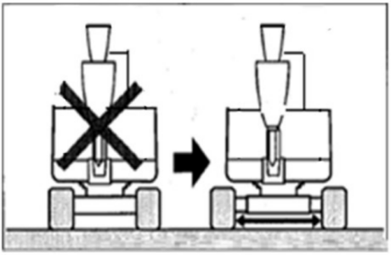
Do not use breaking hammer when the track width becomes narrower.
● Always operate the machine with
extended track width of 950mm, in
order to improve the machine stability to the maximum extent. Operating the machine with narrow track width
(800mm) will probably result in rollover of machine due to poor stability.
● If it’s necessary to operate the machine with narrow track width (800mm),
retract the bucket working device and lower the boom to reduce the gravity center and face the machine towards front before traveling.

While operating the optional products such as breaking hammer, tipping bucket, and grab
bucket, ensure that the track width is extended to 950mm.
Important: While installing an attachment,
ensure that it’s suitable for the machine model in use.
If the recommendations are required for the
choice of attachment, please contact your sales or service dealer.

8-6

Accessories
Hydraulic Hammer

Precautions for Operations

● Start the engine and run at 75% of maximum speed.
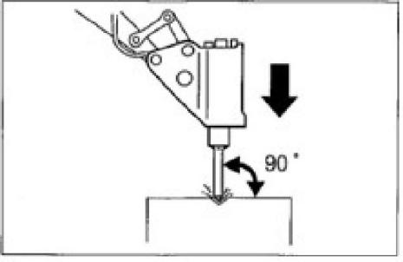

● Perform the crushing operation by placing the hammer head perpendicular to the
working face.
● During the crushing operations,
appropriately aim the hammer head at the object to be crushed and avoid the air
impact.

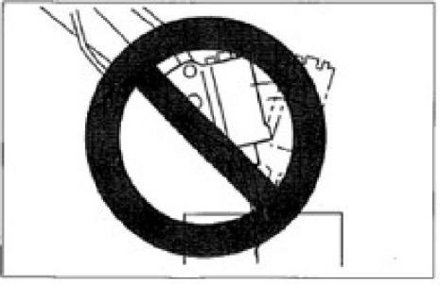
● Do not pry by hammer head or pry during breaking.
● Do not move the hammer head during crushing.
● Do not impact one same surface continuously for >30s.
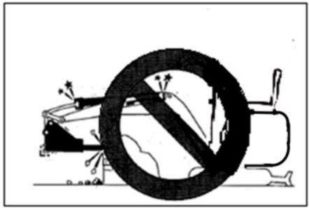

Do not crush when the cylinder is fully extended or retracted (at travel end).
●
Reserve at least 50mm travel.

8-7

Accessories
Hydraulic Hammer

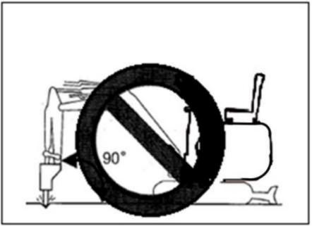

● Do not crush when the bucket arm is perpendicular to the ground.
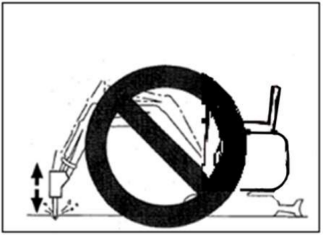
● Do not crush any object to be impacted by the gravity drop of breaking hammer.
● Do not use the breaking hammer to move any object or rock to be crushed.
● Slew the machine occasionally to cool down the engine.
● In event of abnormal vibration of hydraulic pipes, the nitrogen in the accumulator is
probably leaking. Please check as soon as possible.

Periodical Replacement of Hydraulic Oil
With installed hydraulic breaking hammer, the hydraulic oil deteriorates faster than the normal operations. Ensure to replace the hydraulic oil and oil return filter element.
● The failure to replace timely will result in damage of machine and breaking hammer hydraulic system. To prolong the life of hydraulic system, ensure to replace the
hydraulic oil and oil return filter element after the hours listed in table below.
● During the replacement of hydraulic oil, clean the oil suction filter screen.

Replacement period (Hour)

Item | Hydraulic oil | Filter element
1st time | – | 25
2nd time | ― | 100
Periodic | 1200(600) | 200
By taking the breaking hammer operating ratio of 100% for instance.

8-8

Accessories
Hydraulic Hammer
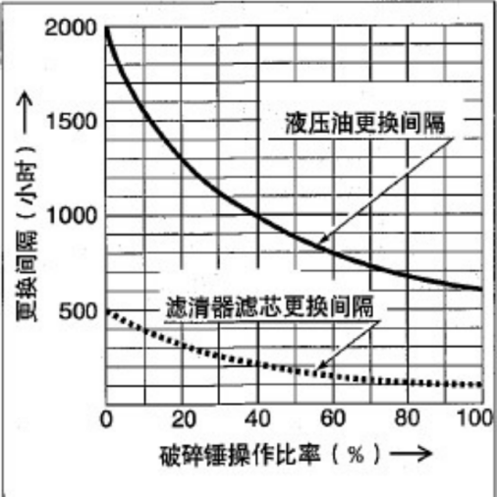
Replacement period (Hour)
Hydraulic oil
replacement period

Filter element
replacement period

hammer operating ratio (%)
Breaking
( ): For the use of common anti-wear hydraulic oil.

8-9

Records

8-10

Optional accessories

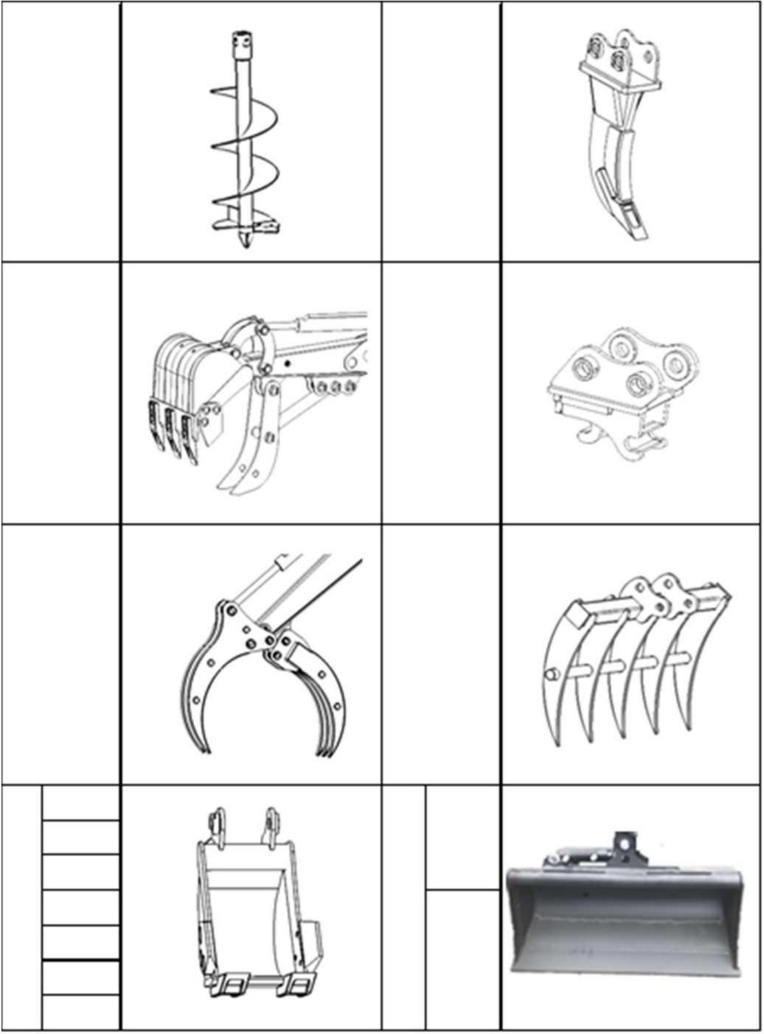
Auger Ripper

Thumb part

Grab

Quick hitch

Rake

200mm 300mm 500mm 600mm 700mm 800mm
Digg ing bucket
900mm

600mm
Tilt bucket

